Grade 2
Contributors: Katie Hauserman, Sara Hill, Olga Karwoski, Carly O’Brien
Theme/Big Idea | Content area language
Science  1. I want my students to understand that fossils give information about plants and animals that lived on Earth long ago.  2. I want my students to understand that different dinosaurs lived on Earth long ago.  3. I want my students to understand that new discoveries about dinosaurs are made by paleontologists.  4. I want my students to understand that earth’s features change over time.  English Language Arts  1. I want my students to understand that making connections improves comprehension and writing.  2. Effective listening and speaking skills are critical for communicating, collaborating, understanding and evaluating our world. | Language allocation for Bilingual classrooms in this grade.  70% Spanish  210 min (3.5 hrs)  30% English  90 min (1.5 hrs)
Content Area | Language allocation
Science  English Language Arts | 70% Spanish  210 min (3.5 hrs)  30% English  90 min (1.5 hrs)
Standards
Illinois Common Core State Standards
CCSS.ELA-Literacy.RI.2.1
Ask and answer such questions as who, what, where, when, why, and how to demonstrate understanding of key details in a text.
CCSS.ELA-Literacy.RI.2.2
Identify the main topic of a multiparagraph text as well as the focus of specific paragraphs within the text.
CCSS.ELA-Literacy.RI.2.4
Determine the meaning of words and phrases in a text relevant to a grade 2 topic or subject area.
CCSS.ELA-Literacy.RI.2.5
Know and use various text features (e.g., captions, bold print, subheadings, glossaries, indexes, electronic menus, icons) to locate key facts or information in a text efficiently.
CCSS.ELA-Literacy.RI.2.6
Identify the main purpose of a text, including what the author wants to answer, explain, or describe.
CCSS.ELA-Literacy.RI.2.8
Describe how reasons support specific points the author makes in a text.
CCSS.ELA-Literacy.RI.2.10
By the end of year, read and comprehend informational texts, including history/social studies, science, and technical texts, in the grades 2-3 text complexity band proficiently, with scaffolding as needed at the high end of the range.
CCSS.ELA-Literacy.W.2.2
Write informative/explanatory texts in which they introduce a topic, use facts and definitions to develop points, and provide a concluding statement or section.
CCSS.ELA-Literacy.W.2.8
Recall information from experiences or gather information from provided sources to answer a question.
CCSS.ELA-Literacy.SL.2.1
Participate in collaborative conversations with diverse partners about grade 2 topics and texts with peers and adults in small and larger groups.
CCSS.ELA-Literacy.SL.2.4
Tell a story or recount an experience with appropriate facts and relevant, descriptive details, speaking audibly in coherent sentences.
CCSS.ELA-Literacy.SL.2.5
Create audio recordings of stories or poems; add drawings or other visual displays to stories or recounts of experiences when appropriate to clarify ideas, thoughts, and feelings.
CCSS.ELA-Literacy.L.2.2
Demonstrate command of the conventions of standard English capitalization, punctuation, and spelling when writing.
CCSS.ELA-Literacy.L.2.2.a
Capitalize holidays, product names, and geographic names.
CCSS.ELA-Literacy.L.2.3
Use knowledge of language and its conventions when writing, speaking, reading, or listening.
CCSS.ELA-Literacy.L.2.4.e
Use glossaries and beginning dictionaries, both print and digital, to determine or clarify the meaning of words and phrases.

Science Standards

SLA Standards
1.A.1ª Demostrar la comprensión de conceptos de texto impreso.
1.A.1c Entender palabras desconocidas utilizando pistas del contexto y conocimiento anterior, verificar significados con materiales informativos.
1.C.1a Volver a contar cuentos en la secuencia correcta, identificando los personajes, ideas principales y detalles complementarios, predecir desenlaces y sacar conclusiones.
1.D.1e Leer en voz alta material propio del grado con fluidez, precisión y demostrando haber entendido.
2.A.1a Redactar escritos creativos en respuesta a un estímulo.
2.B.1ª Construir oraciones completas que demuestren concordancia, uso de mayúsculas propios del español.
3.A.1b Hacer preguntas aclaratorias y responder a las preguntas del maestro y de los miembros del grupo.
3.A.1c Seguir las instrucciones orales con precisión.
3.B.1d Participar en discusiones sobre un tópico común.
4.A.1c Comenzar a usar la ortografía española correctamente.

Language Development Standards
ELD1 Social and Instructional Language: English language learners communicate for Social and Instructional purposes within the school setting.

ELD2 The Language of Language Arts: English language learners communicate information, ideas, and concepts necessary for academic success in the content area of Language Arts

Content targets
Students will identify main idea within the text. (R.I. 2.2)
Students will be able to identify and define text features in an informational text. (R.I. 2.5)
Students will be able to compare and contrast different fossils/dinosaurs/characteristics ( R.I. 2.9)
Students will write an informative text in which they introduce a topic, use facts and definitions to develop points, and provide a concluding sentence. ( W.2.2)
Language targets
· Spanish:
· English:
· Cross linguistic: Students will identify main idea within the
text.
Building oracy and background knowledge | Formative assessment
- Language of instruction: Spanish & English  - Language resources, linguistic creativity, and cultural funds of knowledge  - Building background knowledge  Concept attainment  1. First do a gallery walk around the classroom to spark their interest. Each table is covered with a piece of butcher paper and different photographs pertaining to fossils.  2. Students will be working in cooperative groups to write down what words/phrases/thoughts come to mind when they see these fossils. They will write this on the butcher paper.  3. Students will come together and create an anchor chart about “Pete the paleontologist” students will come up with words for what a paleontologist needs and teacher will label it on the anchor chart.  4. Students will watch Fossil video: https://www.youtube.com/watch?v=TVwPLWOo9TE  5. Students will create their own fossils.  6. Create concept map after students have created their own fossils and discussed with a partner how they made them and what they did to create them.  7. Watch Magic School Bus episode on dinosaurs - https://www.youtube.com/watch?v=Cup92ogKITk. Then take pop quiz on Magic School Bus video. http://www.scholastic.com/magicschoolbus/games/quizzes/dinosaurs/  Vocabulary Match for Unit: Using picture/vocab students work in pairs to match the word to the picture. Students will create two piles of their vocab cards, words that they can define and words they cannot define. Students can then use the vocab word in a sentence, come up with examples, or their own definition of the word(s).  dinosaurio/dinosaur  esqueleto/skeleton  carnivoro/carnivore  herbivoro/herbivore  fosil/fossil  extinguido/extinct  prehistórico/prehistoric  paleontólogo/paleontologist  restos/remains | Student observation during gallery walk.  3-2-1 Slip  3 Things You Found Out  2 Interesting Facts  1 Question You Still Have  Teacher observes discussion, responses, and use of receptive and productive language.  Teacher observes student understanding and use of vocabulary through partner and whole group activities.
Reading comprehension | Formative assessment
(Reading plan specified in the Learning Plan at the bottom of this document)  Guided Reading Suggestion for the Bilingual Classrooms:  1. Read Vida Prehistórica National Geographic Lectoescritura Temprano. Stopping often to model visualizing, making connections, and check for understanding.  2. Students (in whole group first, then pairs) will summarize the book read as a class orally using the following sentence prompts:  3. Students will guide the LEA dictating to teacher what they learned in their reading. The teacher will write word for word what the students dictate.  4. Magic Tree House: Dinosaurs After Dark (Spanish copies available at York Center)  District reading & guided reading materials available in English:  1. Scott Pearson science book chapter 7  2. Magic Tree House: Dinosaurs After Dark  3. Dino Discovery Passage (found in shared folder)  4. Dinosaur Mini Book (found in shared folder)  5. Extension: High-level reading comprehension pages about dinosaurs (guided reading folder in BUF)\  6. Leveled readers found on www.pearsonsuccess.net. | Formative Assessment:  (Teacher observation of receptive and productive language.) Teacher will observe as students interact in on-task activities: Think-pair-share, small and/or whole group discussions. Teacher will observe as students orally summarize content read. Teacher will model how to make visualize and summarize to check their own understanding. Option: Teacher can create a chart and write down students’ various connections.
Writing | Formative assessment
1. Spanish & English - Student Interactive- journals: Bridge notebook (listing cognates and discussing), vocabulary words, what they learned from the lessons, questions, read-talk-write, etc.  2. Spanish - Letras tramposas q/c (esqueleto, prehistórico ), c/s (dinosaurio, fosil); accents for words ending in -ción  3. Students will work on a shared research to write an informative paragraph comparing herbivores vs. carnivores.  Prompt: In this unit we have been learning about prehistoric life. We have studied fossils and dinosaurs. Write a paragraph describing the differences and similarities between carnivores and herbivores.  Spanish Prompt: Hemos estado aprendiendo acerca de los dinosaurios. Escriba un párrafo explicando las diferencias y similitudes entre los carnivoros y herbivoros.  ** Writing Fundamentals Non-fiction Kit , Writing a Report will be addressed through the Dinosaurs BUF. | Teacher Observation of , dialogue, discussion, answers.  Rubrics:  1. Writer’s Notebook  2. Research Rubric (Schoolwide)
Word study and fluency | Formative assessment
1. Breaking words into syllables and joining them together  2. Circling and counting syllables in LEA  3. Circling and counting words and understanding that syllables make up words  4. Read to self and to a partner to focus on improving fluency  5. Synonym Study: Flower Power (Dinosaur edition)  6. Spanish and English Dictation with word work activities:  Day 1 - Teacher presents the dictado by reading it aloud several times. After the first reading, the students write as teacher dictates (use template). Then, the teacher writes the dictado so students may correct their own attempt. Mini lesson - writing mechanics, grammar, or spelling.  Day 2 - Teacher presents mini-lesson, this can be a review of Monday’s lesson or may have a new focus depending on students’ age or abilities.  Day 3 - Partner activities such as: Cutting up sentences and rearranging them to form the dictation. Partners take turns dictating to one another and writing in template.  Day 4 - Continued focus on spelling and writing mechanics introduced earlier in the week. Students may add content to dictation (use back of page) to show what they have learned (enrichment activity).  Day 5 - Final Dictation and evaluation. Teacher may re-teach as needed and re-evaluate, give chances  Word sort for vocabulary words  1. Sorting words with one or more syllables  Vocabulary Practice: Write vocabulary words on numbered giant dinosaur footprints. Students roll a dice and jump onto the footprint that corresponds to the number. The student will give a definition of the word or use the word correctly in a sentence.  Options:  - Students gather the prints after they land on them; whichever student ends with the most footprints wins.  - Put numbers 2 - 12 on the cards. Students must roll two dice and add the numbers together to find their vocabulary footprint. Example: roll a 2 and 3. Student goes to the footprint numbered 5. | Teacher observation of receptive and productive language as students write what teacher has said.  Teacher will use Dictation template.  *Dictation rubric is available.*
Summative assessment
1. Students will take a pretest in the beginning of the unit and a posttest at the end of the unit that assesses key vocabulary, key concepts, and reading comprehension.

The Bridge: Strengthening bridges between languages | Formative assessment
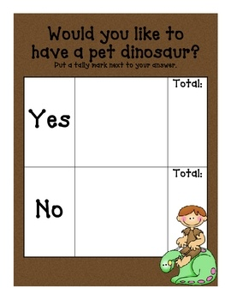
1. Teacher will use anchor chart created at the beginning of the unit in spanish to bridge the vocabulary to english.
2. Teacher will do a mini lesson using a four square organizer to practice using the new words in english.
3. Teacher will take a poll to ask students “Would you like to have a pet dinosaur?”
4. Students will work in partners to complete an opinion writing graphic organizer. (in resources)
Extension activity | Formative assessment
Language of instruction: English  LISTENING  Students listen to and learn to sing the “Go Find a Fossil” to help reinforce learning what a fossil is and how one is formed (pg. 206 in science textbook).  ADDITIONAL ARTISTIC ACTIVITY:  Students will create a “dinorama” that shows prehistoric life, including animals and plants that lived long ago.  Students create their own dinosaurs. They write about what their dinosaur eats, what it looks like, where it lives, what it likes to eat, and name it. Students make a model of their dinosaur using toothpicks and marshmallows (or using construction paper).  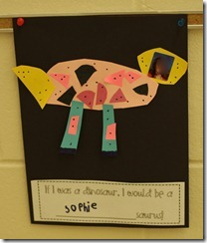  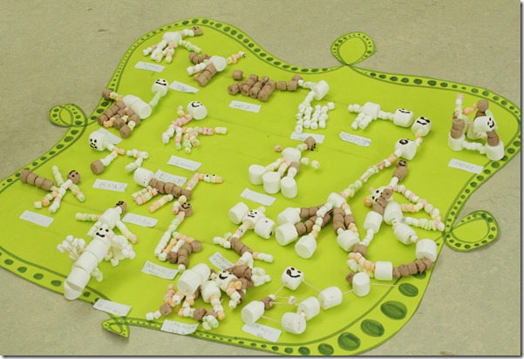  MATH  Students will use different texts to find the sizes of different dinosaurs.  In the hallway/outside they will use toilet paper or chalk to show the sizes of different dinosaurs.  Enrichment: students can chart the different sizes.  Scholastic interactive game:  http://teacher.scholastic.com/activities/dinosaurs/realormakebelieve/index.htm  Scholastic Build a Dinosaur Game:  http://teacher.scholastic.com/activities/dinosaurs/buildadino/index.htm | SPEAKING  Observation of receptive and productive language exhibited by students during the Language Experience Approach.  WRITING  Rubrics for...  1. Dinosaur booklets.  2. Dinosaur Project.  READING  Observation of comprehension and use of text to answer questions.  LISTENING  Observation of receptive and productive language based on discussions after watching videos.

LEARNING PLAN
Summary of Key Learning Events and Instruction
Lesson | Day(s) | Topic | Activities
Building Background Knowledge | 1 - 2 | Vocabulary | Day 1: Concept attainment  1. First do a gallery walk around the classroom to spark their interest. Each table is covered with a piece of butcher paper and different photographs pertaining to fossils.  2. Students will be working in cooperative groups to write down what words/phrases/thoughts come to mind when they see these fossils. They will write this on the butcher paper.  3. Pass out the Dinosaur Report Booklet. Go over expectations of how to add to the book and when we will add to the book (each day after learning something new).  Day 2:  3. Students will come together and create an anchor chart about “Pete the paleontologist” students will come up with words for what a paleontologist needs and teacher will label it on the anchor chart.  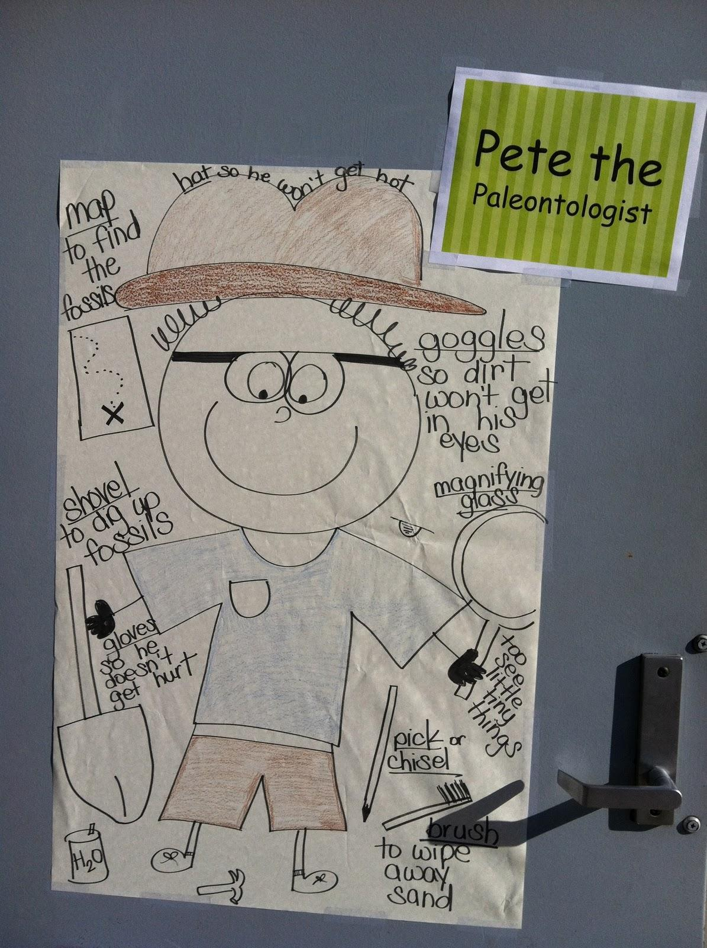  4. Students will watch Fossil video: https://www.youtube.com/watch?v=TVwPLWOo9TE  Optional paleontologist video:  https://www.youtube.com/watch?v=B7zo2zY1Zqg  5. Students will create their own fossils using clay and shells or other objects.  6. Create concept map after students have created their own fossils and discussed with a partner how they made them and what they did to create them.
Reading Comprehension | 3 | Preview + Set Purposes for Reading | 1. Read/ Sing the song on p. 206 together.  A. Look at illustration: What on this page is an example of a fossil? How is a plant fossil like a plant?  B. Partner Work: Students add ART motions and repeat the song with a partner. Decide as a class which motions to include.  2. Reading: Set purposes for reading: How do fossils form?
Reading Comprehension  (Bilingual Classrooms - find the book Fosiles y Dinosaurios in Scott Foresman Science GR library to copy for students) | 4 - 5 | Retelling | 1. Read Scott Foresman (English - Fossils and Dinosaurs; Spanish - Fosiles y Dinosaurios) pg. 2 - 5 about how fossils are formed. Key words: paleontologist, fossils. Students will re-read in partners and for homework as assigned to practice fluency.  2. After reading, students will retell with hand motions how a fossil is formed (the animal dies, it’s covered by sand and mud, the sand and mud become rock, the print of the animal becomes a fossil). Add more tools to Pete the Paleontologist. What other tools do paleontologists use?  3. Use the “What is a fossil?” organizer to illustrate the steps of fossilization. Students will practice orally retelling the steps with a partner.
Reading Comprehension | 6 | Retelling & Vocabulary Practice | Read Scott Foresman (English - Fossils and Dinosaurs; Spanish - Fosiles y Dinosaurios) pg. 6 - 7. Turn and tell a partner what it means when an animal becomes extinct and what paleontologists can learn from examining fossils.  Vocabulary Practice:  Write vocabulary words on numbered giant dinosaur footprints. Students roll a dice and jump onto the footprint that corresponds to the number. The student will give a definition of the word or use the word correctly in a sentence.  Options:  - Students gather the prints after they land on them; whichever student ends with the most footprints wins.  - Put numbers 2 - 12 on the cards. Students must roll two dice and add the numbers together to find their vocabulary footprint. Example: roll a 2 and 3. Student goes to the footprint numbered 5.  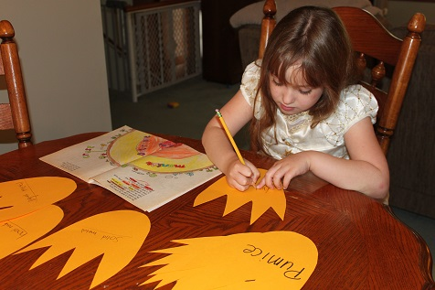
Reading Comprehension | 7 | Vocabulary Development | Read Scott Foresman (English - Fossils and Dinosaurs; Spanish - Fosiles y Dinosaurios) pg. 8 - 11. After reading, students will orally describe their dinosaurs, coming up with synonyms. They will then use the dinosaur template, write the “boring word” in the center, and come up with synonyms for the “boring word”.  Guided reading extension: dinosaur fact cards with an informational response sheet.
Reading Comprehension | 8 | Reading Comprehension & Written Response | Read Scott Foresman (English - Fossils and Dinosaurs; Spanish - Fosiles y Dinosaurios) pg. 12 - 15. Read and respond: Students can choose between the two following writing prompts:  1. What information can you learn from studying fossils?  2. What do paleontologists do?  All students must respond to this questions:  What questions do you have about life on Earth long ago?  Below-level students must come up with at least 2 questions. Above-level students must come up with at least 3 questions.
Reading | 9 | Context Clues | Read “Cookie Excavation” using highlighters to highlight the context clues that lead students to understand what the words “paleontologist” and “excavate” mean.  Perform the “cookie excavation” experiment with chocolate chip cookies and excavating tools (popsicle sticks). Students will be paleontologists and graph their findings.
Writing | 10 - 15 | Journal Writing  LEA  Informative Paragraph  (Word Study) | 1. Spanish & English - Student Interactive- journals: Bridge notebook (listing cognates and discussing), vocabulary words, what they learned from the lessons, questions, read-talk-write, write LEA together in chart paper, then students can add to more in their notebooks.  2. Spanish - Letras tramposas q/c (esqueleto, prehistórico ), c/s (dinosaurio, fosil); accents for words ending in -ción  3. Students will work on a shared research to write an informative paragraph comparing herbivores vs. carnivores.  Prompt: In this unit we have been learning about prehistoric life. We have studied fossils and dinosaurs. Write a paragraph describing the differences and similarities between carnivores and herbivores.  Spanish Prompt: Hemos estado aprendiendo acerca de los dinosaurios. Escriba un párrafo explicando las diferencias y similitudes entre los carnivoros y herbivoros.
Word Study and Fluency | 10 - 15 | Word Study | 1. Breaking words into syllables and joining them together  2. Circling and counting syllables in LEA  3. Circling and counting words and understanding that syllables make up words  4. Read to self and to a partner to focus on improving fluency  5. Synonym Study: Flower Power (Dinosaur edition)  6. Spanish and English Dictation with word work activities:  Day 1 - Teacher presents the dictado by reading it aloud several times. After the first reading, the students write as teacher dictates (use template). Then, the teacher writes the dictado so students may correct their own attempt. Mini lesson - writing mechanics, grammar, or spelling.  Day 2 - Teacher presents mini-lesson, this can be a review of Monday’s lesson or may have a new focus depending on students’ age or abilities.  Day 3 - Partner activities such as: Cutting up sentences and rearranging them to form the dictation. Partners take turns dictating to one another and writing in template.  Day 4 - Continued focus on spelling and writing mechanics introduced earlier in the week. Students may add content to dictation (use back of page) to show what they have learned (enrichment activity).  Day 5 - Final Dictation and evaluation. Teacher may re-teach as needed and re-evaluate, give chances  Word sort for vocabulary words  1. Sorting words with one or more syllables  Vocabulary Practice: Write vocabulary words on numbered giant dinosaur footprints. Students roll a dice and jump onto the footprint that corresponds to the number. The student will give a definition of the word or use the word correctly in a sentence.  Options:  - Students gather the prints after they land on them; whichever student ends with the most footprints wins.  - Put numbers 2 - 12 on the cards. Students must roll two dice and add the numbers together to find their vocabulary footprint. Example: roll a 2 and 3. Student goes to the footprint numbered 5.
Assessment | 16 |  | Post-Test on Unit (Found in pearson assessment book)
The Bridge for Bilingual Classrooms | 17 | Bridging - Contrastive Analysis and Metacognitive Focus | 1. Teacher will use anchor chart created at the beginning of the unit in spanish to bridge the vocabulary to english.  2. Teacher will do a mini lesson using a four square organizer to practice using the new words in english.  3. Teacher will take a poll to ask students “Would you like to have a pet dinosaur?”  4. Students will work in partners to complete an opinion writing graphic organizer. (in resources)
Extension | 18 - 20 | Extending for Language Acquisition Multiple Modalities | Language of instruction: English  LISTENING  Students listen to and learn to sing the “Go Find a Fossil” to help reinforce learning what a fossil is and how one is formed (pg. 206 in science textbook).  WRITING  Students will write words that describe dinosaurs or a specific dinosaur. Use tagxedo.com to type the words and generate a word picture of a dinosaur.  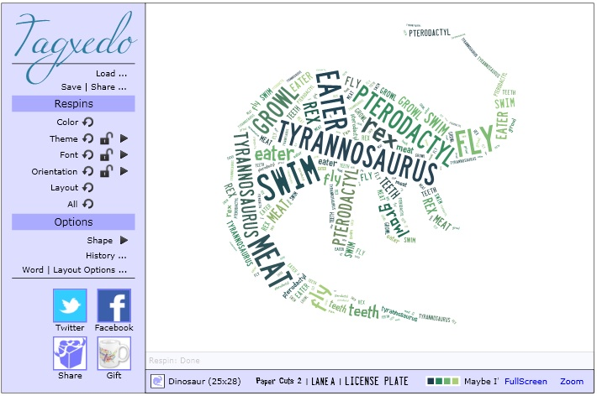  SPEAKING  Practice and recite these poems:  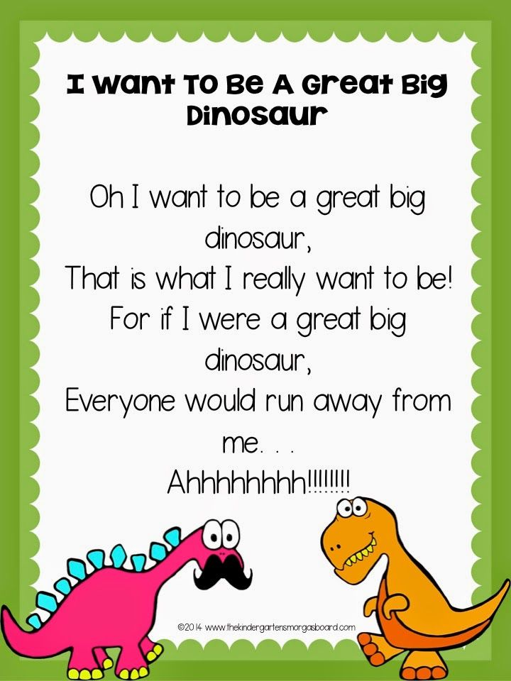  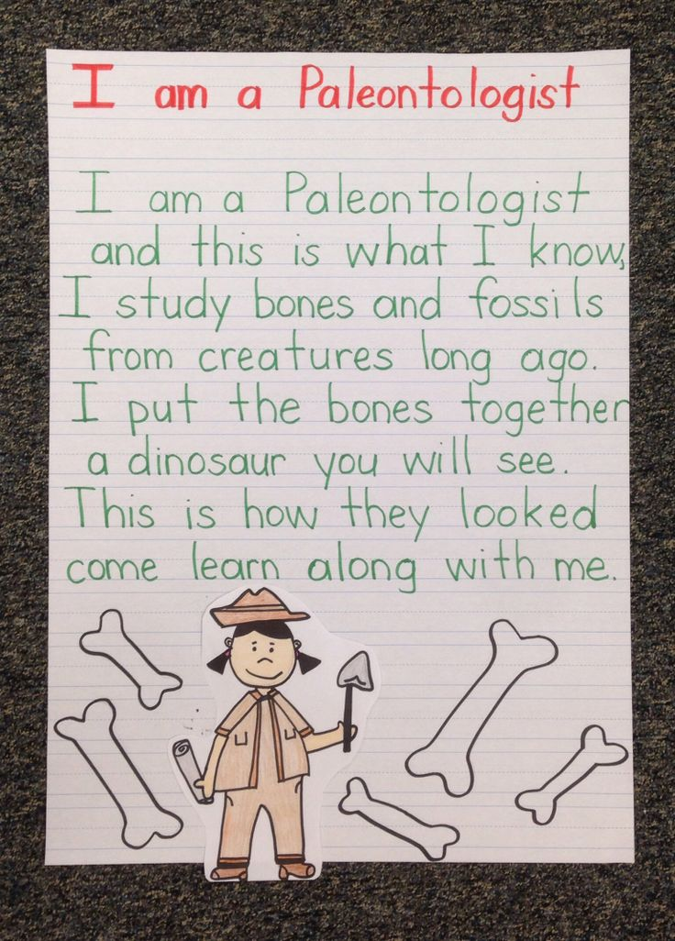  MATH  Students will use different texts to find the sizes of different dinosaurs.  In the hallway/outside they will use toilet paper or chalk to show the sizes of different dinosaurs.  Enrichment: students can chart the different sizes.  Scholastic interactive game:  http://teacher.scholastic.com/activities/dinosaurs/realormakebelieve/index.htm  Scholastic Build a Dinosaur Game:  http://teacher.scholastic.com/activities/dinosaurs/buildadino/index.htm

EXTENSION CHOICE MENU

Dinorama  Students will create a “dinorama” that shows prehistoric life, including animals and plants that lived long ago.  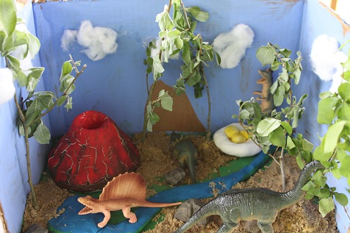 | Design Your Own Dinosaur  Students create their own dinosaurs (i.e. “Katie-saurus”). They write about what their dinosaur eats, what it looks like, where it lives, what it likes to eat, and name it. Students may use the “If I Were a Dinosaur” organizers.  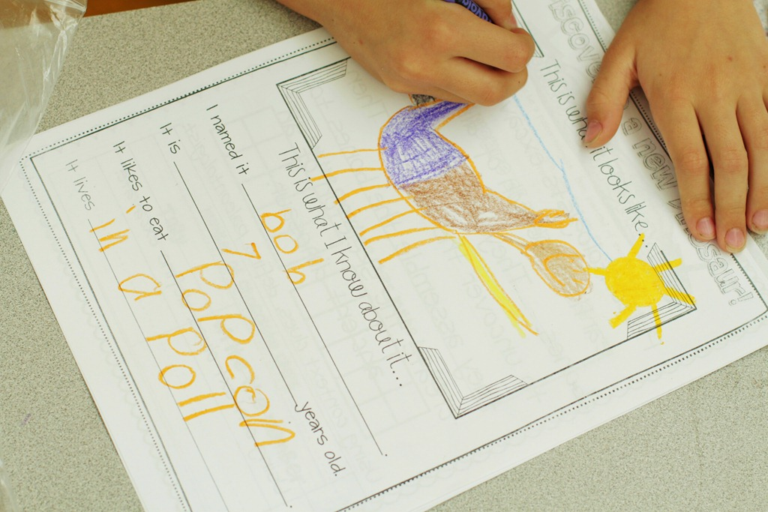 | Dino Model  Students make a model of their dinosaur using toothpicks and marshmallows (or using construction paper). Students write an explanation of what their dinosaur looks like.
Dino Diamante
Students write a poem in “diamante” form to compare two dinosaurs (ex: herbivores/carnivores).

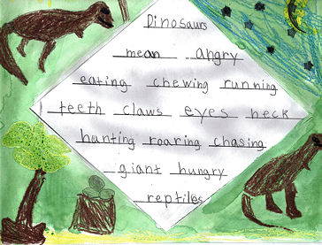

Name ____________________ Date__________________
Design Your Own Dinosaur Rubric
Category | 4 | 3 | 2 | 1
Written Information | Written product contains all required information. | Written product contains most of the required information. | Written product contains some of the required information. | Written product contains little of the required information.
Knowledge of topic | Product demonstrated outstanding knowledge of dinosaurs. | Product demonstrated good knowledge of dinosaurs. | Product demonstrated some knowledge of dinosaurs. | Product demonstrated little knowledge of dinosaurs.
Speaking | The student presented their design your own dinosaur clearly, and described it orally. | The student mostly presented their design your own dinosaur clearly, and described it orally. | The student presented their design your own dinosaur and described some of the project orally. | The student did not present the information on his/her design your own dinosaur clearly and did not describe it correctly.
Effort | Demonstrated outstanding effort throughout the project. | Demonstrated good effort throughout the project. | Demonstrated some effort throughout the project. | Demonstrated little effort throughout the project.

Name ____________________ Date__________________
“Dino-rama” Rubric
Category | 4 | 3 | 2 | 1
Knowledge of topic | The dino-rama demonstrated outstanding knowledge of the dinosaurs. | The dino-rama demonstrated good knowledge of dinosaurs. | The dino-rama demonstrated some knowledge of dinosaurs. | The dino-rama demonstrated little knowledge of the dinosaurs.
Design and illustration of stamp | The design of the dino-rama is highly creative, and the illustration is neat. | The design of the dino-rama is creative, and the illustration is neat. | The design of the dino-rama is somewhat creative, and the illustration is somewhat neat. | The design of the dino-rama shows little creativity and/or neatness.
Speaking | The student presented their dino-rama clearly, and described it orally. | The student mostly presented their dino-rama clearly, and described it orally. | The student presented their dino-rama and described some of the project orally. | The student did not present the information on his/her dino-rama clearly and did not describe it correctly.
Effort | Demonstrated outstanding effort throughout the project. | Demonstrated good effort throughout the project. | Demonstrated some effort throughout the project. | Demonstrated little effort throughout the project.

Name ____________________ Date__________________

Dino Model Rubric
Category | 4 | 3 | 2 | 1
Written Information | Written product contains a complete explanation of what the dinosaur looks like including size, color, and descriptive details. | Written product contains an explanation of what the dinosaur looks like with some description. It is missing some information. | Written product contains some of the required information. More than one detail is missing. | Written product contains little of the required information. Most details are missing.
Sentence Structure | Wrote at least 3 complete sentences with correct punctuation and capitalization. | Wrote at least 2 complete sentences with correct punctuation or capitalization. | Wrote at least 1 complete sentence but did not capitalize and use correct punctuation. | Did not write any complete sentences.
Effort | Demonstrated outstanding effort throughout the project. | Demonstrated good effort throughout the project. | Demonstrated some effort throughout the project. | Demonstrated little effort throughout the project.
Speaking | The student presented their project clearly, and described his/her dinosaur model orally. | The student mostly presented their project clearly, and described his/her dinosaur model orally. | The student presented their project and described his/her dinosaur model orally. | The student did not present the information on his/her poster clearly and did not describe his/her dinosaur model orally.

Name ____________________ Date__________________

Dino Diamante Rubric
Category | 4 | 3 | 2 | 1
Quality of information | The facts recording were highly interesting. | The facts recorded were interesting. | The facts recorded were somewhat interesting. | The facts recorded were not interesting.
Effort | Demonstrated outstanding effort throughout the project. | Demonstrated good effort throughout the project. | Demonstrated some effort throughout the project. | Demonstrated little effort throughout the project.
Speaking | The student presented their Dino Diamante clearly. | The student mostly presented their Dino Diamante clearly. | The student presented their Dino Diamante somewhat clearly. | The student did not present the information on his/her Dino Diamante clearly.

