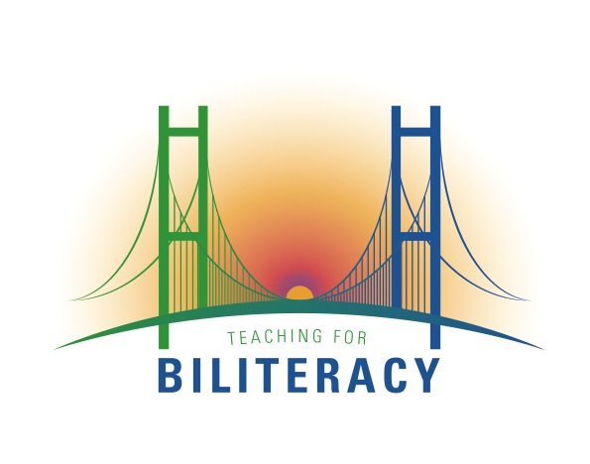
How Administrators Can Support the Three Premises for Biliteracy: Leadership Considerations

June 23, 2015

Guest | Position | Program Description
Jon Baricovich  baricovich@sd104.us  Summit, Il. | Bilingual Program Director | Summit is in its third year of rolling out an 80/20 TWI program in a predominantly Latino suburb of Chicago. Summit has a very deliberate roll out plan that includes BUF writing and teacher training.
Jaime Barraza  jbarraza@nssd112.org  Jennifer Ferrari  jferrari@nssd112.org  Stephanie Cardella  scardella@nssd112.org  North Shore District 112 | District Language Programs Coordinator  Assistant Superintendent  Learning Coordinator | North Shore District 112 has had a dual language program for approximately 15 years. The program began with initial literacy instruction in the students’ home language, then switched to initial literacy instruction for all in Spanish, and is now shifting to biliteracy in a 90/10 program. These shifts reflect the evolution of research and best-practices in the field.
Laurie Burgos  burgosl@verona.k12.wi.us  Verona Area School District  Wisconsin | Director of Bilingual Programs & Instructional Equity | The Verona Area School District is phasing out a transitional bilingual program (K-3) and replacing it with a TWI program (two-way immersion), which is moving into 2nd grade this fall. The TWI language plan is 50/50.
Lauren Leitao  leitaol@district65.net  Lindsey Rose  rosel@district65.net  Evanston/Skokie School District 65  Illinois | Bilingual Curriculum Coordinator  Bilingual Facilitator | The Evanston/Skokie School district places all of their ELLs in the TWI program, which has been operating for about 15 years. This program has recently shifted from sequential to simultaneous literacy instruction. The TWI language plan is 90/10.

