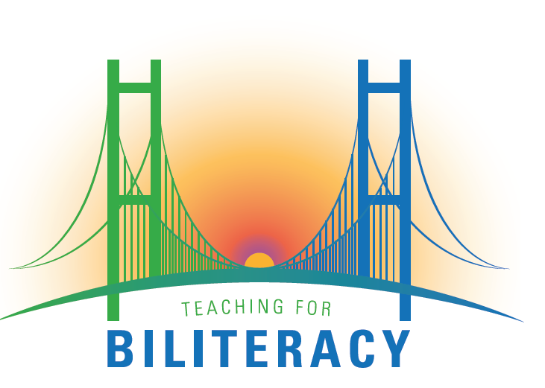

BUF Writing Process: Recommended Steps

- Review and clarify the program’s language and content allocation plan.

  - Determine how much time is spent in what language at each grade level. Include the Bridge. For examples, go to www.teachignforbiliteracy.com/programmaticresources

  - Assign each content area to a language: math, science and social studies. Be sure that language arts is taught in both languages starting at kindergarten.

- Develop a year long plan for each grade level that includes the following:

  - Chronological list of units and themes taught in Spanish and in English. Indicate the time of year these units are to be taught.

  - Anchor these units in your state’s learning and language standards (CCSS for ELA and SLA, WIDA, Next Generation Science Standards, Social Studies Standards, etc.). Include references to the standards in this document to ensure that all standards are being addressed throughout the year.

  - Determine and illustrate the relationship between Spanish and English literacy units, and be sure these are anchored in your language and content allocation plan. In grades 50/50 programs, the units for K-2 look significantly different than in 80/20 programs at the K-2 grade level. For examples, go to www.teachingforbiliteracy.com/BUFs.

- Create a biliteracy schedule for each of the grade levels. The schedule should:

  - Reflect the language and content allocation plan for that grade level.

  - Include reading and writing in both Spanish and English at every grade level, including kindergarten in an 80/20 or a 90/10 program.

  - Include uninterrupted chunks of time in each language (reduce the switching back and forth). Ideally, there should be one language transition per day.

  - List the literacy routines used by the district and that should be included in each literacy block.

- Write BUFs for every unit identified in the year-long plan.

  - Big ideas for CONTENT

  - Big ideas for LANGUAGE ARTS

  - Language targets (unit level):
    - Spanish
    - The Bridge
    - English

  - Content targets (unit level):

  - Academic Language at the word, sentence and discourse level in both Spanish and English.
  - Summative Assessment that evaluates student learning of the language and content targets.
  - Identify activities, strategies and materials for every element in the BUF: oracy and background knowledge, reading, writing, word study and fluency, the Bridge and extension activities.

- Create a weekly lesson plan:

  - Include the same literacy routines that are included in the daily schedule.

  - Provide space for teachers to describe when and how they will deliver the activities described in the BUF. This is where teachers can differentiate and be more specific in their planning.

  - Include a section where teachers can plan language and content area objectives for the lessons (as opposed to language and content area targets).

  - Include a space for formative assessment (rubrics, checklists, anecdotal evidence, conferencing, student self-evaluation, etc.)

