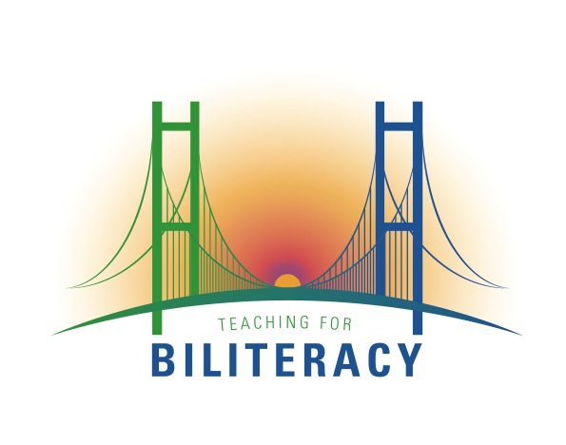
Panel of Practitioners: BUF Writing Process and Product
June 24, 2015
Agenda:

- Overview of the BUF Writing Process: Recommended Steps (Karen Beeman). Description of samples and trends we see in the field as districts/schools engage in the process of writing bilingual units. 1:30-1:35 p.m.

- Administrator Perspective:

  - Gretchen Lettau – Menasha Joint School District, Wisconsin 1:35-1:50 p.m.
    - Overview of the process undertaken in MJSD
    - Successes
    - Challenges
    - Next Steps

  - Jon Baricovich – Summit School District, Illinois – 1:50-2:05 p.m.
    - Overview of the process undertaken in Summit
    - Successes
    - Challenges
    - Next Steps

- Teacher Perspective:

  - Bilingual Program Perspective (TBE shifting to DBE): Olga Karowski 2:05-2:20 p.m.
    - School or District Context
    - Successes
    - Challenges
    - Next Steps

  - Two-Way Immersion Perspective: Kindergarten – Susan Pryor 2:20-2:35 p.m.
    - School or District Context
    - Successes
    - Challenges
    - Next Steps
  - Two-Way and One-Way Dual Language: First Grade – Sara Robles 2:35-2:50 p.m.

4. Questions, Closing Comments: Karen Beeman 2:50-3:00 p.m.

