High Leverage Biliteracy Strategies
Spanish Version: https://bit.ly/47llSz9

Strategy Name and Description | Language Supports and Notes
Concept Attainment: Concept attainment is a constructivist strategy wherein students construct an understanding of a new concept through a series of hints or examples of the concept. This is in contrast to the more teacher-centered (and abstract) approach, where the teacher tells the students the concept they will be studying and then describes the concept to the students.  Teaching for Biliteracy Book: page 81-82 | 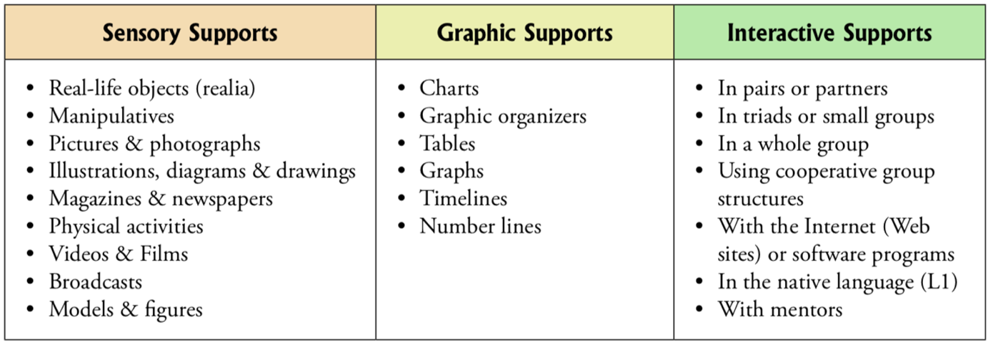  © WIDA Language Development Standards  Notes:  - Meaningful Frame (i.e., content and unit theme)
Strategy Name and Description | Language Supports and Notes
Language Experience Approach (LEA): Students experience a meaningful event together (field trip, experiment, acting out a story). Afterwards, using sentence prompts and strategic partners, the teacher asks students to generate sentences that retell the shared experience, and their contributions are transcribed into a written piece. This shared text becomes a meaningful literary resource that may be used as a writing mentor text, reading fluency practice, and/or meaningful application of grade-level language standards and foundational skills.  Teaching for Biliteracy Book: page 94 & 104-105 | © WIDA Language Development Standards  Notes:  - Meaningful Frame (i.e., content and unit theme)
Strategy Name and Description | Language Supports and Notes
Adapted Reader’s Theater (ART): An adaptation of readers’ theater where the teacher summarizes or paraphrases a text while the students, guided by the teacher, act out the story either silently or joining into the narration using the key academic vocabulary. This previews concepts and vocabulary from the text through narration and movement. While it is similar to concept attainment, the difference is that there is not as much of an emphasis on associating specific vocabulary with a specific movement.  Teaching for Biliteracy Book: page 81 | © WIDA Language Development Standards  Notes:  - Meaningful Frame (i.e., content and unit theme)
Strategy Name and Description | Language Supports and Notes
Fishbowl: A small group of students is selected to model a cooperative activity or center task in the "fishbowl," with the rest of the students observing their actions and language. The teacher guides the students in the fishbowl through the activity, narrating and providing sentence prompts as needed. After the students observe their peers participating in the fishbowl, they return to their places and begin the same activity.  Teaching for Biliteracy Book: page 82 & 136 | © WIDA Language Development Standards  Notes:  - Meaningful Frame (i.e., content and unit theme)
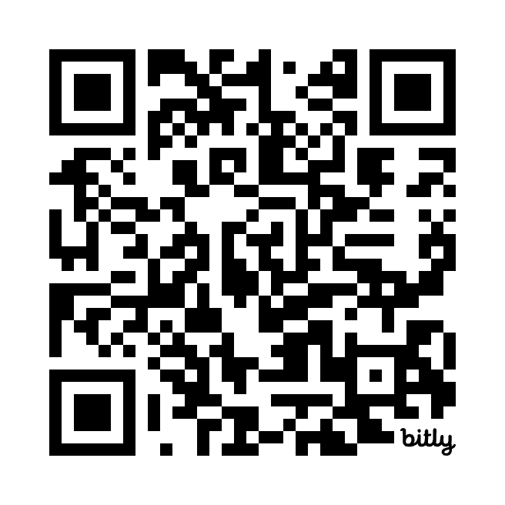 | For more information about the strategies above and descriptions to even more high leverage biliteracy strategies, scan the QR Code!

