
Center for Teaching for Biliteracy
www.TeachingForBiliteracy.com

Dual Language Programs in Action:
Effective Planning and Implementation
Lloyd Elementary School, CPS
June 9-11, 2026

Outcomes:
- Describe the goals of dual language programs, its pillars, and what they look in practic4
- Describe a fully developed bilingual, and the different bilingual/ biliteracy trajectories of our students
- Define biliteracy and explain how it should be implemented
- Describe the Biliteracy Unit Framework (BUF) and how it reflects the research on language acquisition and literacy development
- Experience biliteracy in action, focusing on:
  - Language acquisition strategies
  - Connection between oracy (academic listening and speaking) and literacy
  - Building background knowledge
  - Reading and writing
  - Foundational skills
  - The Bridge
- Identify and describe high leverage biliteracy strategies to use during instruction in any language.
- Describe how language development supports (sensory, graphic, and interactive) engage all learners and are included during instruction in each program language.
- Create a draft Vision and Pedagogy statement for Lloyd, answering these questions:
  - What is the overall vision of the program (3 pillars)
  - How will instruction support students in meeting the vision (what does instruction look like?)
- Review best practices in bilingual/biliteracy assessment
- Create individual goals for incorporating elements of the 3-day session into practice

Presenter:
Karen Beeman
teachingforbiliteracyKB@gmail.com

Agenda:

Tuesday, June 9, 2026 | Wednesday, June 10, 2026 | Thursday, June 11, 2026
- Welcome and Introductions  - Students and Goals of DL/ Biliteracy Programs  - Defining Biliteracy -The Biliteracy Unit Framework (BUF)  - Sample Instruction Part 1: oracy and background knowledge in preparation for content, inquiry and literacy  - Reflection and Application | - Debrief Sample Instruction  - Research on Dual Language Programs  - Teacher and Student Language Use  - Sample Instruction Part 2: Content, literacy, and the summative assessment  - Reflection and Application | - Sample Instruction Part 3: The Bridge  - Debrief Sample Instruction  - The Multilingual Perspective of Language  - Biliteracy Assessment  - Planning for Sustainability: Creating the Lloyd Vision and Pedagogy and “DL Look Fors”  - Closure

To be completed Wednesday, June 11, 2026

https://bit.ly/4e3dtCm

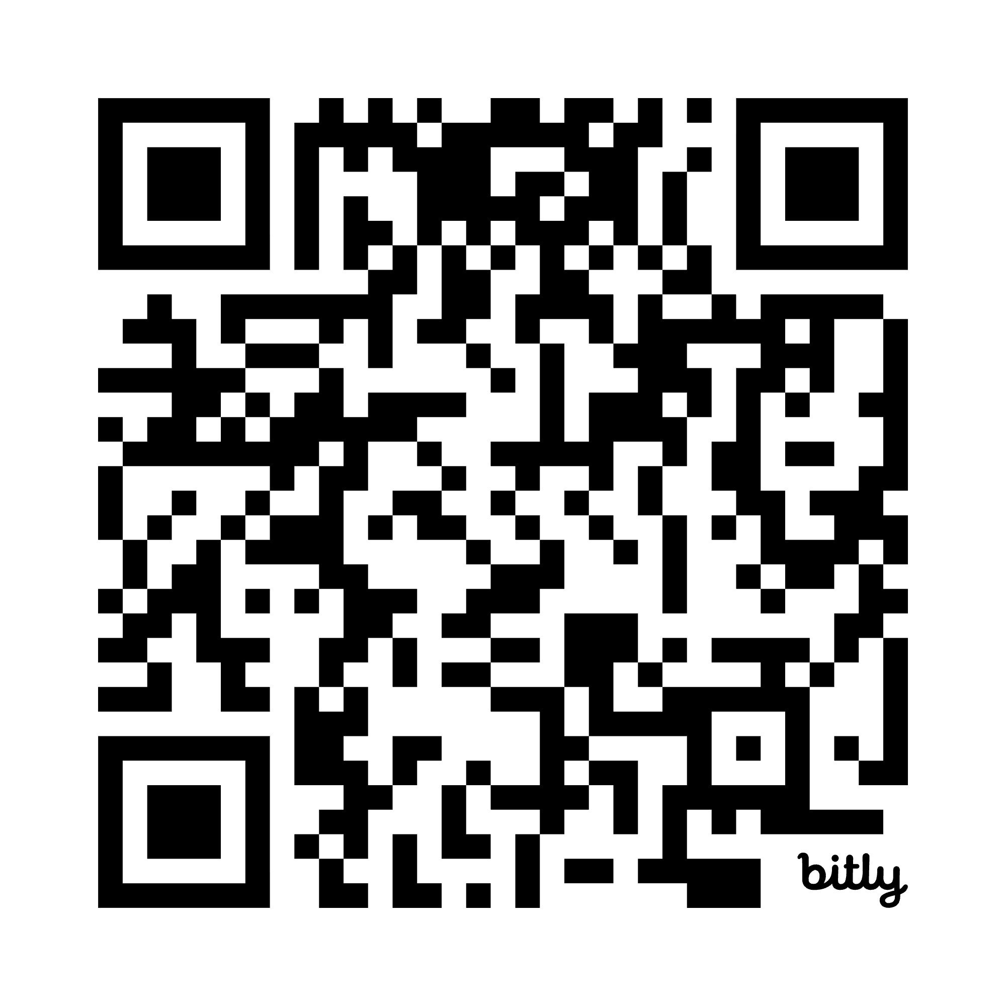

Center for Teaching for Biliteracy Resources and Links

Center for Teaching for Biliteracy Reference List | https://bit.ly/4aepEbX  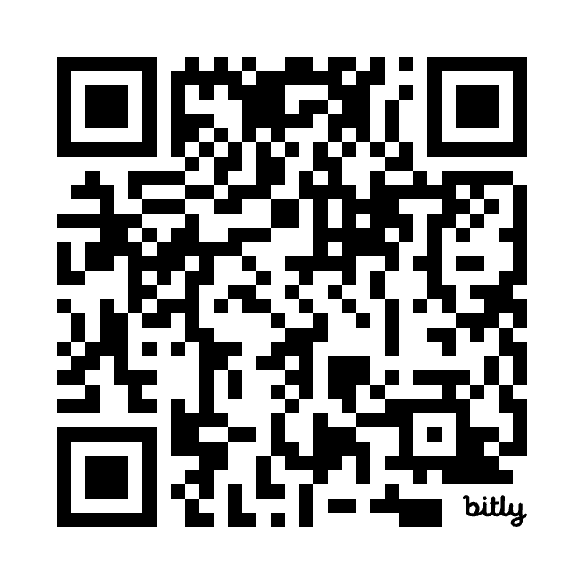
Biliteracy Strategies Glossary | https://bit.ly/BSI2024InstructionalStrategies  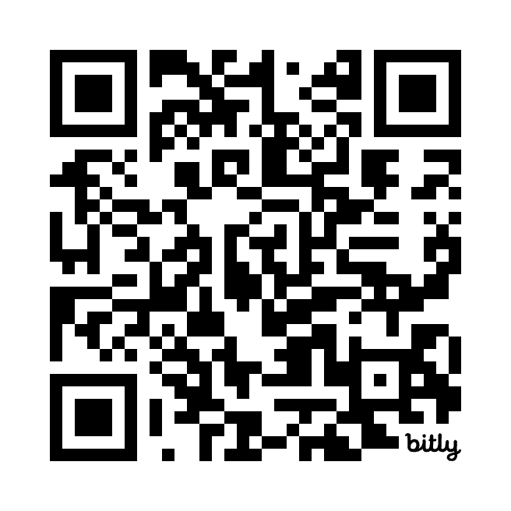
Three Linguistic Spaces | https://bit.ly/ThreeLinguisticSpaces  
Supporting Newcomers | https://bit.ly/T4BNewcomers  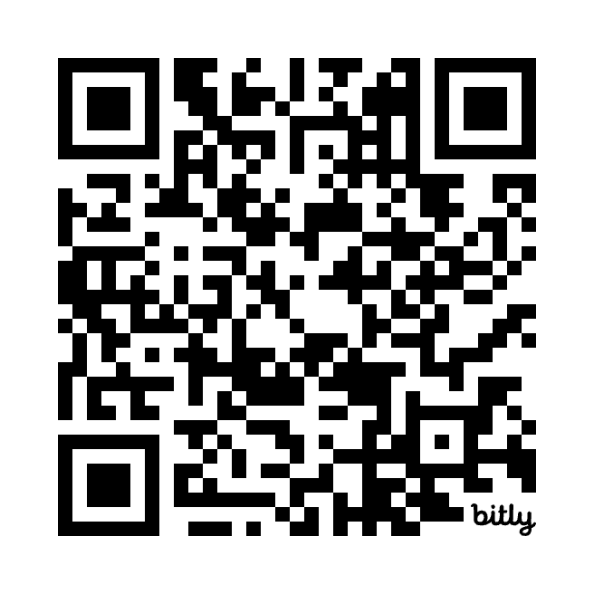
The Science of Reading and English Learners | Clarifying the Science of Reading- Kari Kurto  https://bit.ly/4a64OhT  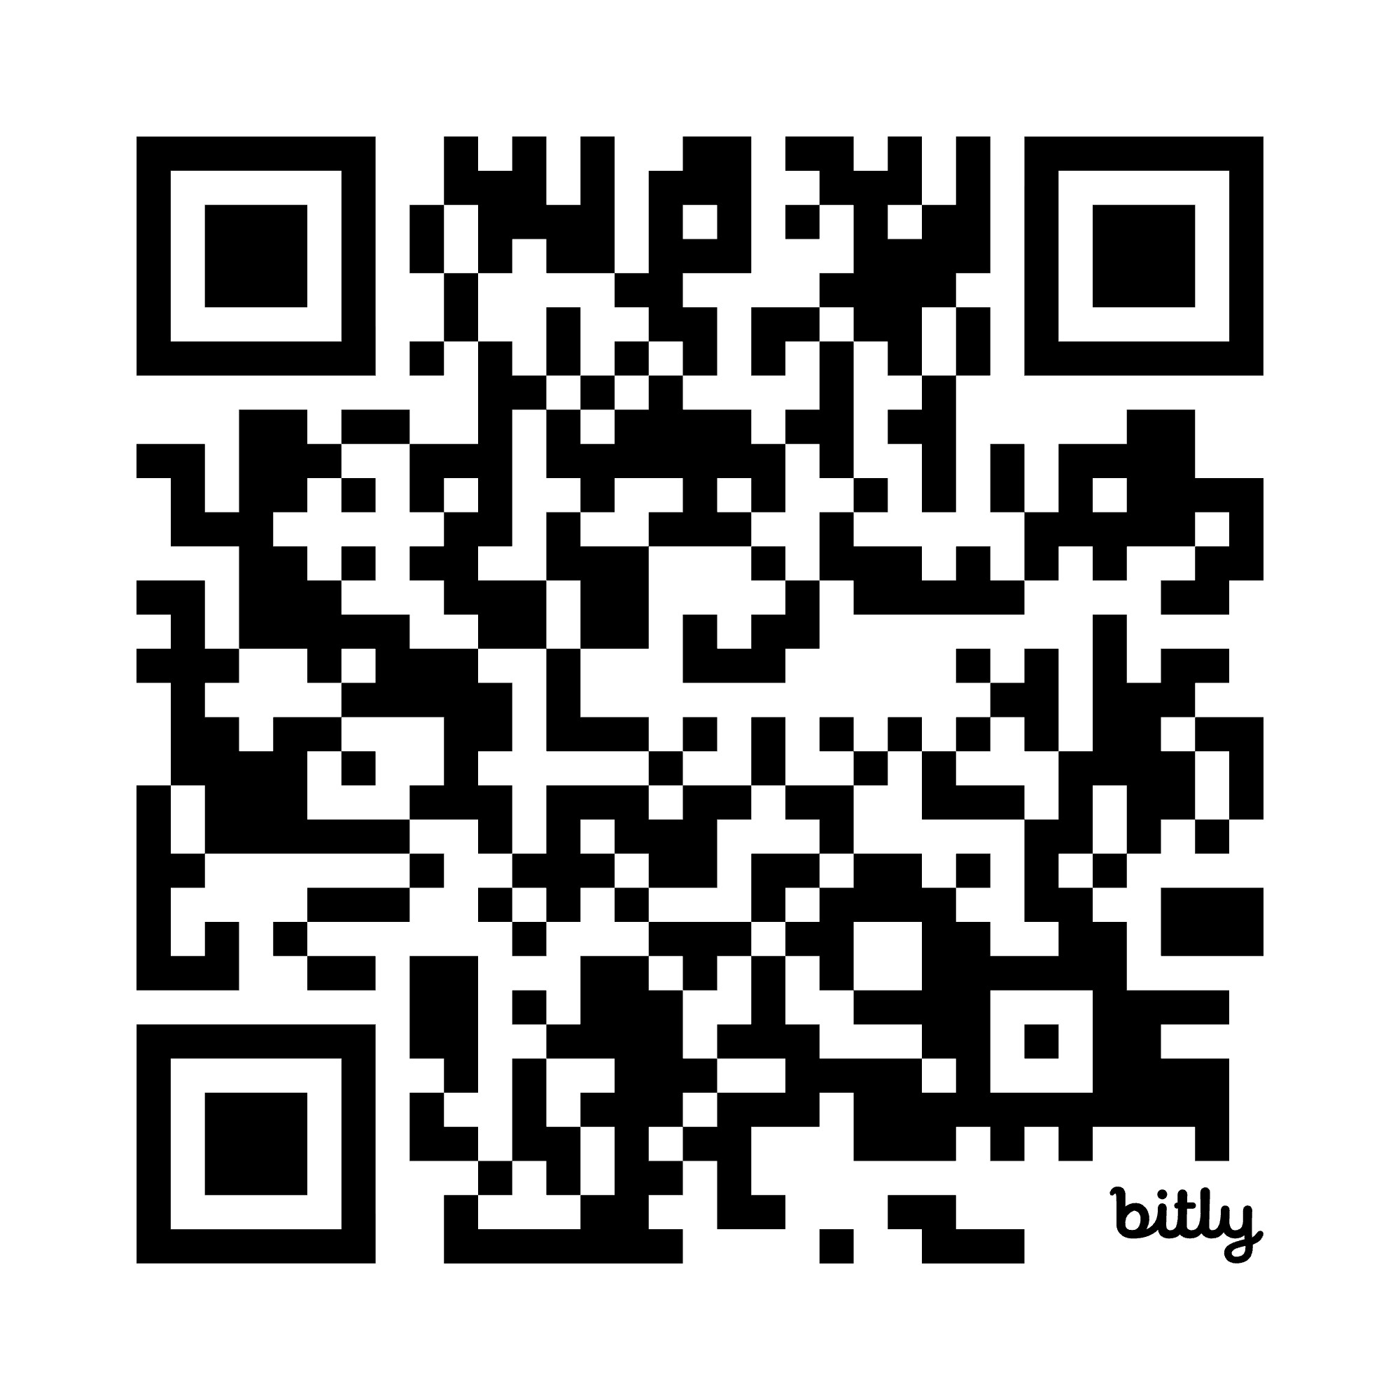  Comprehensive Literacy Instruction for English Language Learners – Laurie Olsen  https://bit.ly/47V6ny0  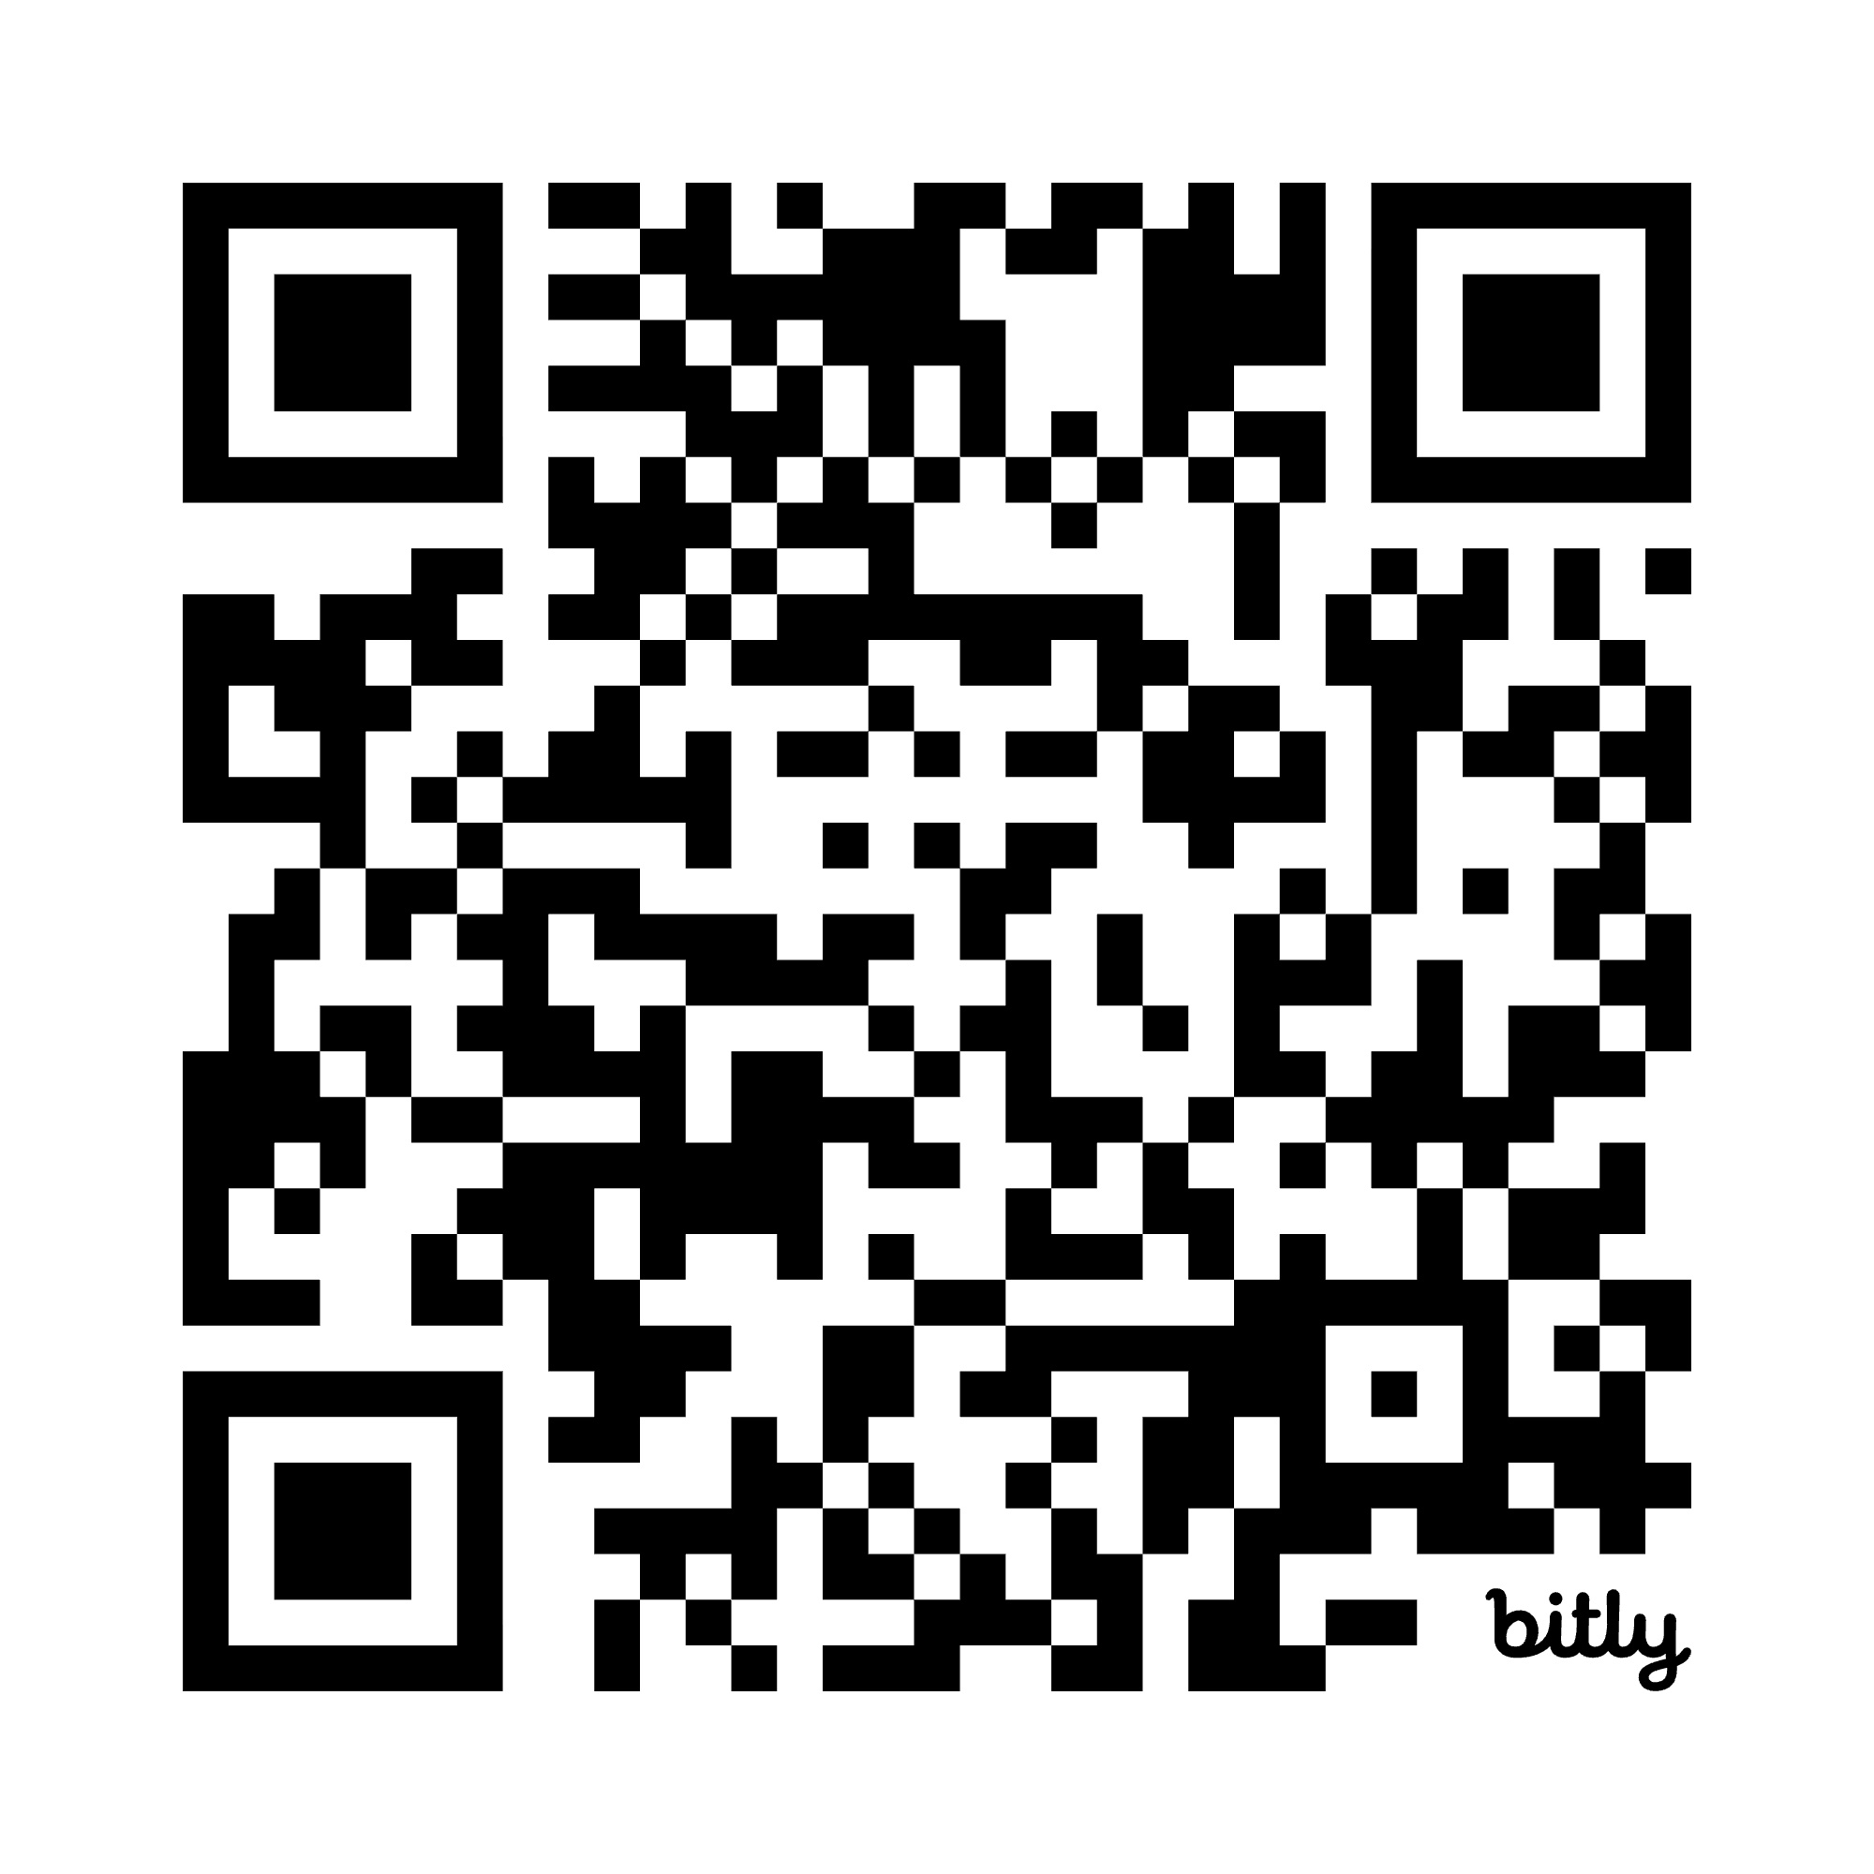  Joint Statement: Understanding the Difference – The SoR and Implementation for ELs  https://bit.ly/4o3vmE5  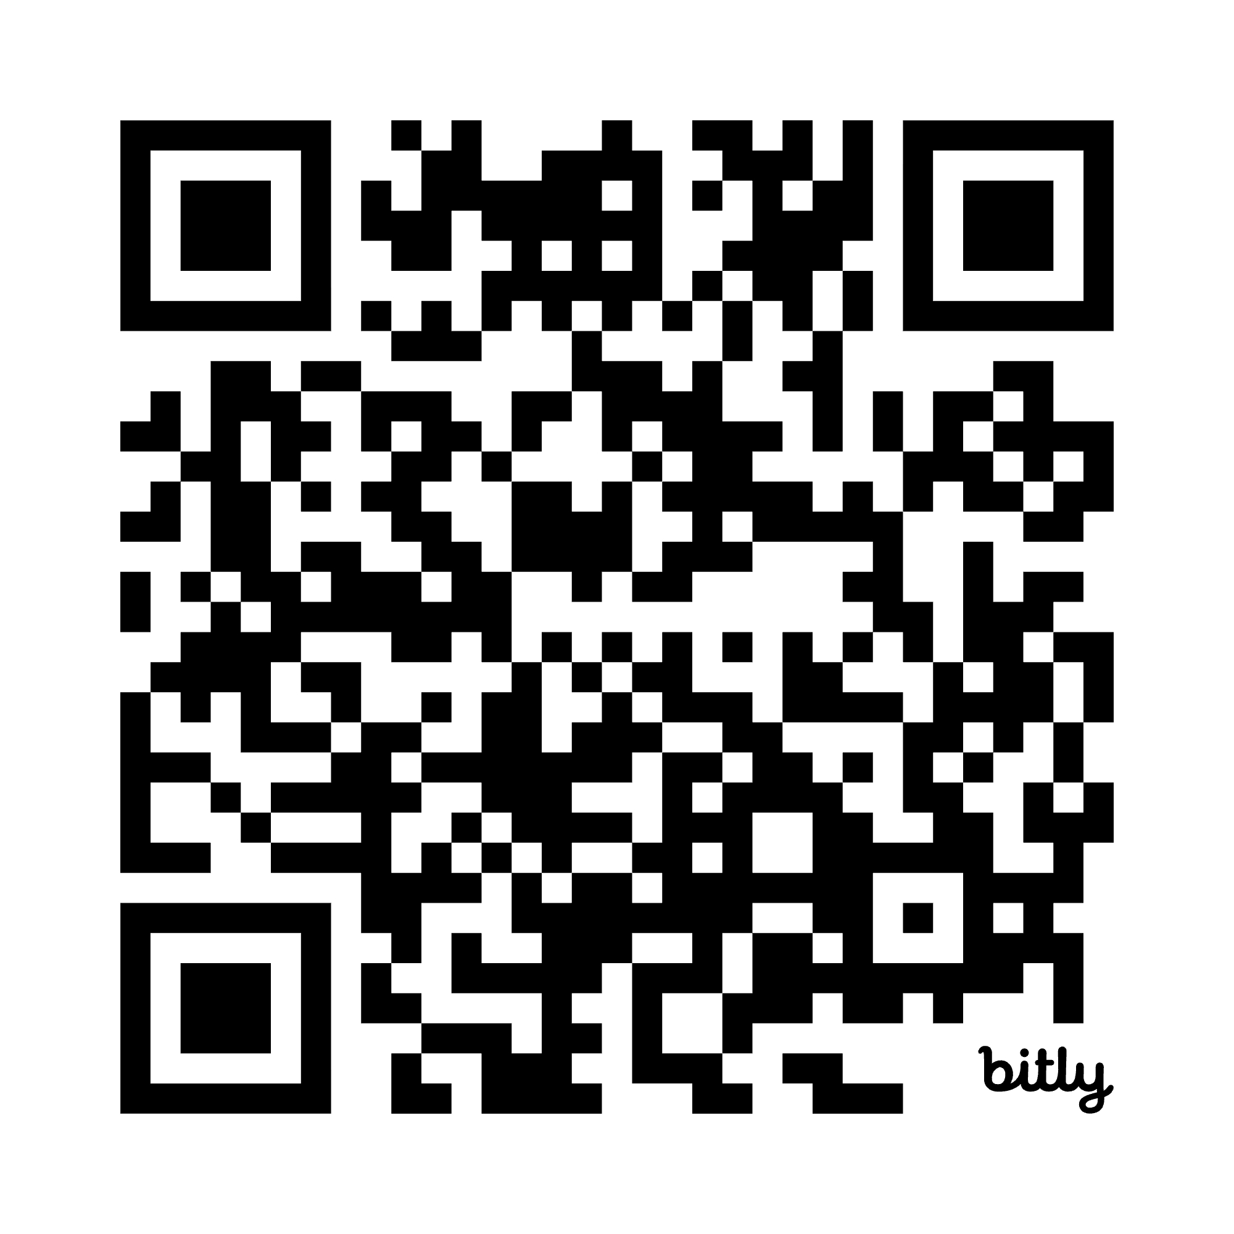

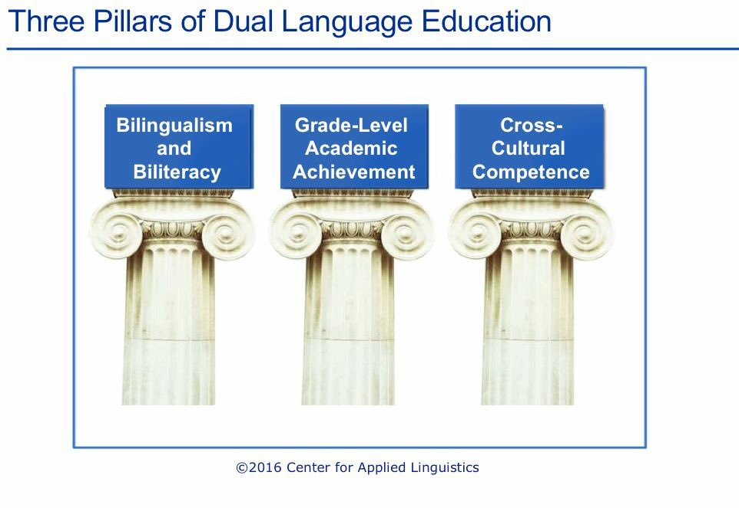
The Goal of Dual Language Programs

“…the term dual language refers to any program that provides literacy and content instruction to all students through two languages and that promotes bilingualism and biliteracy, grade-level academic achievement, and sociocultural competence
– a term encompassing identity development, cross-cultural competence, and multicultural appreciation – for all students.”

Guiding Principles for Dual Language Education, Third Edition

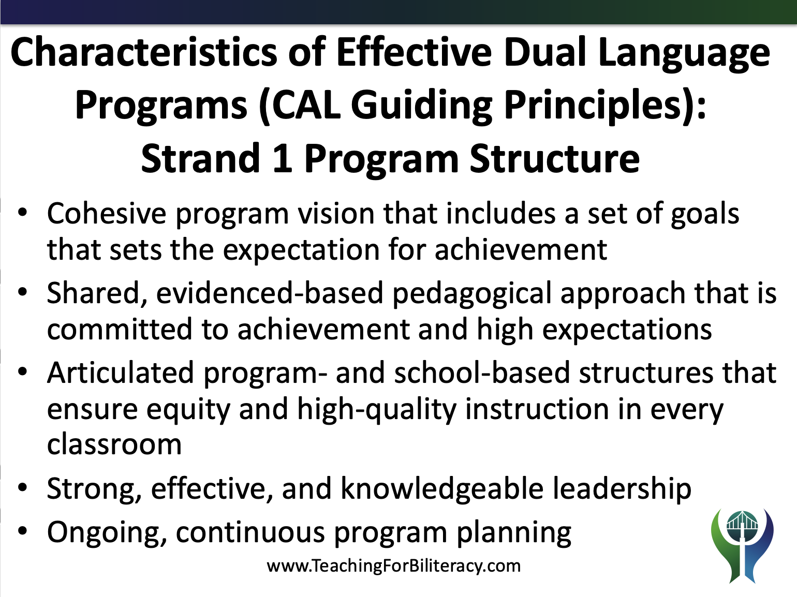

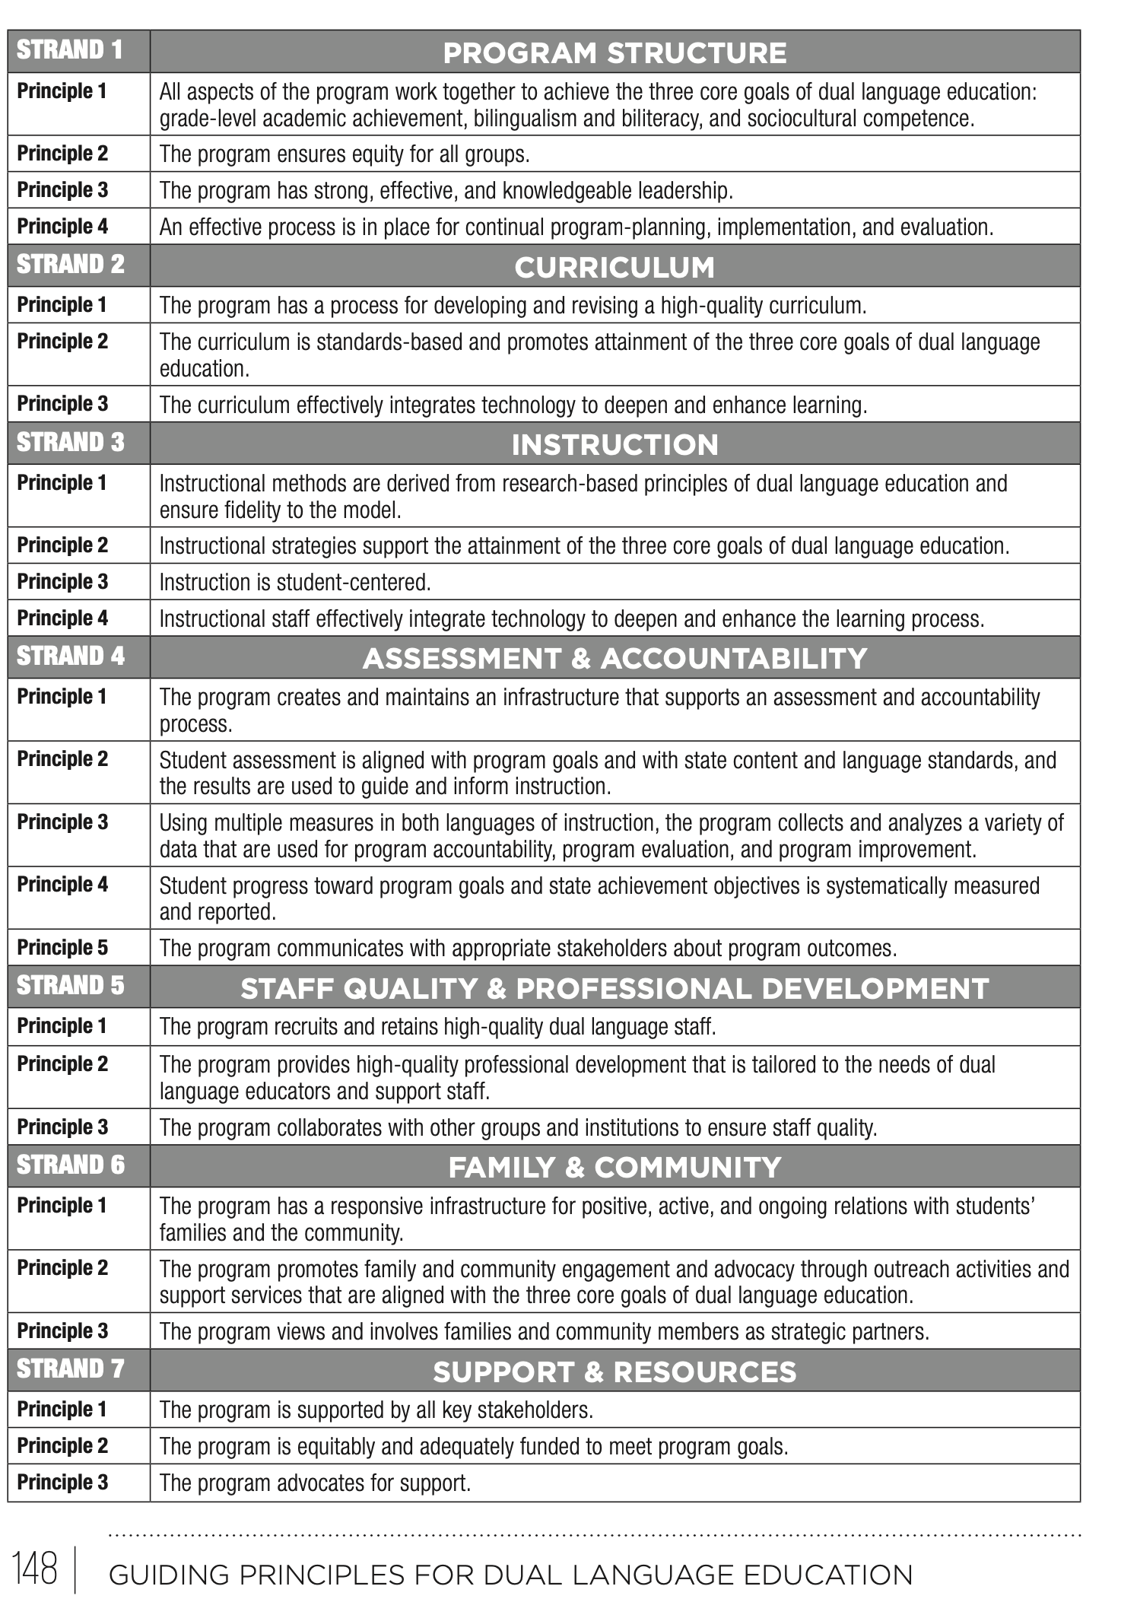

Students in Language Acquisition and Biliteracy Programs
Green students – Students who enter the program with linguistic resources all in the non-English Dual Language program language.
- These students enter the program as ELs
- These students are typically sequential bilinguals

Orange students – Students who enter the program with linguistic resources in a language other than the Dual Language program languages.
- These students are typically sequential bilinguals.
- These students qualify for EL services

Blue-green students – Students who enter the program with linguistic resources in both program languages.
- These students may or may not qualify as ELs
- These students are typically simultaneous bilinguals

Blue students – Students who enter the program with linguistic resources all in English.
- In dual language programs, these students are sequential bilinguals

Dual Language Programs:
- One-Way Dual Language Program: Serves one group of students, all English Learners (emergent bilinguals). This program is also known as developmental bilingual or maintenance bilingual.

- Two-Way Dual Language Program: Serves two groups of students, English Learners and non-English Learners.

- 80/20 Program: Students spend more time in Spanish in grades K-2 reaching 50/50 by 3rd or 4th grade.

- 50/50 Program: Students spend 50% of the day in Spanish and 50% of the day in English starting in kindergarten.

Language Allocation

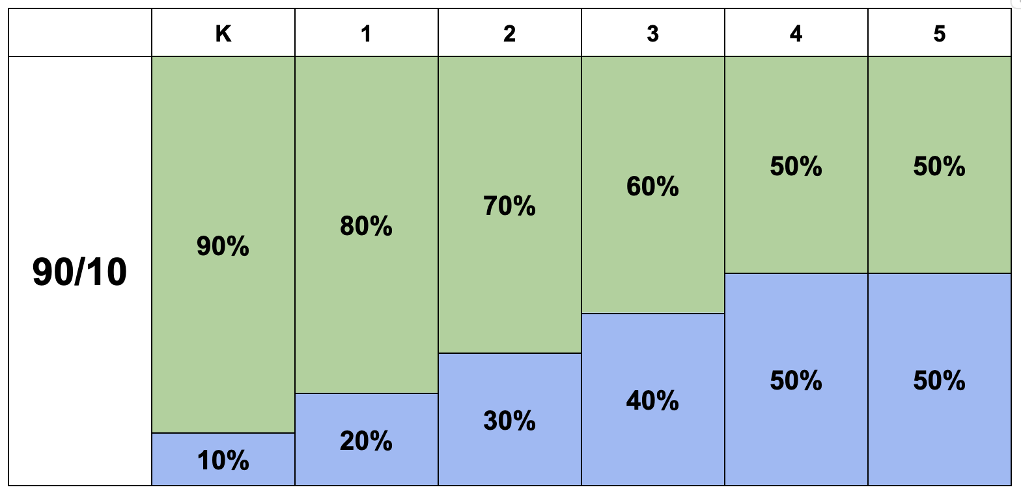

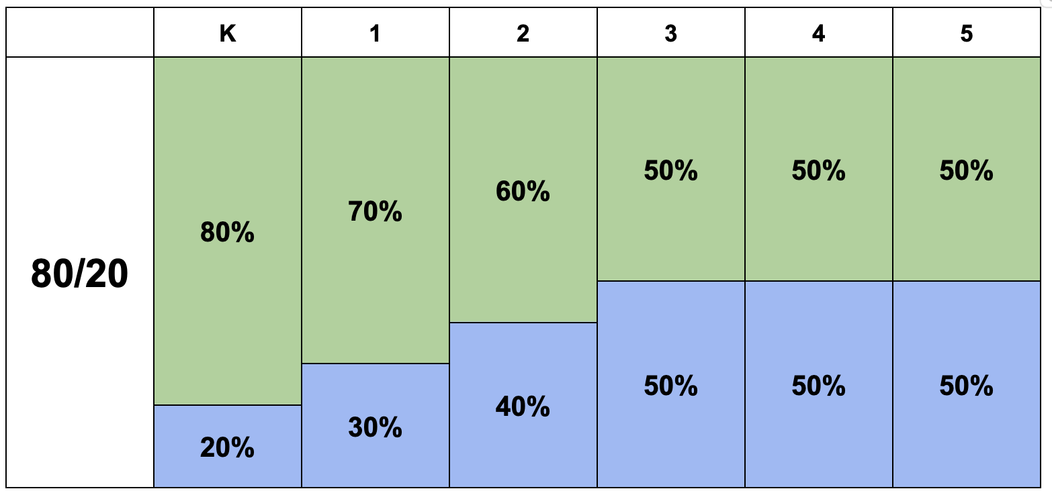

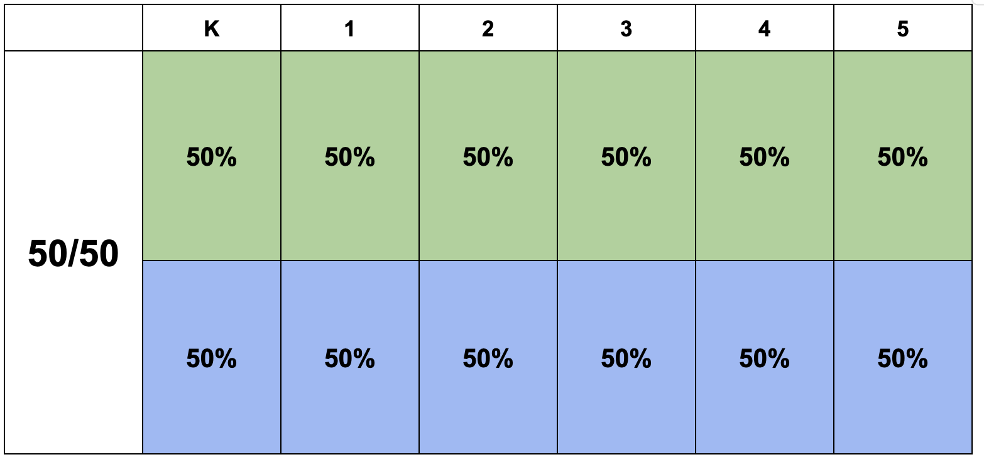

One and Two – Teacher Models

- Both types of models (1 and 2 Teacher) can be used with 80/20 and 50/50 programs
- Schools and districts may choose to use both 1 and 2 teacher model

Type of Model | Pros | Cons
One Teacher Model (One teacher teaches both languages) | Teachers get to know students across both their languages  Time can be more flexible | It may be harder for the teacher to stay in the target language  It may be harder for the students to stay in the target language
Two Teacher Model  (One teacher teaches English and another teacher teaches Spanish to the same students) | Spanish time is protected by place, time, and person  When collaboration works well, it is powerful! | It is harder for teachers to get to know students across both languages  When collaboration is not effective, it is challenging for all.

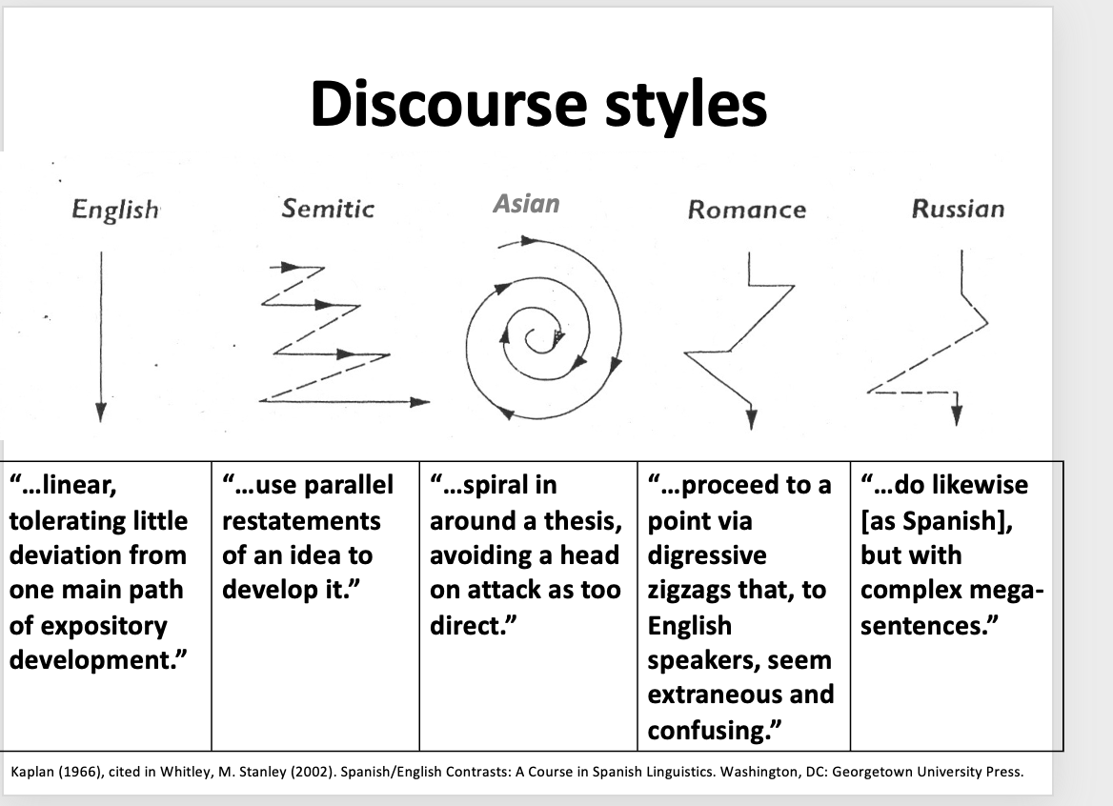
(Montaño-Harmon, 1991, Sáez, 2003, Butvilofsky et al, 2023)

Predictable Stages of Language Acquisition for Sequential Bilinguals
Gottlieb, M., 2006
- First language (L1)
- Preproduction in L2 (Starting – Receptive Language)
- Early Production (Emerging)
- Speech Emergence (Developing)
- Beginning and Intermediate Fluency (Expanding)
- Advanced Fluency (Bridging)
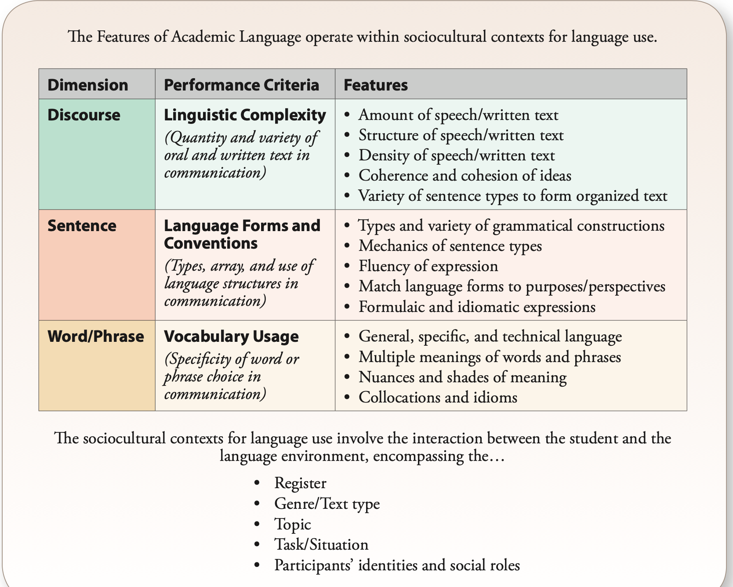

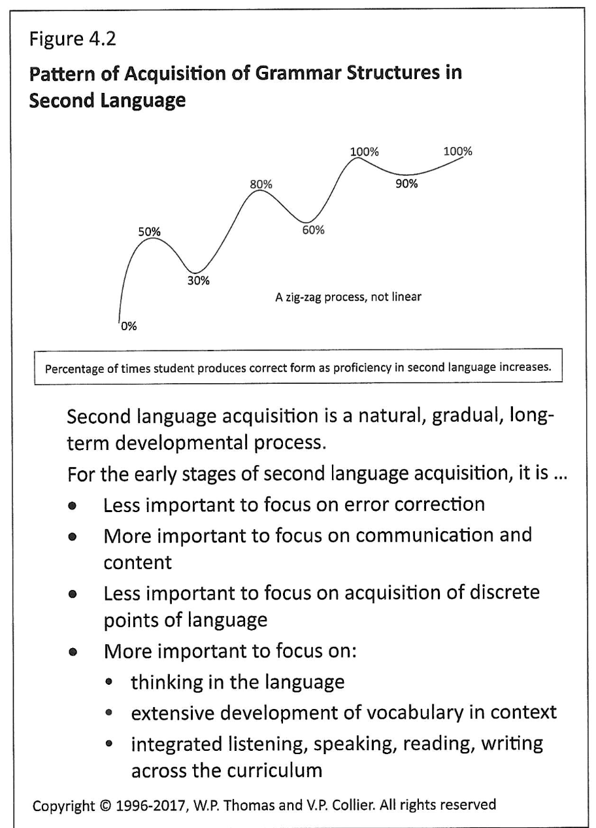

Description of Second Language Acquisition Stages for
Young Sequential Bilinguals

Stage | Description
Home Language Use | The child uses his/her home language even when others do not understand. Length of time in this stage varies by child.
Nonverbal Period | Once the realization sets in that the home language does not work, the child may rarely speak or use nonverbal means to communicate. Receptive language is being developed, and the child demonstrates understanding through actions and other non-language necessary means. The length of time in this stage also varies. Language assessments may result in misleading information that underestimates the child’s true language capacity.
Telegraphic and Formulaic Speech | Formulas are used as the child starts using the new language, as in “me bathroom” indicating she wants to go to the bathroom. During this stage young children use phrases they have heard from others, sometimes not completely understanding the whole meaning of the words they use.
Productive Language | The child uses her/his own phrases and thoughts that may at first contain very simple grammatical patterns such as “I wanna play”. Predictable errors should be expected as children experiment with the new language and learn its rules and structure.
Adapted from: Tabors, P., & Snow, C. (1994). English as a second language in preschools (pp. 103-125). In Genesee, F. (Ed.), Educating second language children: The whole child, the whole curriculum, the whole community. New York, NY: Cambridge University Press

Simultaneous Bilingual Language Development compared to
Monolingual Language Development
 | Simultaneous Bilingual Language Development | Monolingual Language Development
Developmental Stages  The stages are similar, but bilinguals develop two languages instead of one. | Age 1: Most children say their first words and their words are in both Spanish and English.  Age 2: Most children use two-word phrases (Mi pelota, or My Lela for abuela).  Age 3: Most children use full sentences (No quiero ir al supermarket), but they use vocabulary from both their languages. | Age 1: Most children say their first words (only in English)  Age 2: Most children use word phrases (My juice).  Age3 : Most children use full sentences (I don’t want to go to the store).
Vocabulary | Knowledge of words is shared between Spanish and English.  The bilingual child may have more vocabulary in one language than the other, or the vocabulary may be very topic or context specific.  For example, vocabulary related to religion, family, and soccer may be more prevalent in Spanish whereas vocabulary related to TV programs and playing games with siblings may be more prevalent in English. | Monolingual children have developed vocabulary only in English.  Like bilingual learners, context plays an important role in shaping vocabulary development. Children make associate new words with the objects, people and contexts in which they learned them, just as bilingual learners do, but this is done only in English.
Language Use | Bilingual learners use their two languages when appropriate given the context.  Some contexts require the use of both languages simultaneously (a family reunion where everyone is bilingual and both languages are used); others require the use of only one language (going to a religious service in Spanish, for example). | Like bilingual learners, monolingual learners use language based on the requirements of the context (informal versus formal language); however, it is all done exclusively in English.

Spanish in the US is characterized by its relationship with English
Expression | Example | Description
Code-switching | “Tengo el eight.”  “Vamos a ir camping” | Students may know the name of an object or activity only in English, or only in Spanish, and so they insert the words they know from each language.
Linguistic Borrowing | - Wáchale  - Socketines  - Troca  - Carpeta | Students create their own nouns and verbs blending structures and words in both languages.
Semantic Extensions | “Vamos a comprar las groserías.” (Let’s go buy the groceries – a term that in Spanish usually means “bad words”).  La rufa está liquiando. | Students use a word they believe to be a cognate when in fact, it is not.
Calques | Voy a mi tío Marco’s casa. | Students use the syntax of one language but with the words of the other.
Adapted from: Potowski, K. (2005) Fundamentos de la enseñanza del español a hispanohablantes en los
EE.UU. Madrid: Arco Libros.

Literacy and Biliteracy - Agree- Disagree Chart

Statement | Agree or Disagree
- Phonics instruction is the most important element in teaching students how to read in K-2.
- Daily instruction in Spanish and English (without teaching the same topic) is an effective way of developing biliteracy in all students.
- Without language comprehension, students cannot have reading comprehension.
- Oral language and background knowledge are good for students to know, but not necessary since they’re not directly related to comprehension
- Language learners learn how to read and write more effectively when the unit is all related around a meaningful theme, allowing the language to be repeated and deepened, and knowledge to be developed, as the unit progresses.
- When students do not understand the text they are reading, the teacher should read the text in the other language to support comprehension.
- Word recognition is an essential component of reading comprehension, but not the only component.
- Teaching phonics only in English in K -1, and reading, writing and word recognition (phonics) in Spanish K-1 is a feasible path to biliteracy.
- Students should be familiar with the meaning of the words and examples used to learn foundational skills (or word recognition).
- Siloing literacy instruction (i.e., teaching foundational skills separate from reading, separate from writing) organizes literacy well for dual language students.
- Oracy and background knowledge are crucial elements in reading comprehension.
- Reading, writing, and foundational skills should be taught within a theme that connects all literacy activities. This is a feasible path to biliteracy when practiced in each program language.

Sally

Sally first tried setting loose a team of gophers. The plan backfired when a dog chased them away. She then entertained a group of teenagers and was delighted when they brought their motorcycles. Unfortunately, she failed to find a Peeping Tom listed in the Yellow Pages. Furthermore, her stereo system was not loud enough. The crab grass might have worked but she didn’t have a fan that was sufficiently powerful. The obscene phone calls gave her hope until the number was changed. She thought about calling a door-to-door salesman but decided to hang up a clothesline instead. It was the installation of blinking neon lights across the street that did the trick. She eventually framed the ad from the classified section

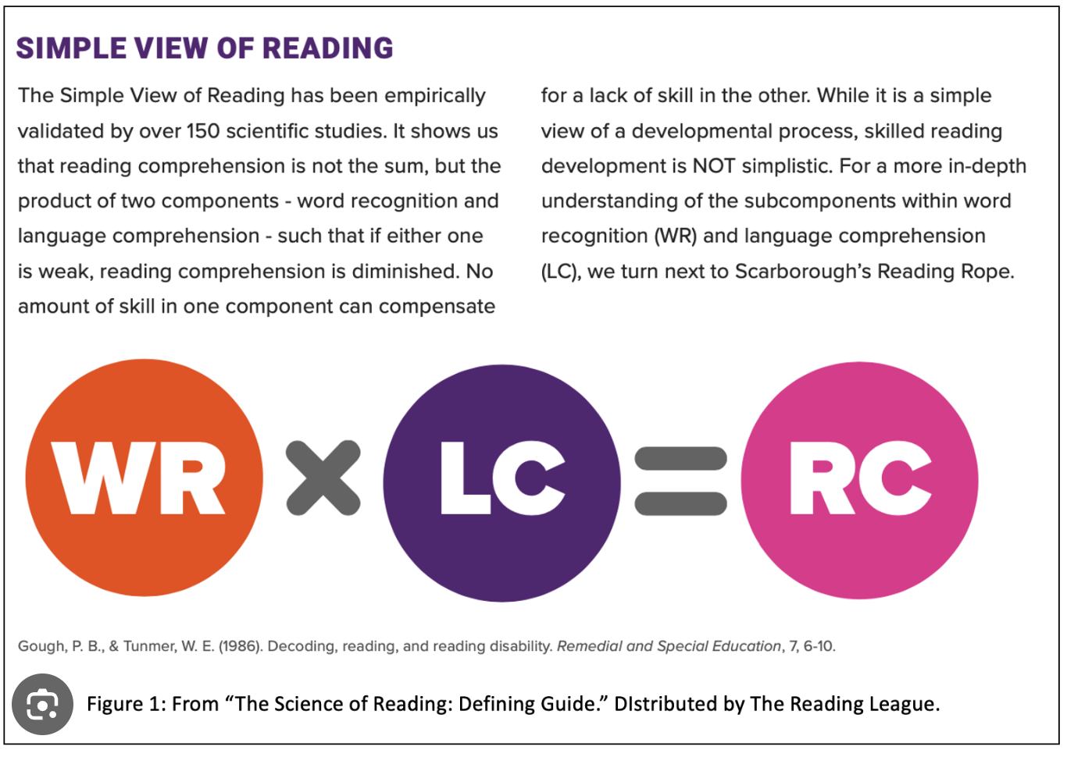

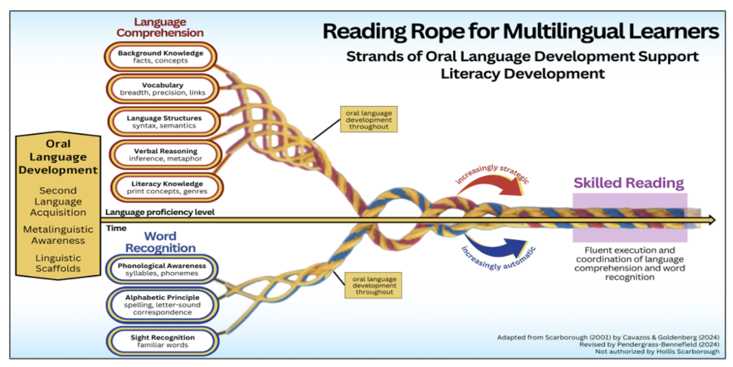
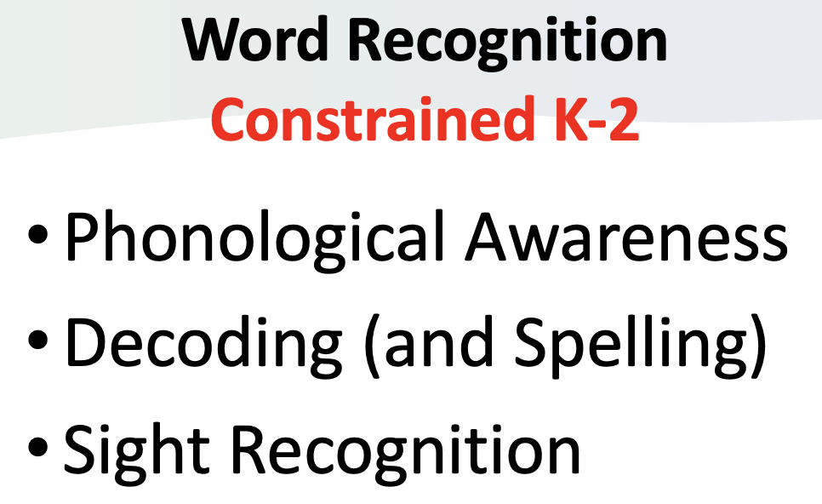 | 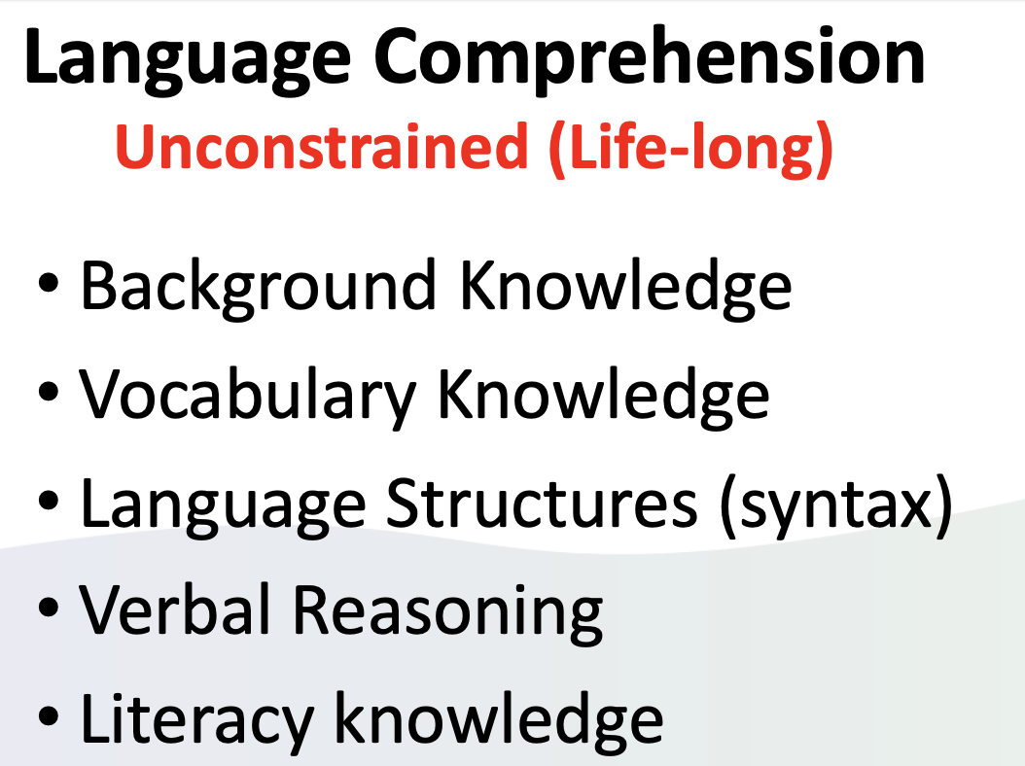

Literacy in Spanish and in English: (L, S, R, W)

- Oracy and Background Knowledge
- Reading
- Writing
- Foundational Skills

Biliteracy Unit Framework (BUF) updated, second edition
Interdisciplinary Unit – Language, Literacy, and Content taught in Spanish
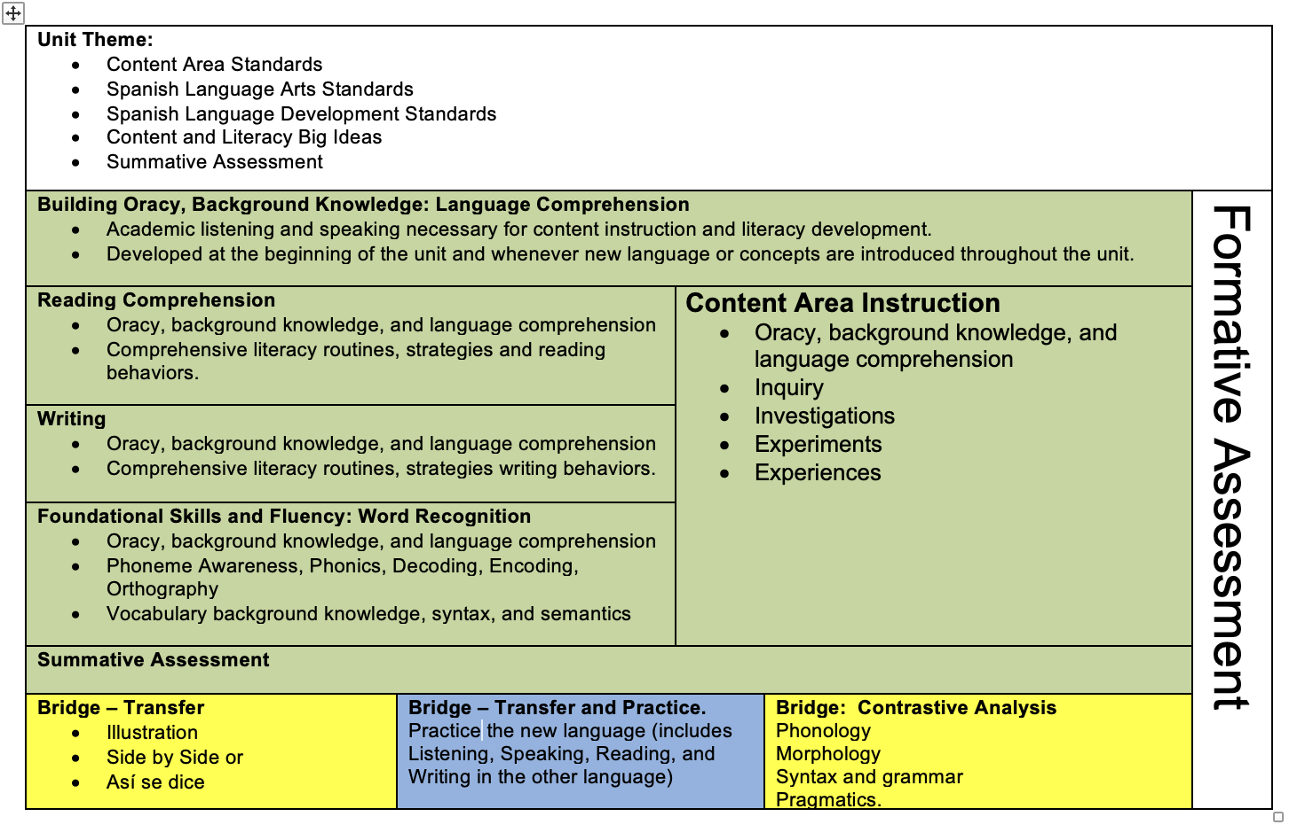
Biliteracy Unit Framework (BUF) updated, second edition
Interdisciplinary Unit – Language, Literacy, and Content taught in English
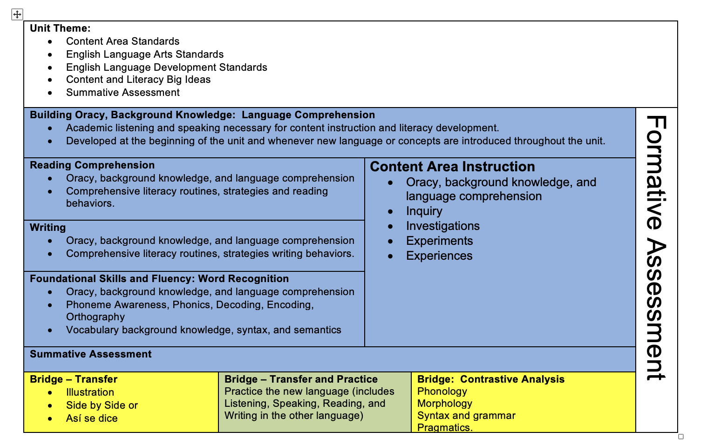

Sample PreK Half-Day Schedule 80/20

Half day - 180 total minutes
- 140 Spanish minutes
- 40 English minutes
8:15-8:40 | Arrival/Journal Writing/Quiet Reading | Spanish
8:45-8:55 | Circle Time (Large Group) (Read Aloud) | Spanish
9:00-9:30 | Gross Motor | Spanish
9:30-10:30 | Free Choice Time (Interest Areas) (Small Groups) | Spanish
10:30-10:35 | Clean Up Time | Spanish
10:35-10:50 | Circle Time (Large Group) (Read Aloud) | English
10:50-11:10 | Free Choice Time (Interest Areas) (Small Groups) | English
11:10-11:15 | Dismissal | English

Sample PreK Full-Day Schedule 80/20
Full day – 395 total minutes – 50 min rest = 345 instructional min
Approximately:
- 276 Spanish minutes
- 69 English minutes
8:35-8:50 | Arrival/Breakfast | Spanish
8:50-9:05 | Circle Time (Large Group) | Spanish
9:05-9:35 | Gross Motor/Outside Play | Spanish
9:35-10:35 | Centers (Interest Areas/Small Groups) | Spanish
10:35-10:45 | Clean Up/Books at the Carpet | Spanish
10:45-11:00 | Wash Hands/Line Up/Walk to Lunch | Spanish
11:00-11:30 | Lunch | Spanish
11:30-11:40 | Bathroom/Walk Back to Classroom | Spanish
11:40-12:30 | Rest Time | Spanish
12:30-1:30 | Centers (Interest Areas/Small Groups) | Spanish
1:30-1:40 | Clean Up/Books at Carpet | Spanish
1:40-2:00 | Circle Time (Large Group) (Read Aloud) | Spanish
2:00-2:30 | Gross Motor/Outside Play | English
2:30-3:05 | Circle Time (Large Group) | English
3:05-3:10 | Folders/Backpack/Dismissal | English

Sample Biliteracy Schedule – 80% of Day in Spanish and 20% of Day in English
Time | Subject | Language
8:00 – 8:20 a.m. | SEL and Classroom Community Building | Spanish
8:20 – 10:30 a.m. | SS/Spanish Language Arts OR  Science/Spanish Language Arts (alternating units)  Over the course of each unit, the students will engage in…  - Oracy  - SS/Science experiences/inquiry  - Whole group instruction  - Writing (independent, small group and whole group)  - Reading (independent, small group and whole group)  - Foundational Skills and Language Comprehension (Word Study)  - Independent Practice | SPANISH
10:30-11:00 a.m. | Interventions (based on student need) | Language determined by the teacher and based on student need
11:00 a.m. – 12:00 p.m. | Specials | If possible, half are offered in Spanish and half in English
12:00 – 12:45 p.m. | Lunch | Student choice
12:45 – 2:00 p.m. | Math in Spanish  - Oracy development  - Math skills and practice  - Reading and writing as applied to math. | SPANISH
2:00 – 3:00 p.m. | English Language Arts  Over the course of each unit, the students will engage in…  - Oracy  - Experiences  - Whole instruction  - Writing (independent, small group and whole group)  - Reading (independent, small group and whole group)  - Foundational Skills and Language Comprehension (Word Study)  - Independent Practice | ENGLISH
- The literacy routines included in these schedules are examples. Districts should include their own district-specific literacy routines in the biliteracy schedule.
- Integrated Language Arts units can alternate between SS and Science
- In these schedules, intervention time is not factored into the total Spanish or English time.

Sample Biliteracy Schedule – 50% of Day in Spanish and 50% of Day in English
Time | Subject | Language
8:00 – 8:20 | SEL and Classroom Community Building | SPANISH
8:20– 10:45 | Science and Language Arts  Over the course of each unit, the students will engage in…  - Oracy  - Science experiences/inquiry  - Whole group instruction  - Writing (independent, small group and whole group)  - Reading (independent, small group and whole group)  - Foundational Skills and Language Comprehension (Word Study)  - Independent Practice | SPANISH
10:45 to 11:15 | Interventions (based on student need) | Language determined by the teacher and based on student need
11:15 – 12:00 | Lunch/Recess | Student choice
12:00 – 1:00 | Math - over the course of a math unit, the students will engage in:  - Oracy development  - Math practice  - Reading and writing as applied to math | ENGLISH
1:00-2:40 | Social Studies and Language Arts  Over the course of each unit, the students will engage in…  - Oracy  - SS experiences/inquiry  - Whole group instruction  - Writing (independent, small group and whole group)  - Reading (independent, small group and whole group)  - Foundational Skills and Language Comprehension (Word Study)  - Independent Practice | ENGLISH
2:40-3:10 | Specials | If possible, half are offered in Spanish and half in English

NOTE: The literacy routines included in this schedule are examples. Districts should include their district specific literacy routines in the biliteracy schedule.

Setting up the Biliteracy Learning Environment

- Each language has its own dedicated space (relevant only to a 1 teacher model)
- Every Biliteracy classroom includes the Bridge
- Teachers use different colors for each language
- Teachers visually indicate the language of instruction

One Teacher Model | Two Teacher Model – Spanish | Two Teacher Model – English
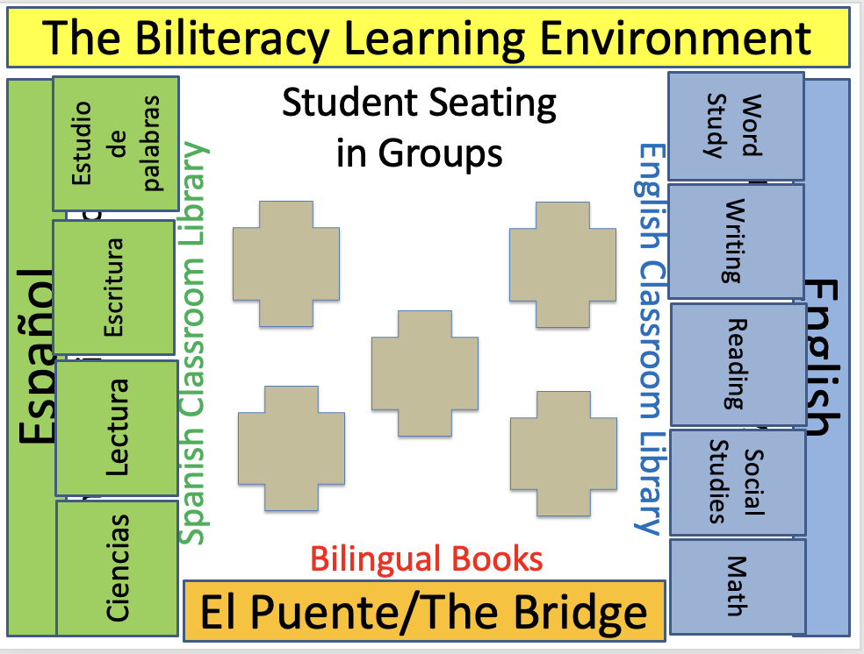 | 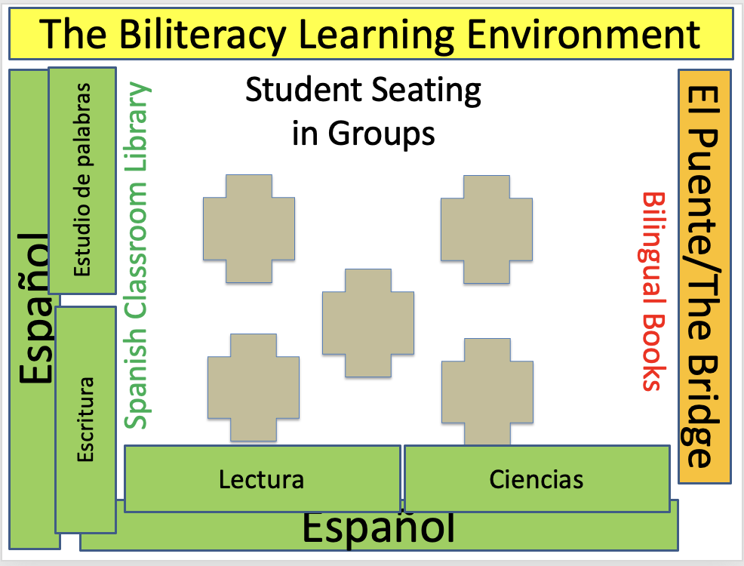 | 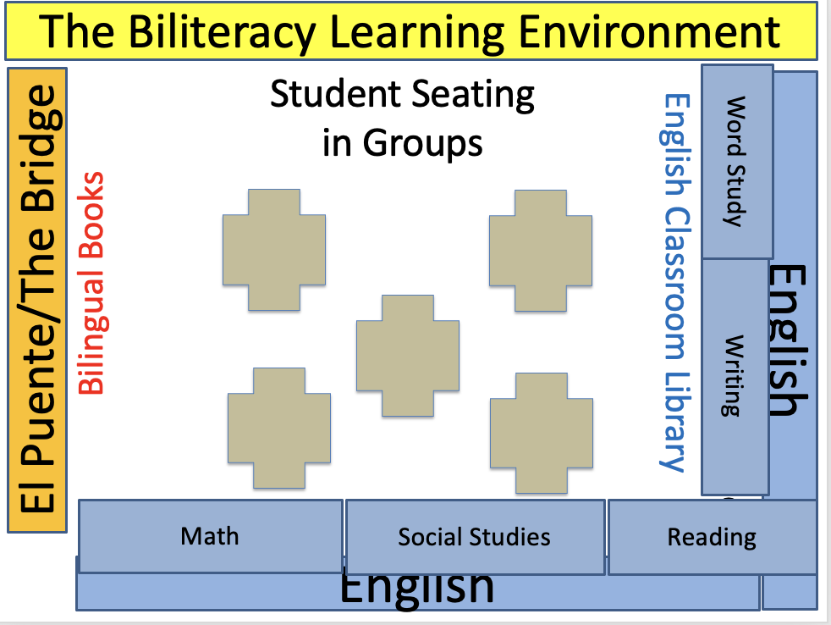

The Biliteracy Learning Environment:
Three Linguistic Spaces
(For 1 teacher model and 2 teacher model)

Spanish | The Bridge | English
- Teacher maintains Spanish  - Students maintain Spanish (teacher scaffolds with language learning supports)  - Materials, instruction and assessments are in Spanish  - Literacy instruction is in Spanish  - Content in Spanish (Science, Social Science, and/or Math – following the Language and Content Allocation Plan) | - Planned moment at the end of a unit (and after summative assessment) when the teacher brings the two languages together for transfer and contrastive analysis.  - Bridging is when teachers guide students in making cross-linguistic connections in each language, during the unit of instruction using contrastive analysis (AKA cross-linguistic connection) charts created during the Bridge or created during the unit. | - Teacher maintains English  - Students maintain English (teacher scaffolds with language learning supports)  - Materials, instruction and assessments are in English  - Literacy instruction is in English  - Content in English all year (Science, Social Science, and/or Math – following the Language and Content Allocation Plan)  - For newcomers (Spanish speakers new to English in grades 2 and up), mediated and personalized use of Spanish.

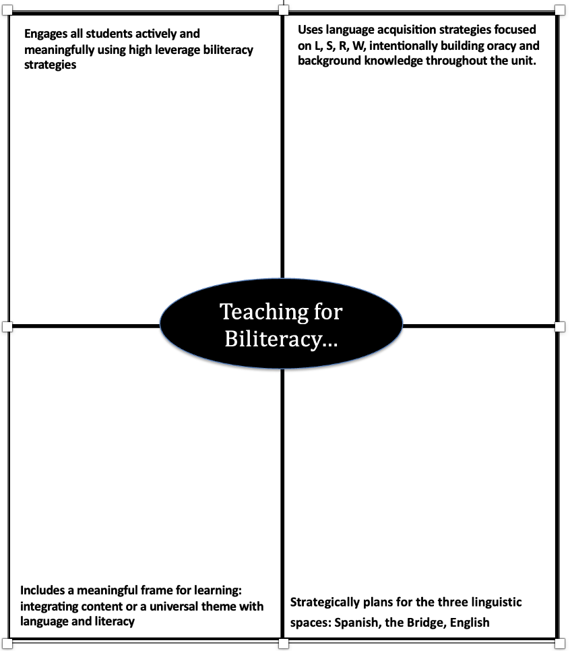
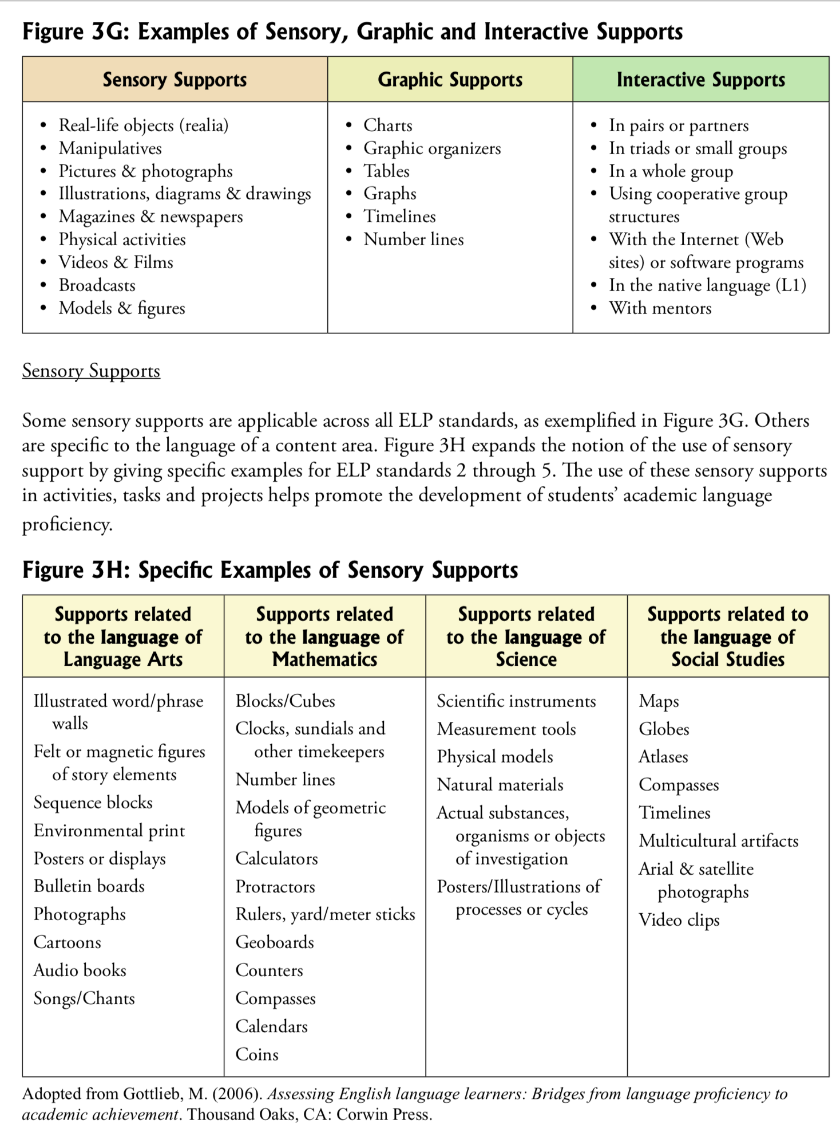
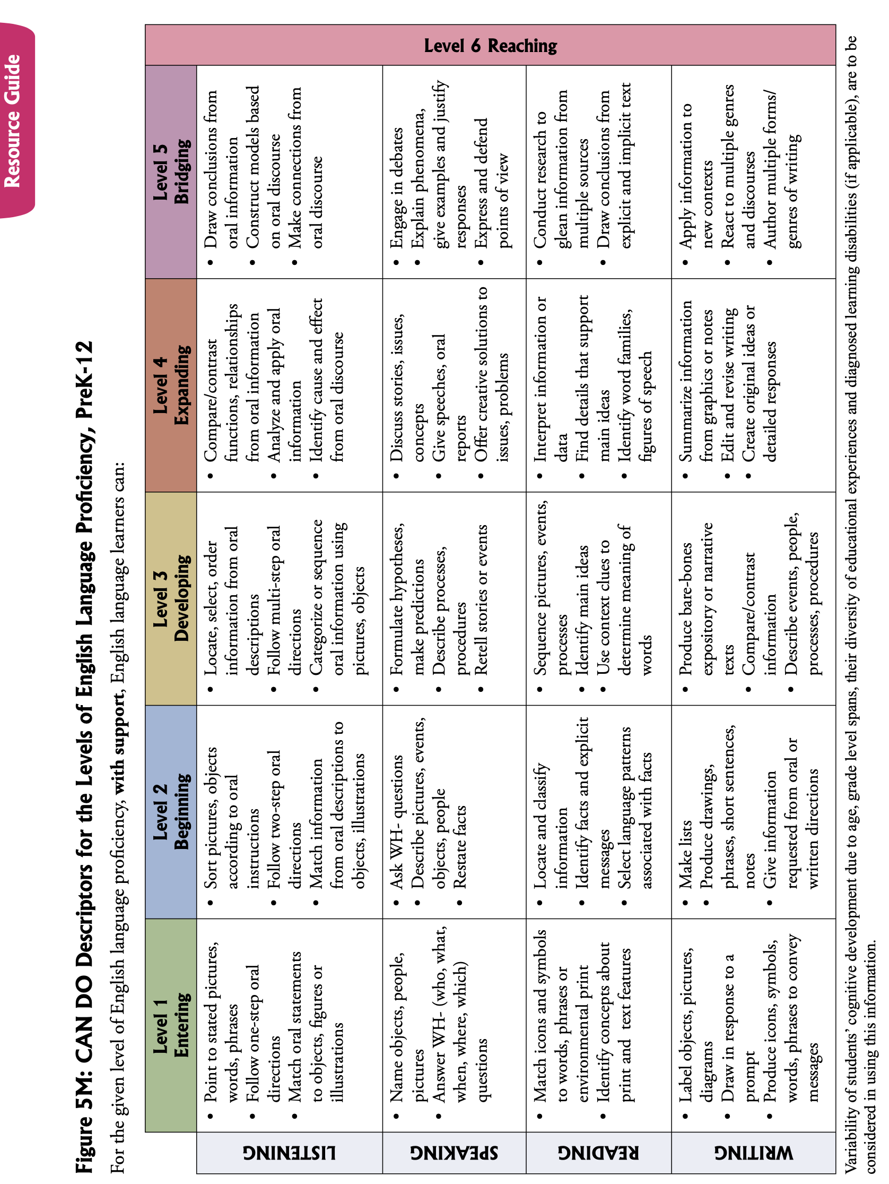
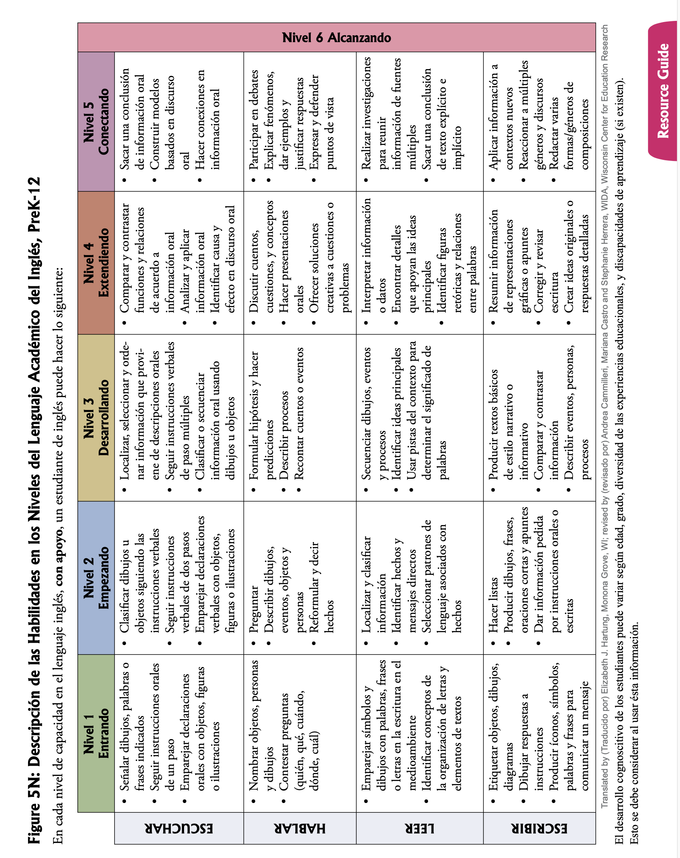

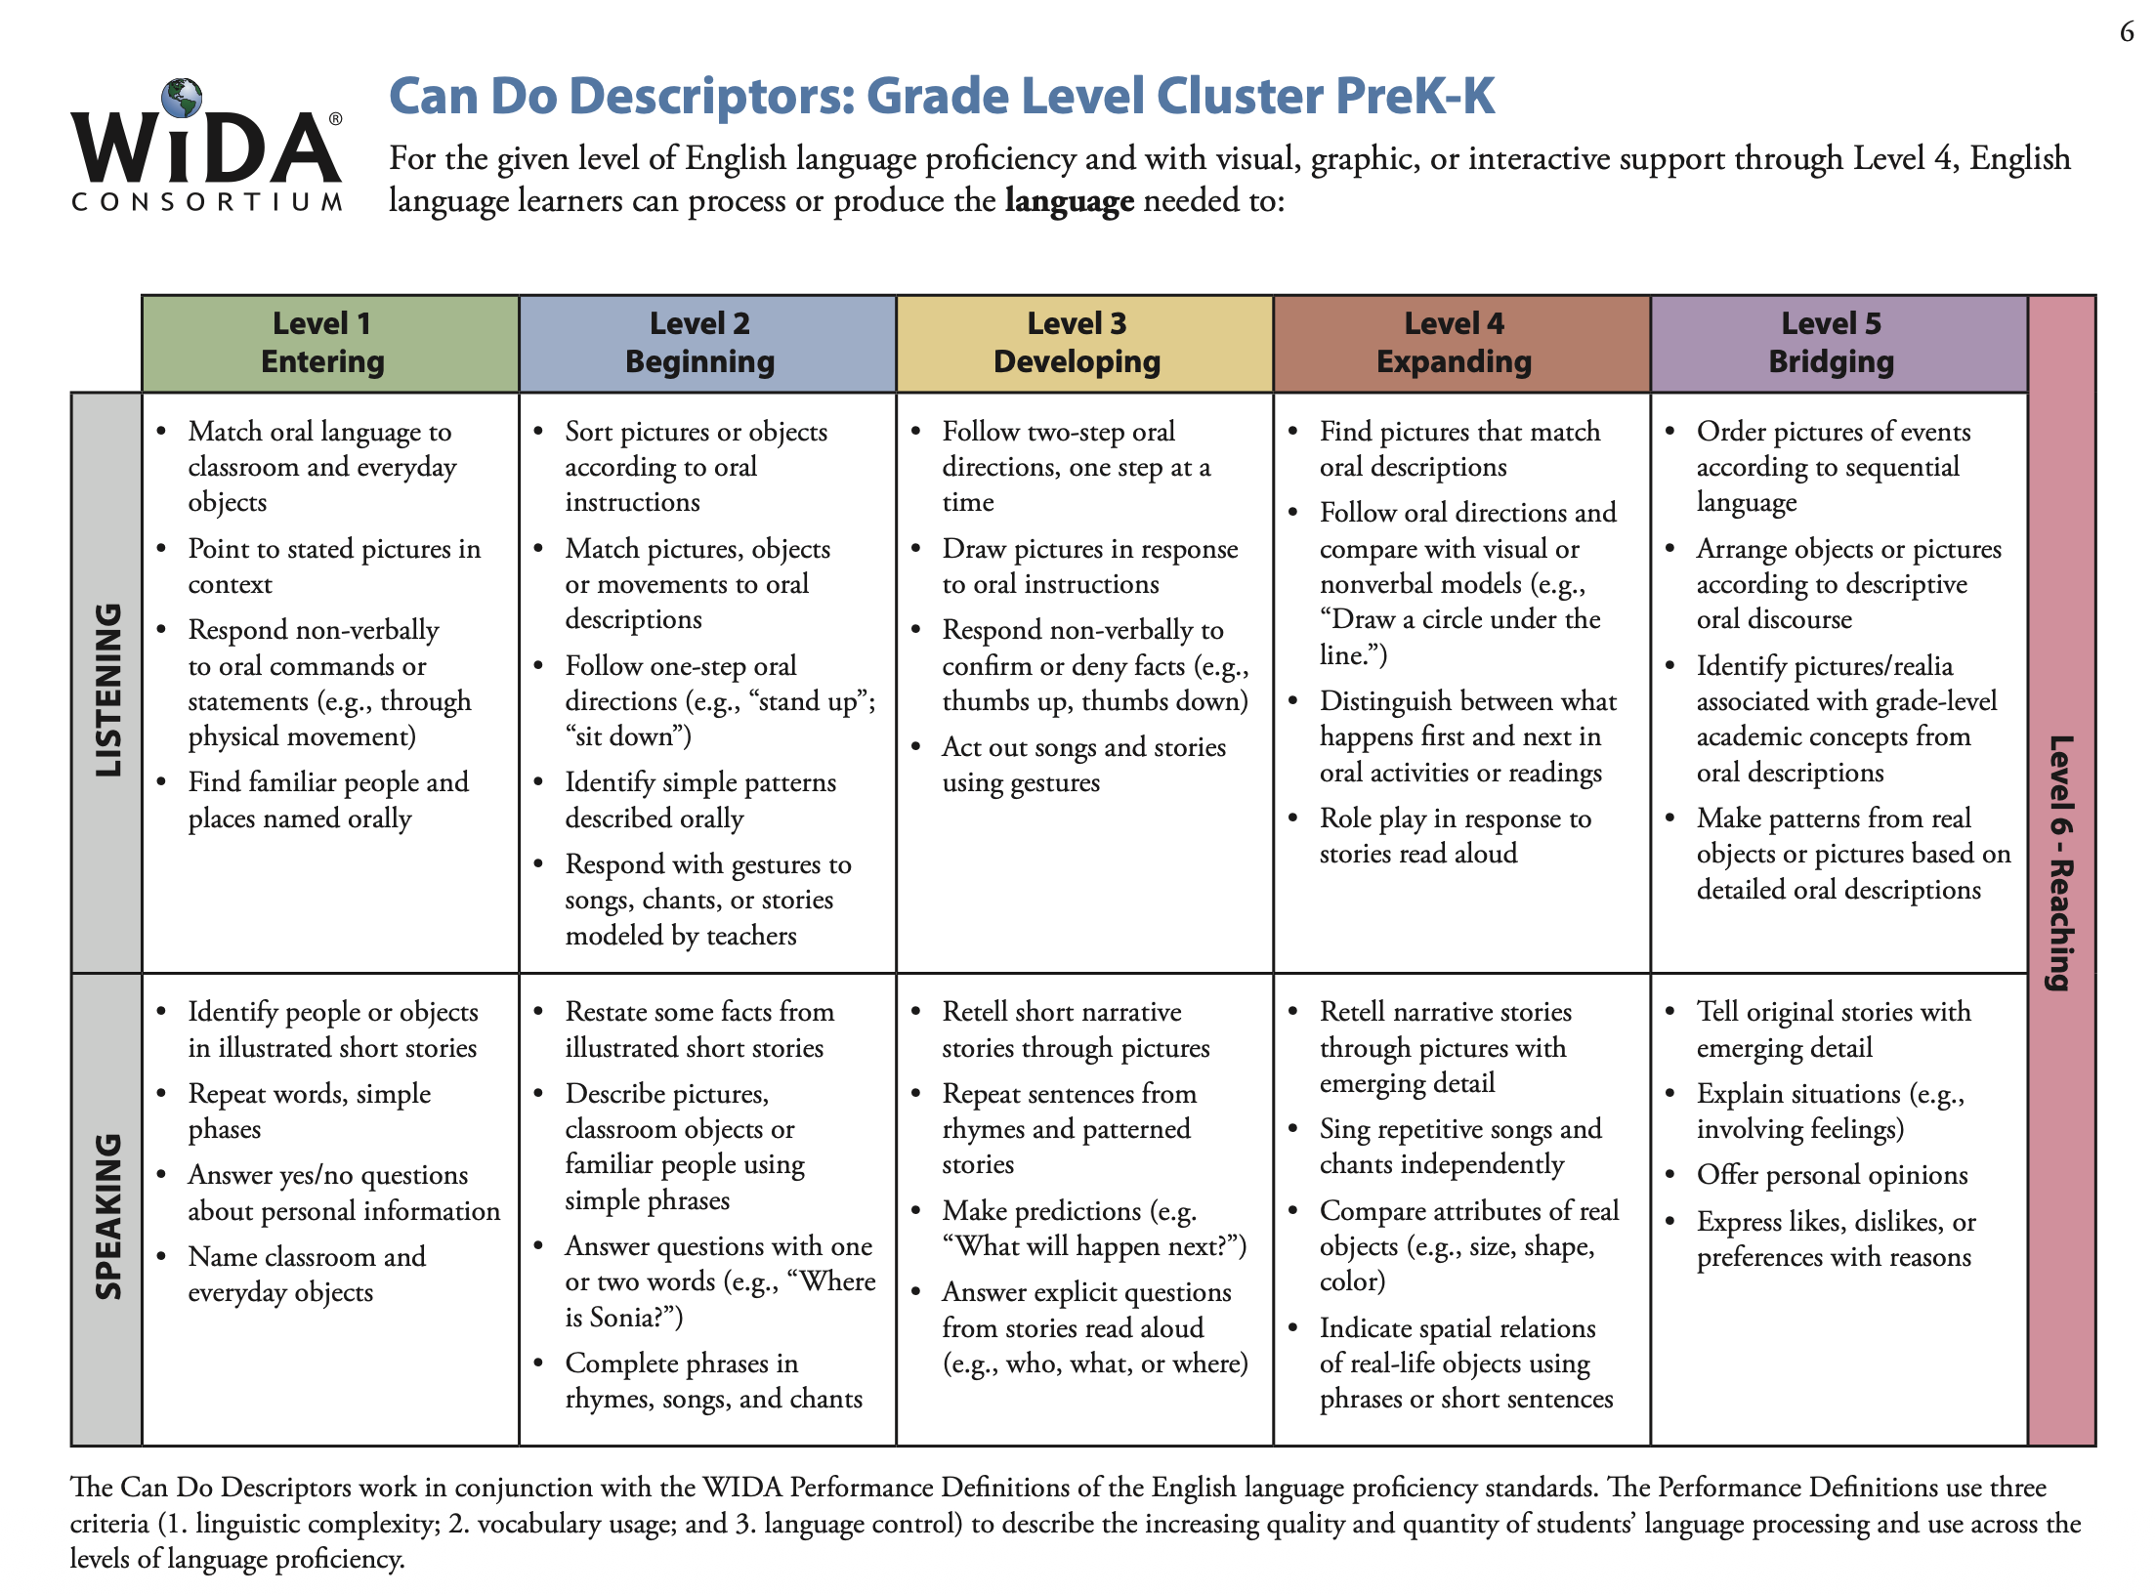
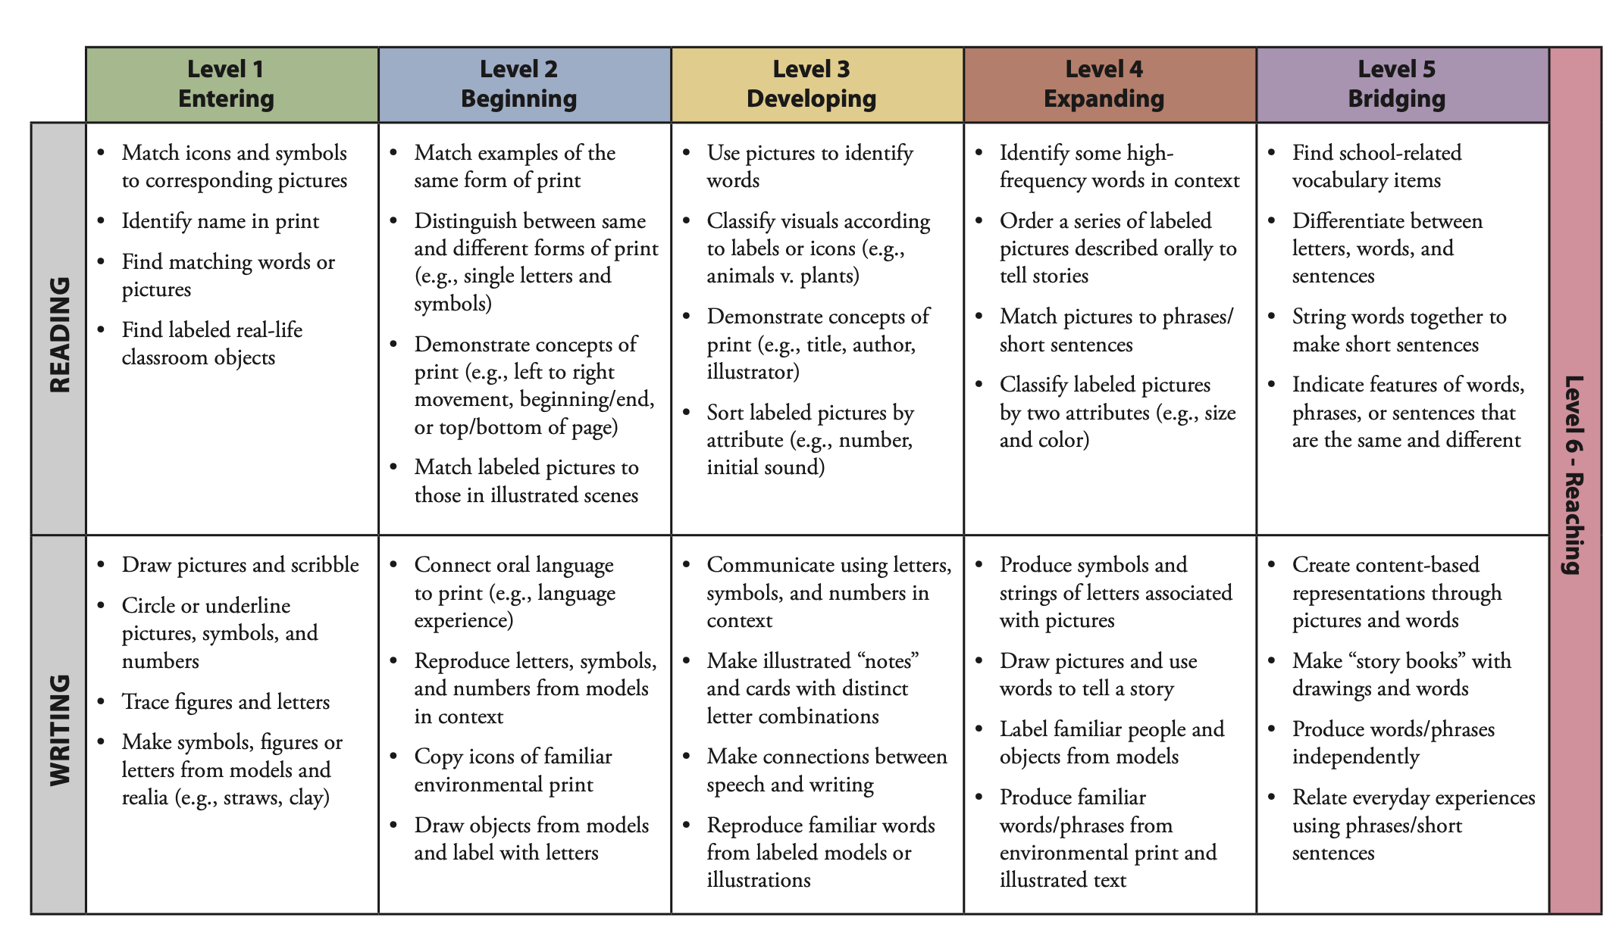

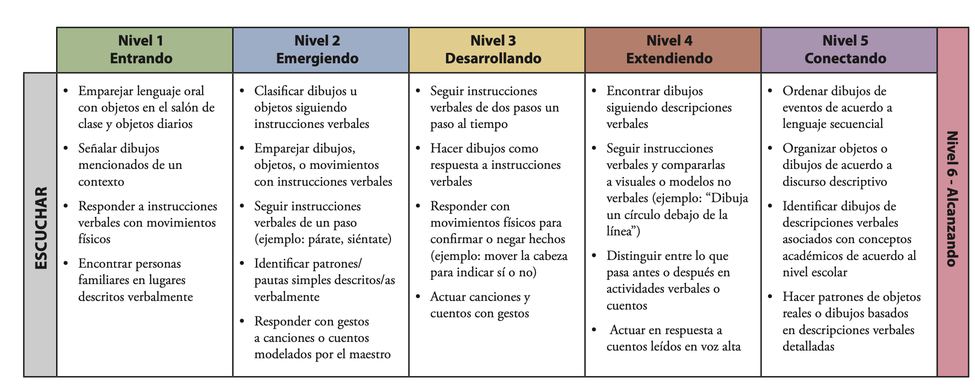
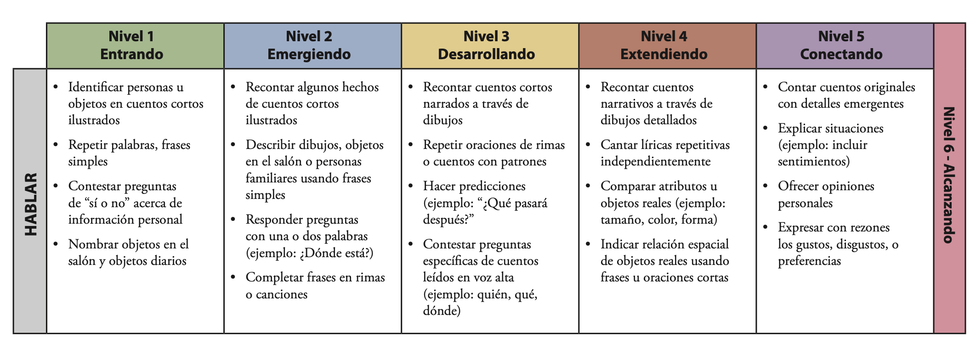
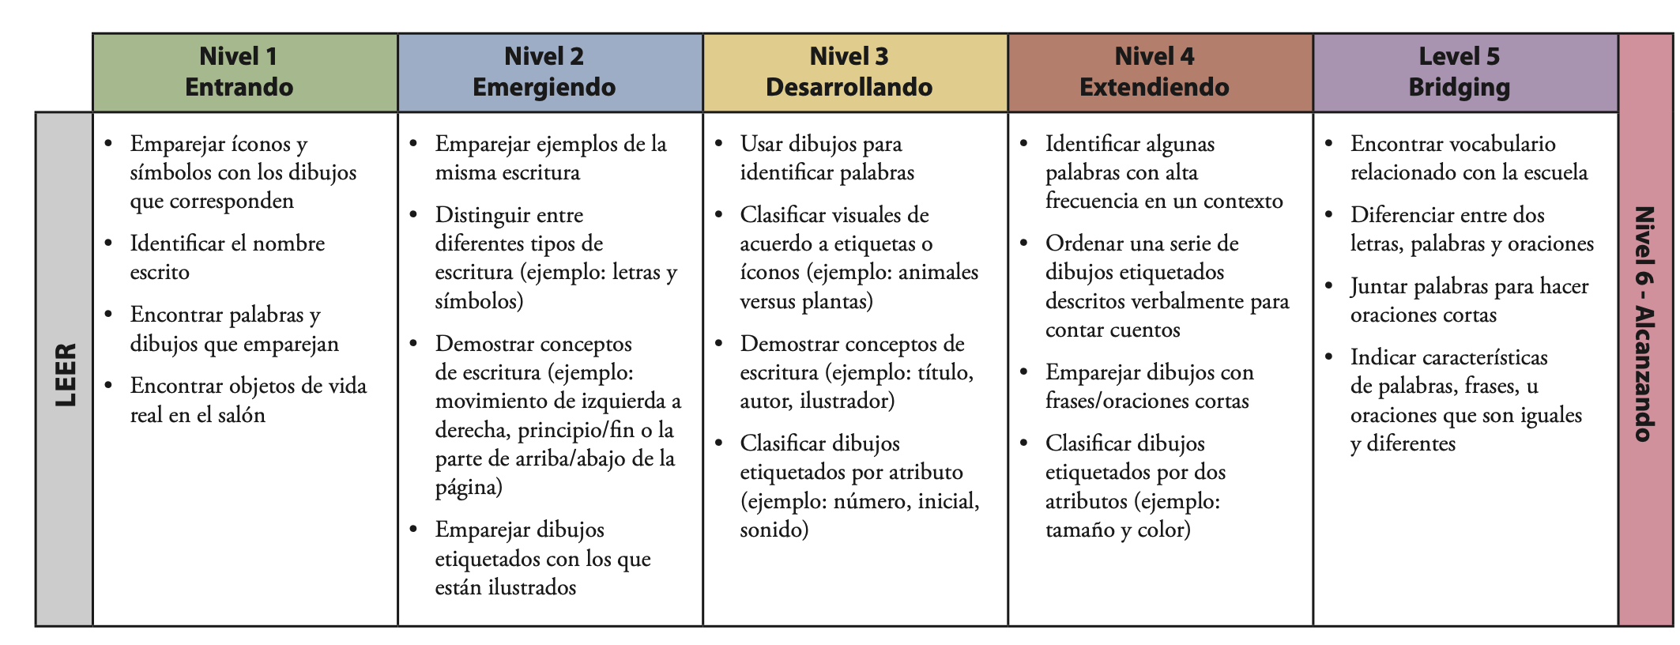
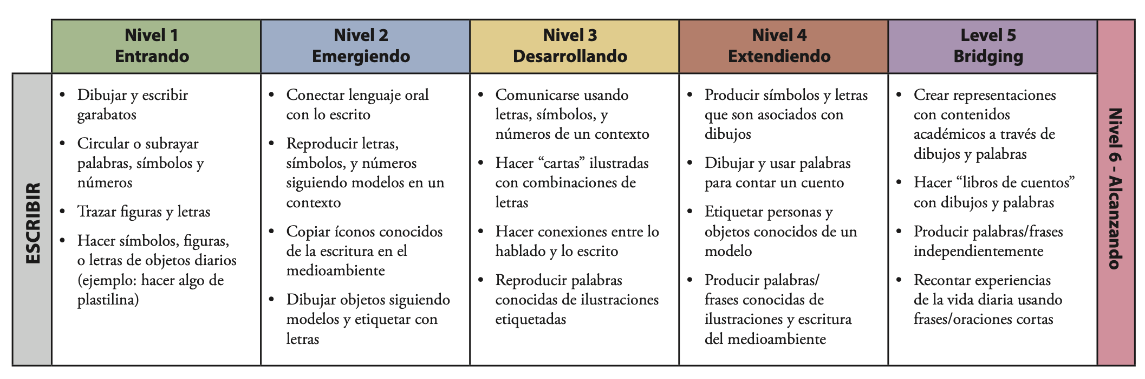

Program Design Recommendations: Planning for Biliteracy

Biliteracy Recommendations for Pre-K:
- Biliteracy PreK classrooms are developmentally appropriate PreK classrooms (Developmentally Appropriate Practice, NAEYC Position Statement Adopted April 2020)
- Students are provided integrated, engaging learning experiences in each language every day that they are in class.
- Teachers and other adults engage students in each program language at different times of the day. This is called language and content allocation.
- Students are together for differentiated, but not separate, instruction.
- Instruction is facilitated strategically in one language by the teacher, and all materials are in that language. Classroom instruction includes a variety of supports, high leverage strategies, and the development of oral language and background knowledge that promotes student comprehension and production.

Biliteracy Recommendations for K-5:
- All students receive literacy (language arts) instruction in each program language every day, beginning when they enter the program (TK/PK/Kindergarten). Each language arts class is contextualized around a meaningful theme or topic in which all components of literacy are taught and addressed as interconnected practices that support each other.
  - It is highly recommended that each literacy class cover different standards and themes or topics to reduce redundancy and optimize transfer.
- Students are together for differentiated, but not separate, instruction, ensuring all students are present during Tier 1 instruction.
- In Pre-K – 5th grades, whenever possible, content and literacy are integrated.
- If possible, each content area (math, science, social studies) is taught in one language only at each grade level. This is called content allocation.
- Instruction is facilitated strategically in one language by the teacher, and all materials are in that language. Classroom instruction includes a variety of supports, high leverage strategies, and the development of oral language and background knowledge that promotes student comprehension and production.
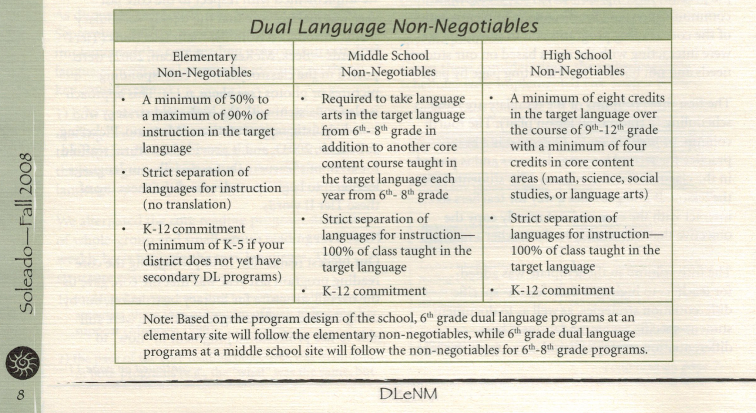

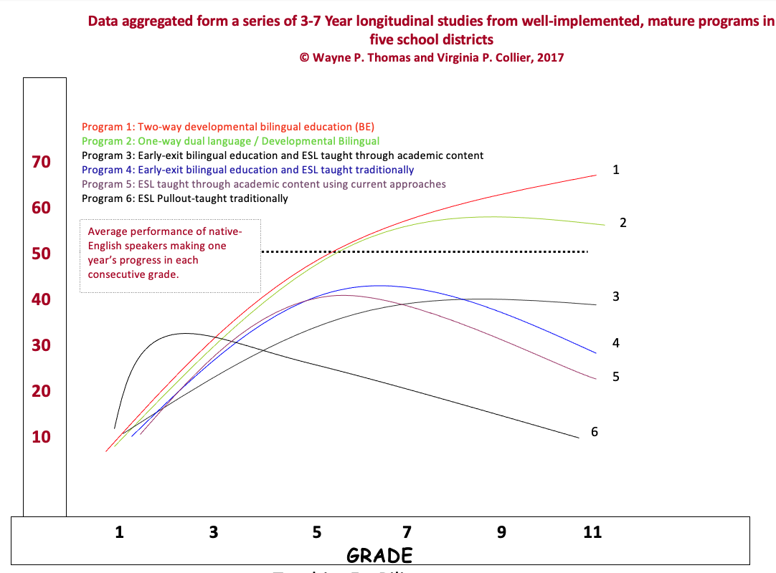

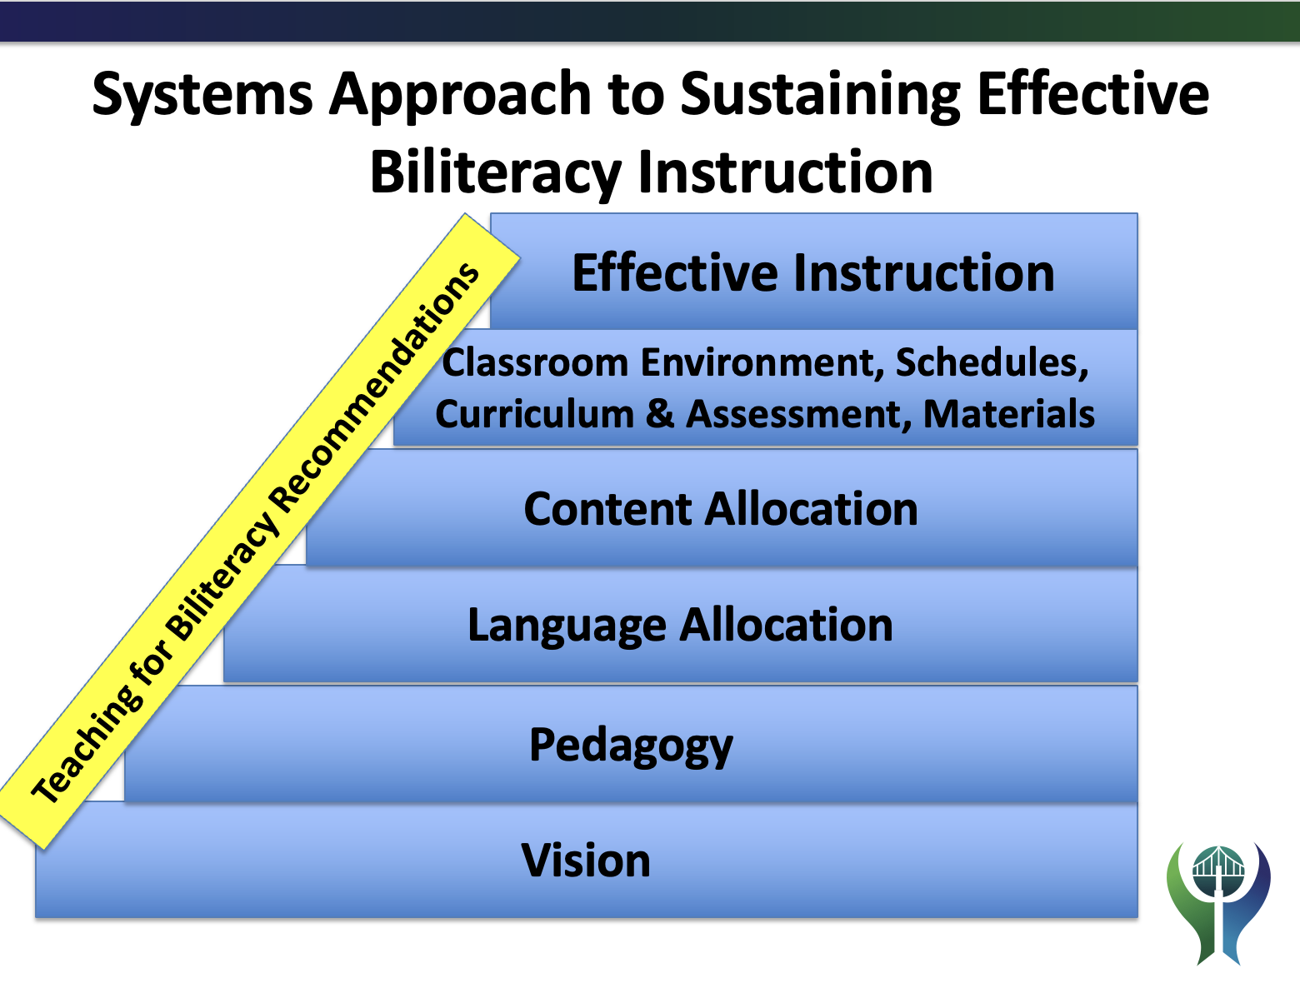

Comparison of the Monolingual and Multilingual Perspectives
Area | Monolingual Perspective | Multilingual Perspective
Perspective of Student Language Ability | Students have a dominant language (or L1, first language). | All students have an L1. For many students, their L1 is bilingual. All students become developing bilinguals as they engage in biliteracy.
Perspective of Student Language Ability | When students make linguistic approximations (puchar; planching) it is a sign of confusion or that they have gaps in their language development. | Students are expected to use language like developing bilinguals. Instruction anticipates and prepares for linguistic approximations.
Perspective of Student Language Ability | Students are expected to produce “monolingual-like Spanish”, especially if they come from a Spanish speaking family. | Students are expected to make linguistic approximations, and classroom instruction strategically moves students from informal to formal language.
Programmatic Structure  Curriculum, Instruction and Assessment | Students receive literacy instruction in their L1. L2 literacy instruction occurs later. | Students receive robust literacy instruction in BOTH languages; from the moment they enter the program.
 | Students are placed in either a Spanish literacy/language or an English literacy/language class based on their strongest language. | Students are placed in a biliteracy program that develops literacy in both languages, developing and then building on students’ oracy skills. Students are integrated all day and exposed to literacy in Spanish and literacy in English from Pk-5 (at a minimum).
 | Literacy instruction in each language looks like monolingual instruction. For example, during English literacy instruction, the biliteracy students are taught the same way and follow the same units of instruction as the monolingual classrooms. | Literacy instruction in each language is standards (TEKS and CCSS) based and reflects best practices in biliteracy instruction for developing bilinguals. For example, language acquisition practices are integrated with content and literacy instruction as the norm, in both English and Spanish.
 | Spanish and English are thought of as separate, and students do not work across both languages. | The Bridge is pre-planned, and it explicitly teaches students how their two languages are similar and different, thereby developing metalinguistic awareness, even in English-only programs of instruction.
 | Students are assessed in each language separately. Bilingual programs follow the monolingual assessment calendar, adjusting it to two languages. | Students are assessed in both languages. Bilingual programs create an assessment calendar that captures what students can do in both languages; not necessarily doing everything twice (reduce redundancy and optimize transfer).
 | It is expected that bilingual/dual language schedules look like those in the general education (monolingual) program. | Bilingual/dual language schedules intentionally look different than those in the general education (monolingual) program.
 | Units of instruction are anchored in standards, use sheltered instruction/GLAD strategies, and focus on instruction and assessment in one language, Spanish or English. | Units of instruction are anchored in standards, use sheltered instruction/GLAD strategies, and focus on instruction and assessment in three linguistic spaces: Spanish, the Bridge, and English.
Beeman and Urow (2013). Teaching for Biliteracy: Strengthening Bridges between Languages. Brookes Publishing: Baltimore, MD.

Bridge and “bridging”
The Bridge is… | Bridging is…
pre-planned by the teacher, occurs at the end of a robust unit of instruction that has been conducted all-in-one language | when teachers guide students in making cross-linguistic connections, in each language, during the unit of instruction.
about transfer – supporting students in transferring their learning (standards, concepts, essential understandings) from the language of instruction to the opposite language | the opportunity for the teacher to guide students in applying and building on the contrastive analysis (AKA cross-linguistic connection) charts created during the Bridge.
about contrastive analysis: comparing and contrasting the Spanish and English in the transfer charts in the areas of phonology, morphology, syntax and grammar, and pragmatics | students noticing how their two languages are similar and different, and add their noticings to the contrastive analysis charts
highly interactive and student-centered | not the same as Bridge.
not a translation, or just about cognates | not the teacher giving students words.

Three Types of Bridges: Part One of the Bridge

Illustration | Side-by-Side | Así se dice
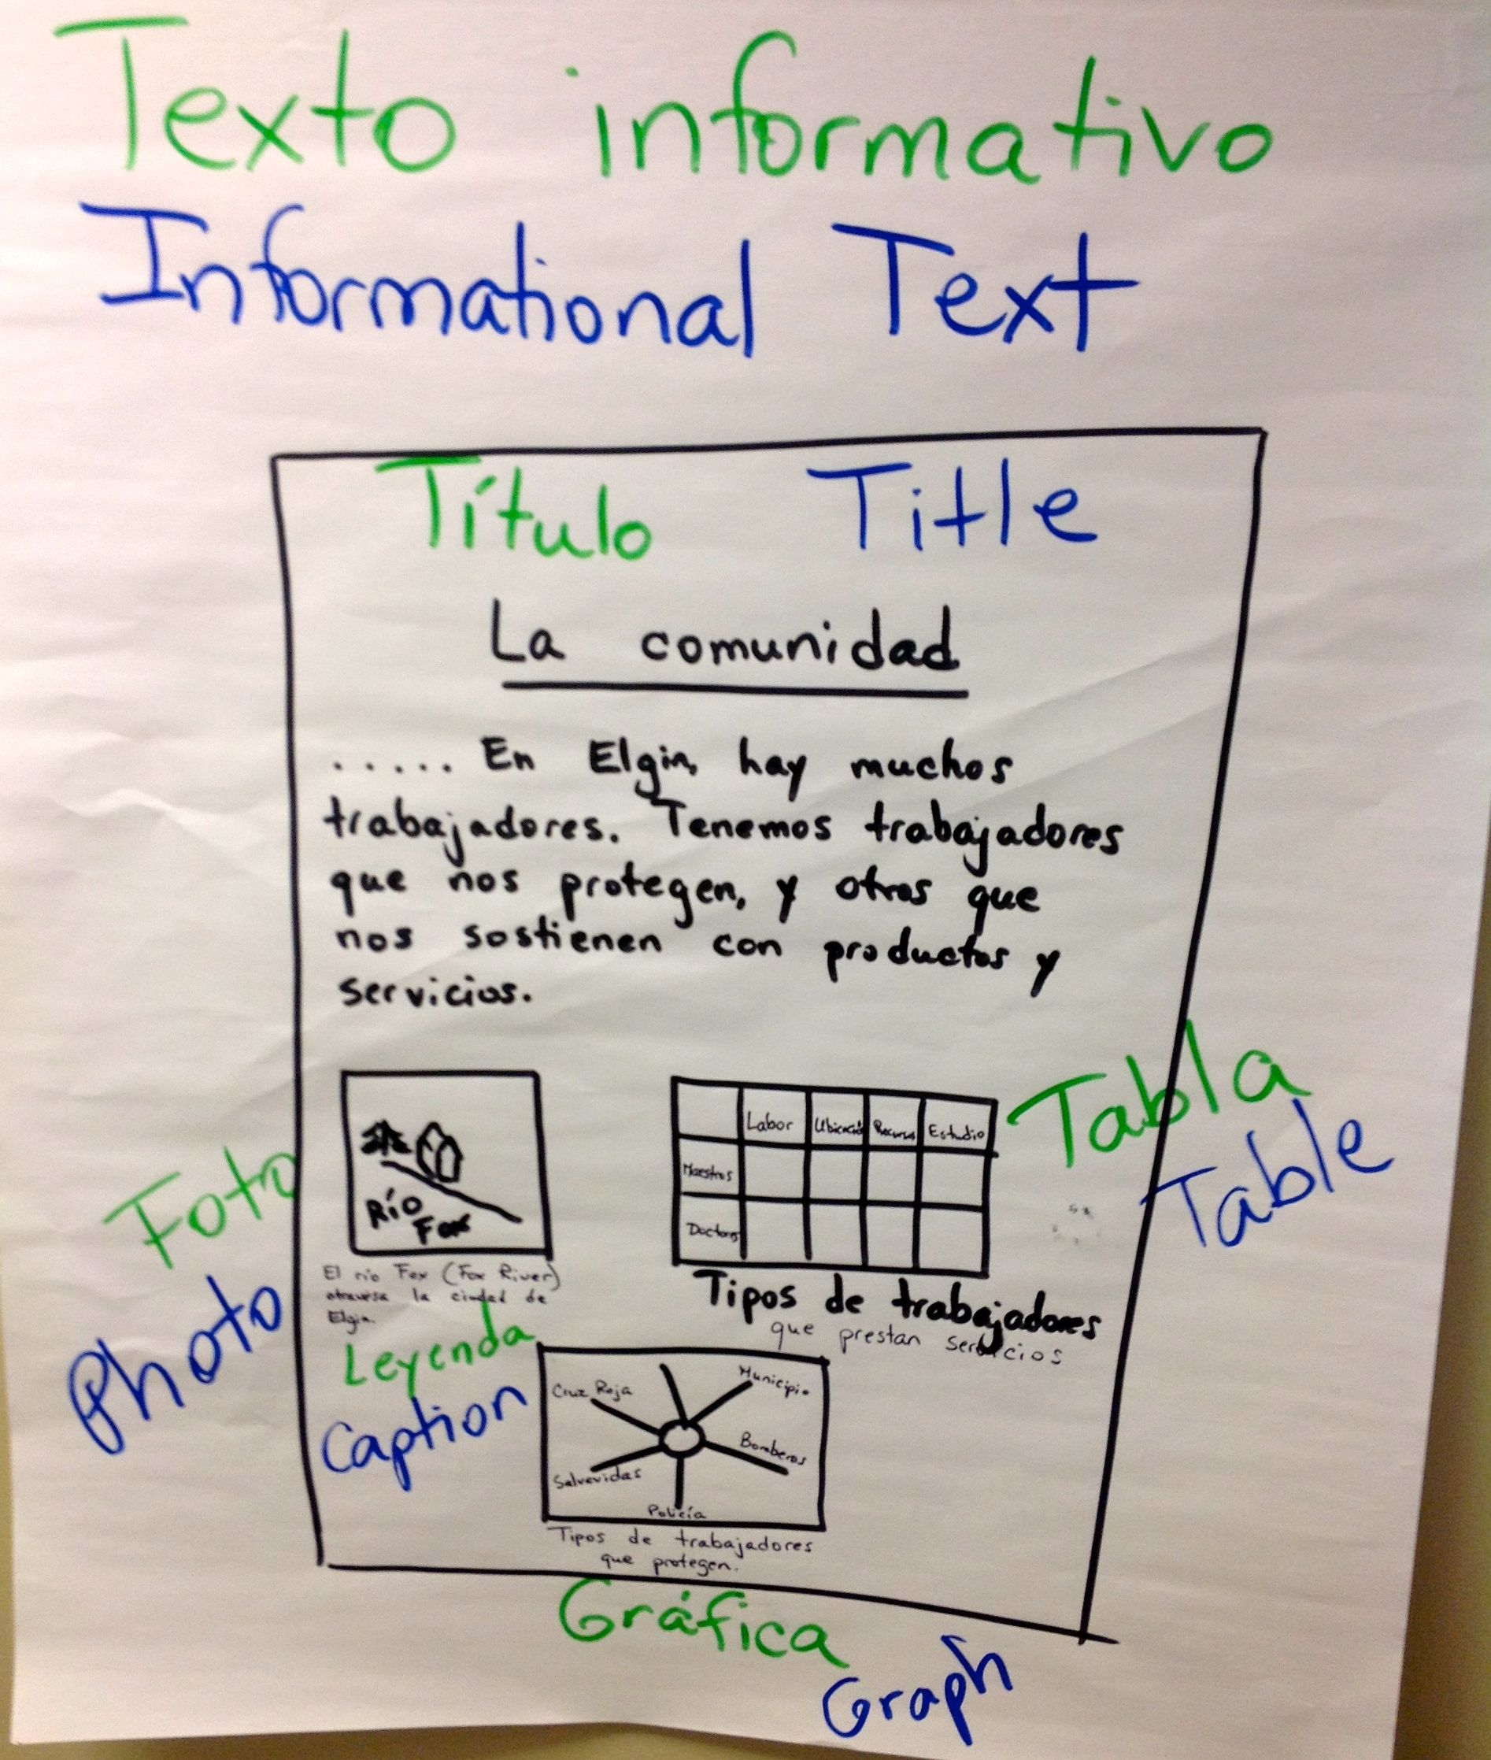 | 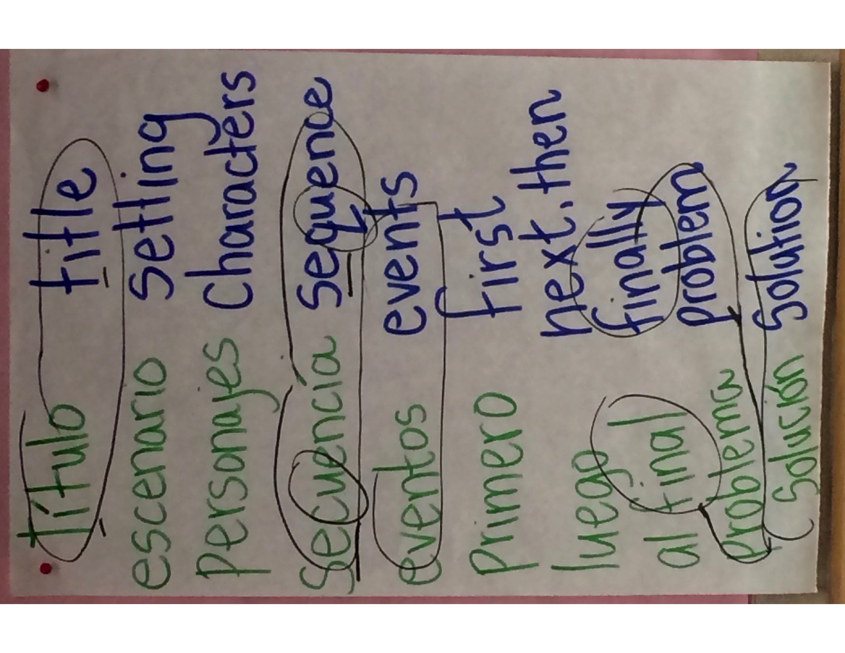 | 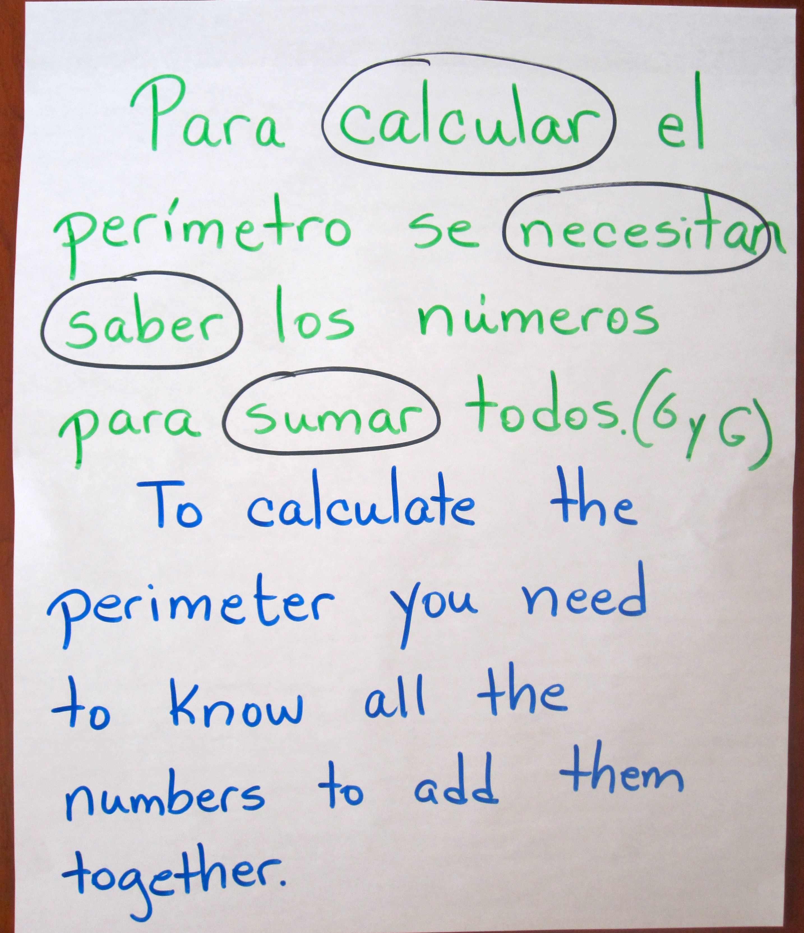

Three Types of Contrastive Analysis Charts: Part Two of the Bridge and part of “bridging”

Phonology | Morphology | Syntax and Grammar
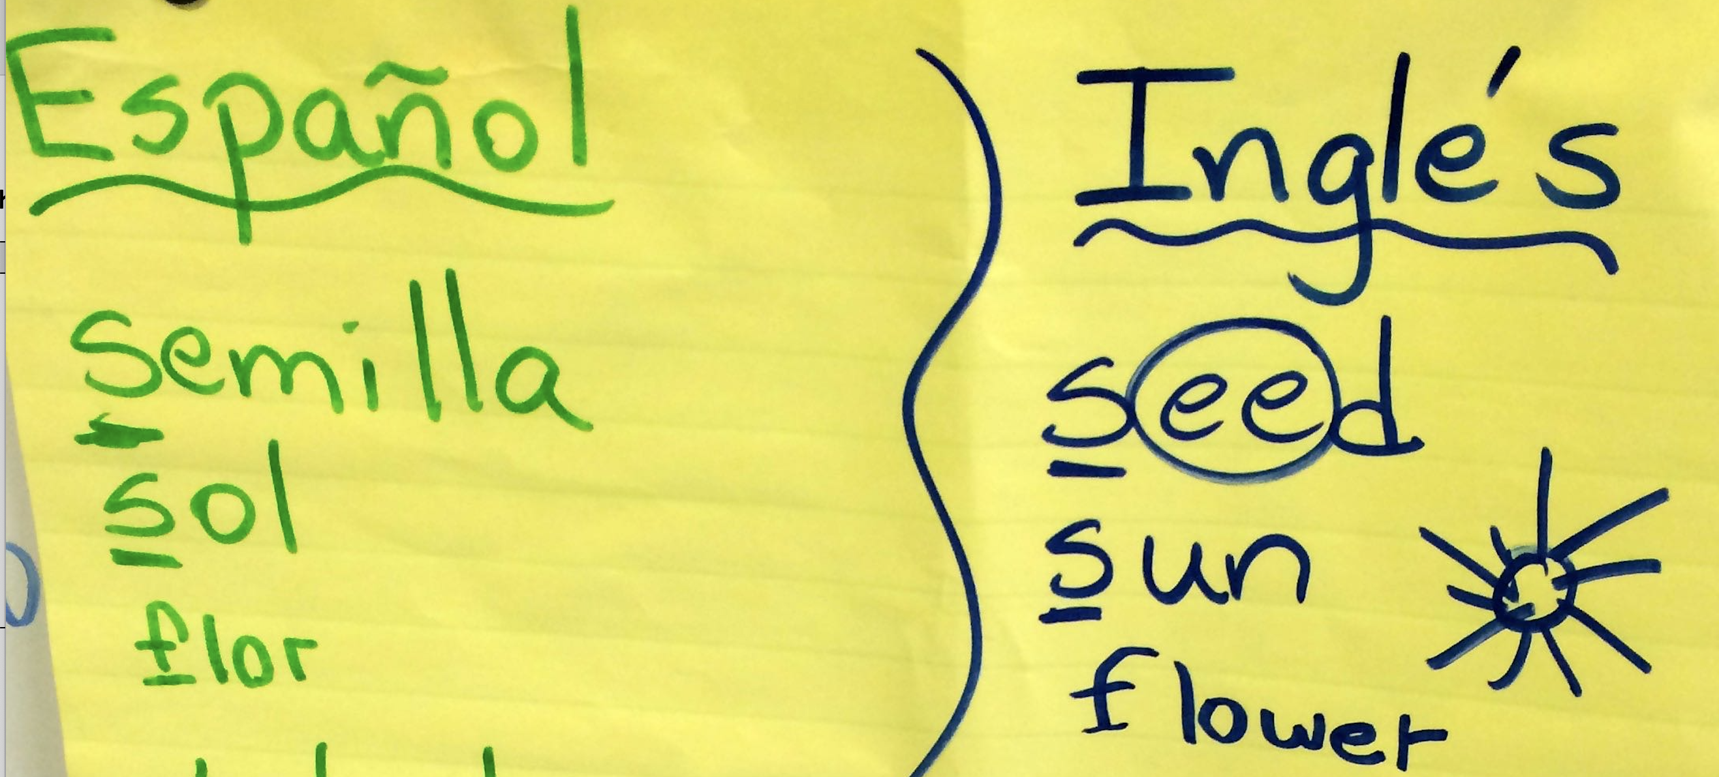 | 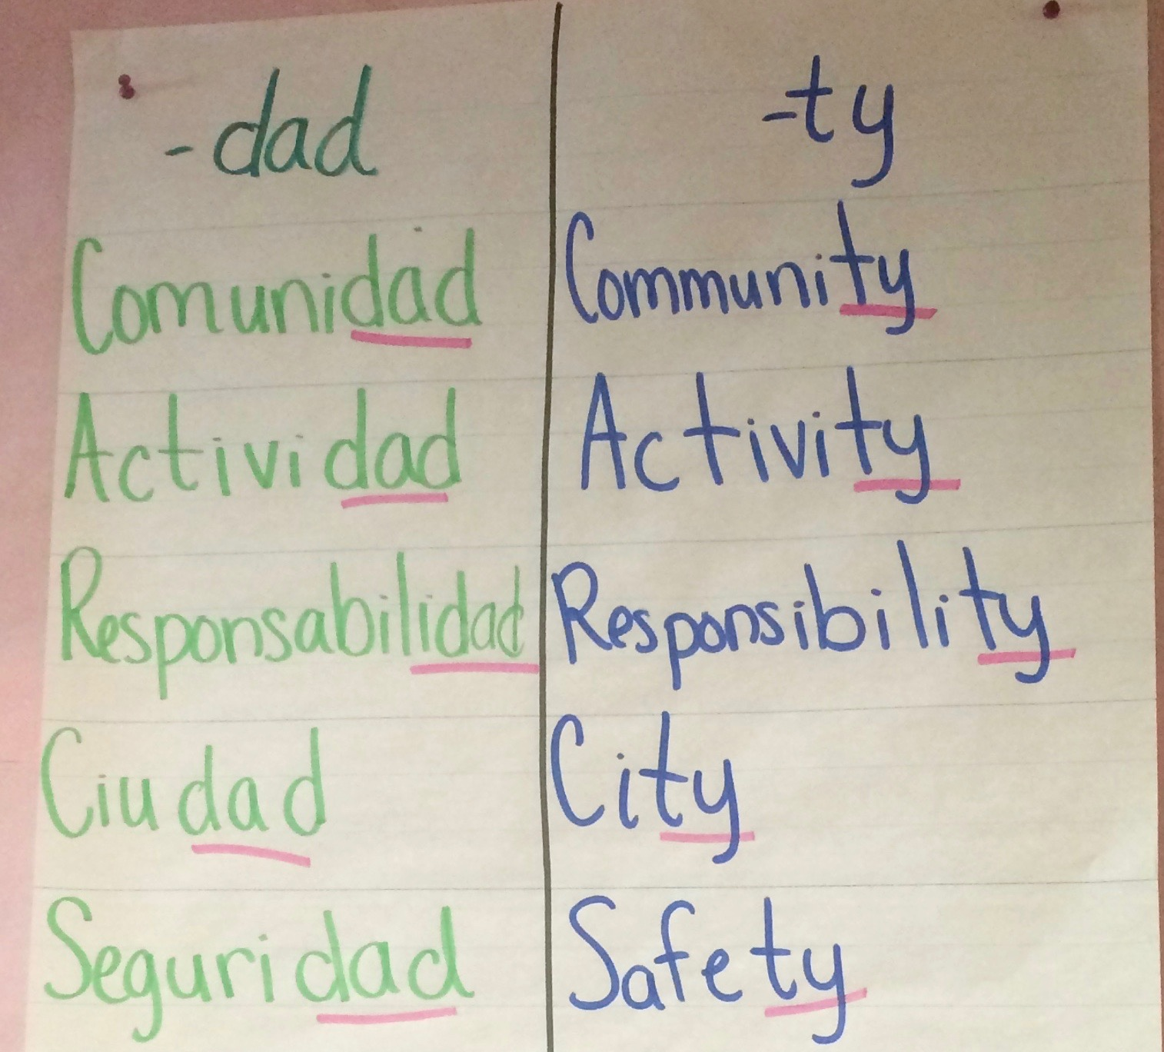 | 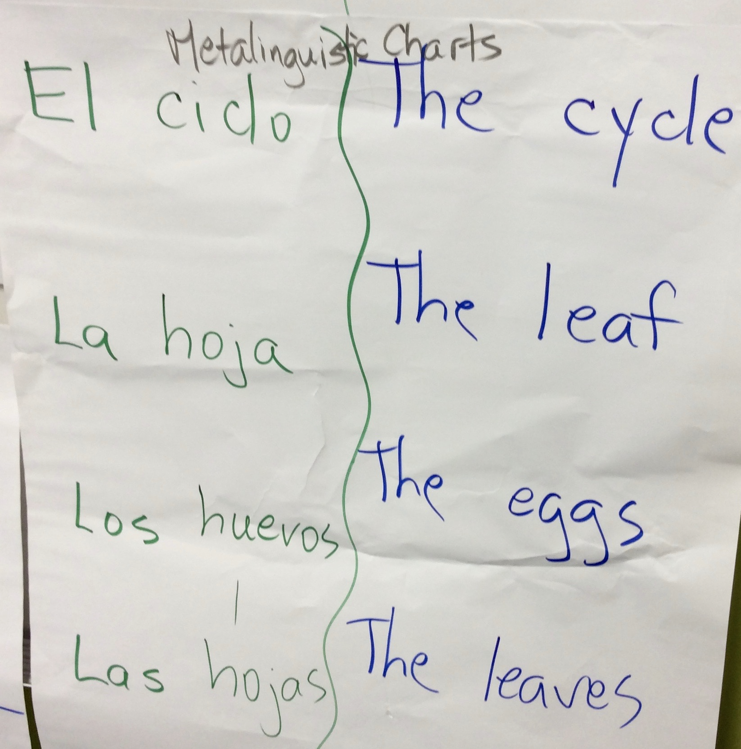
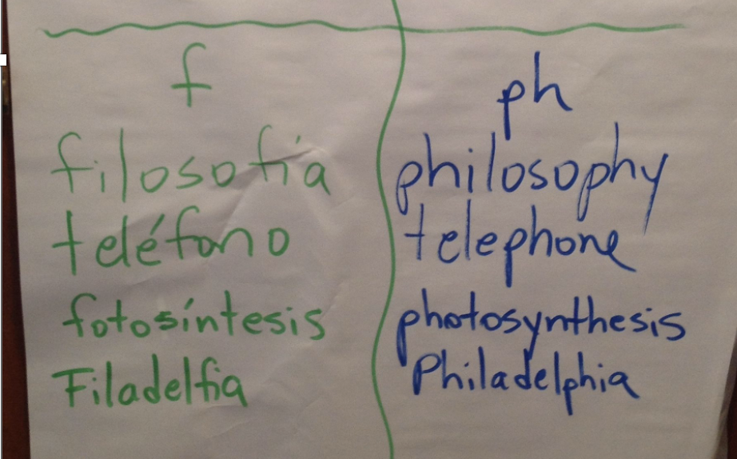 | 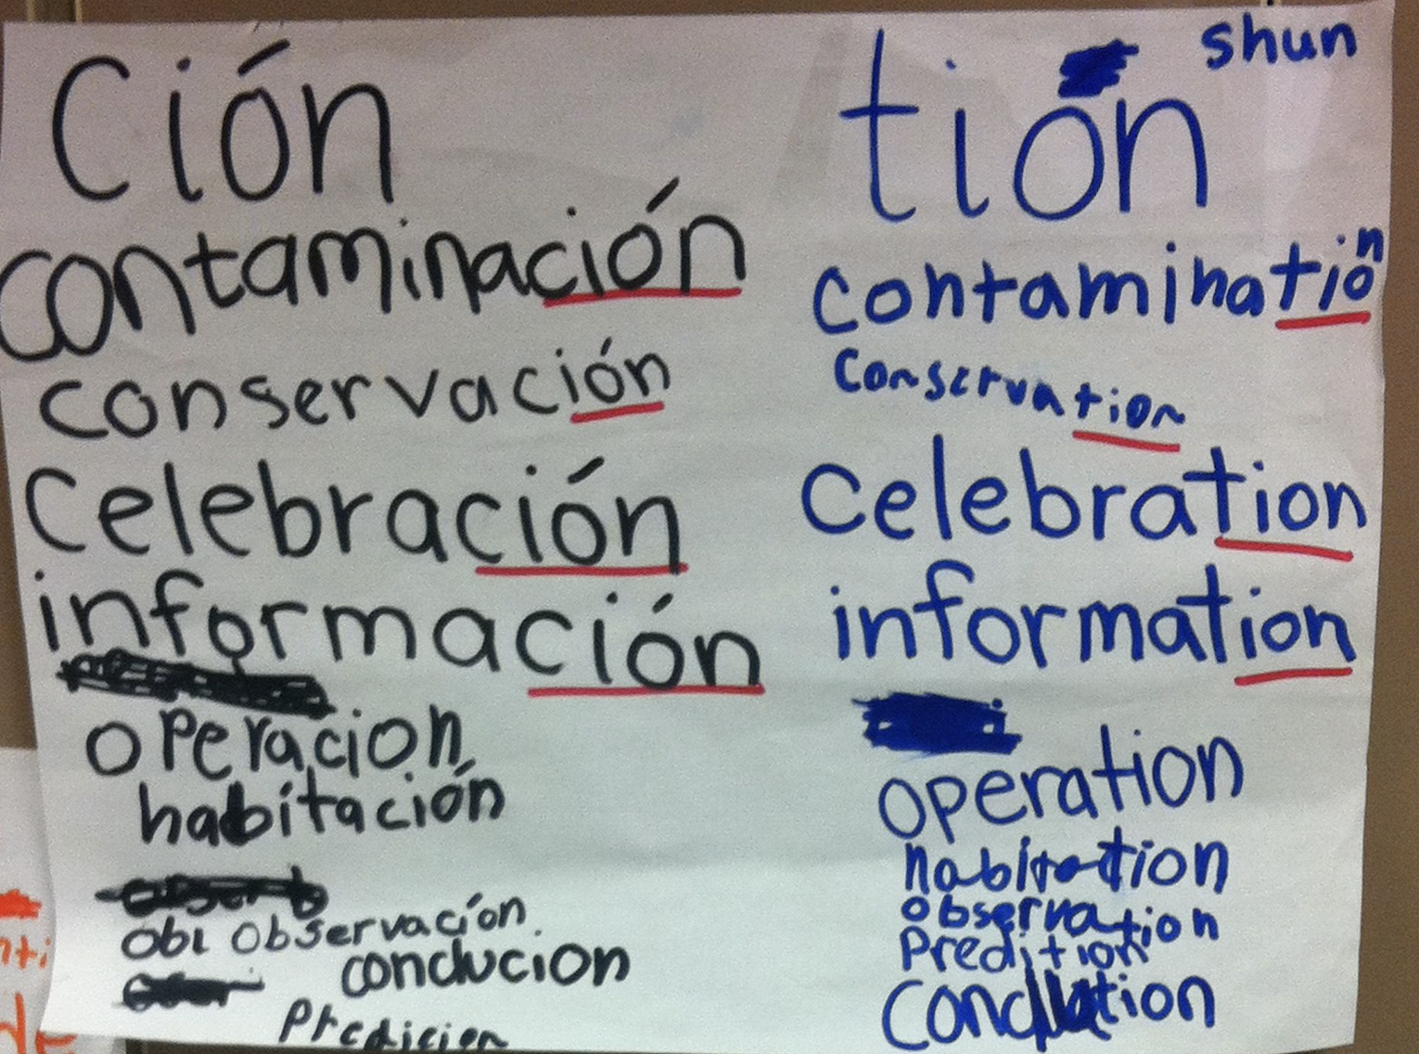 | 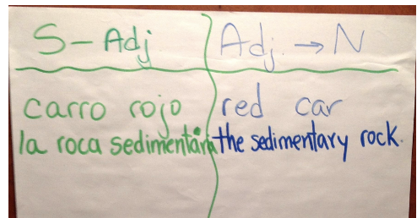  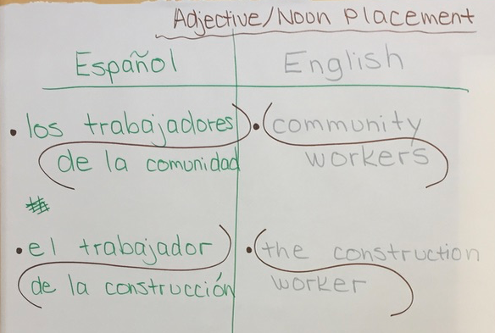
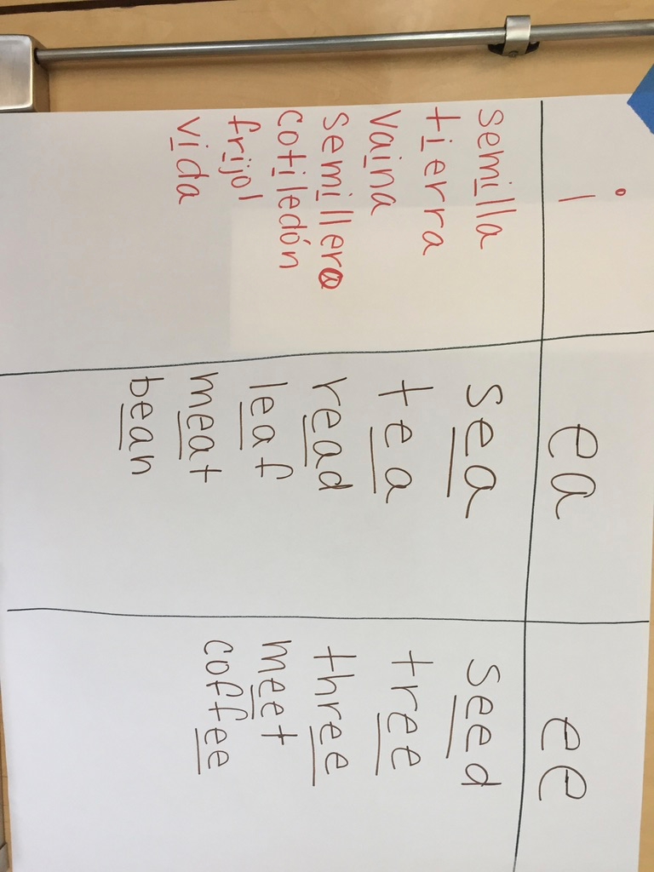 | 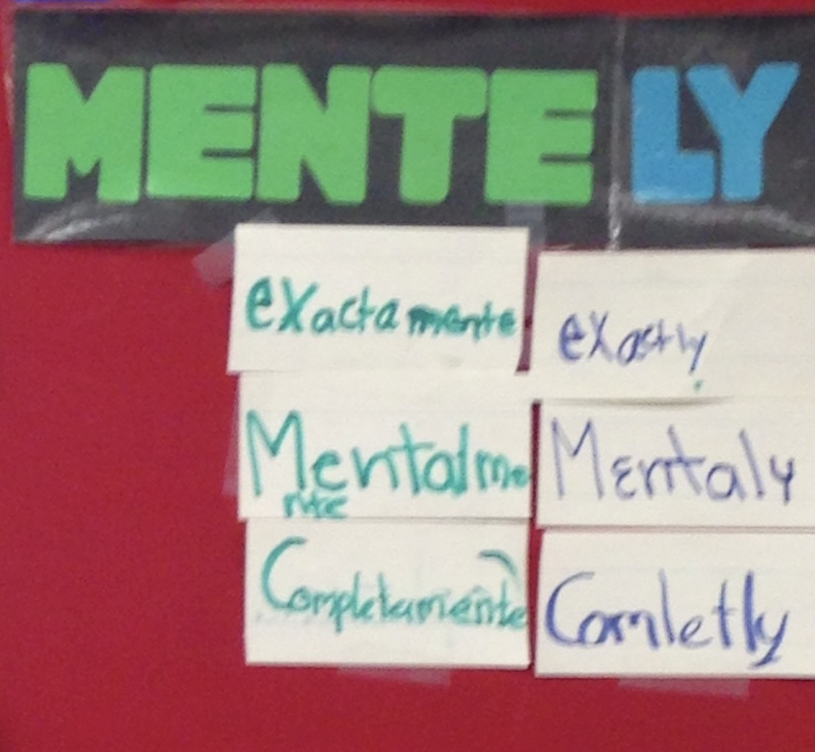 | 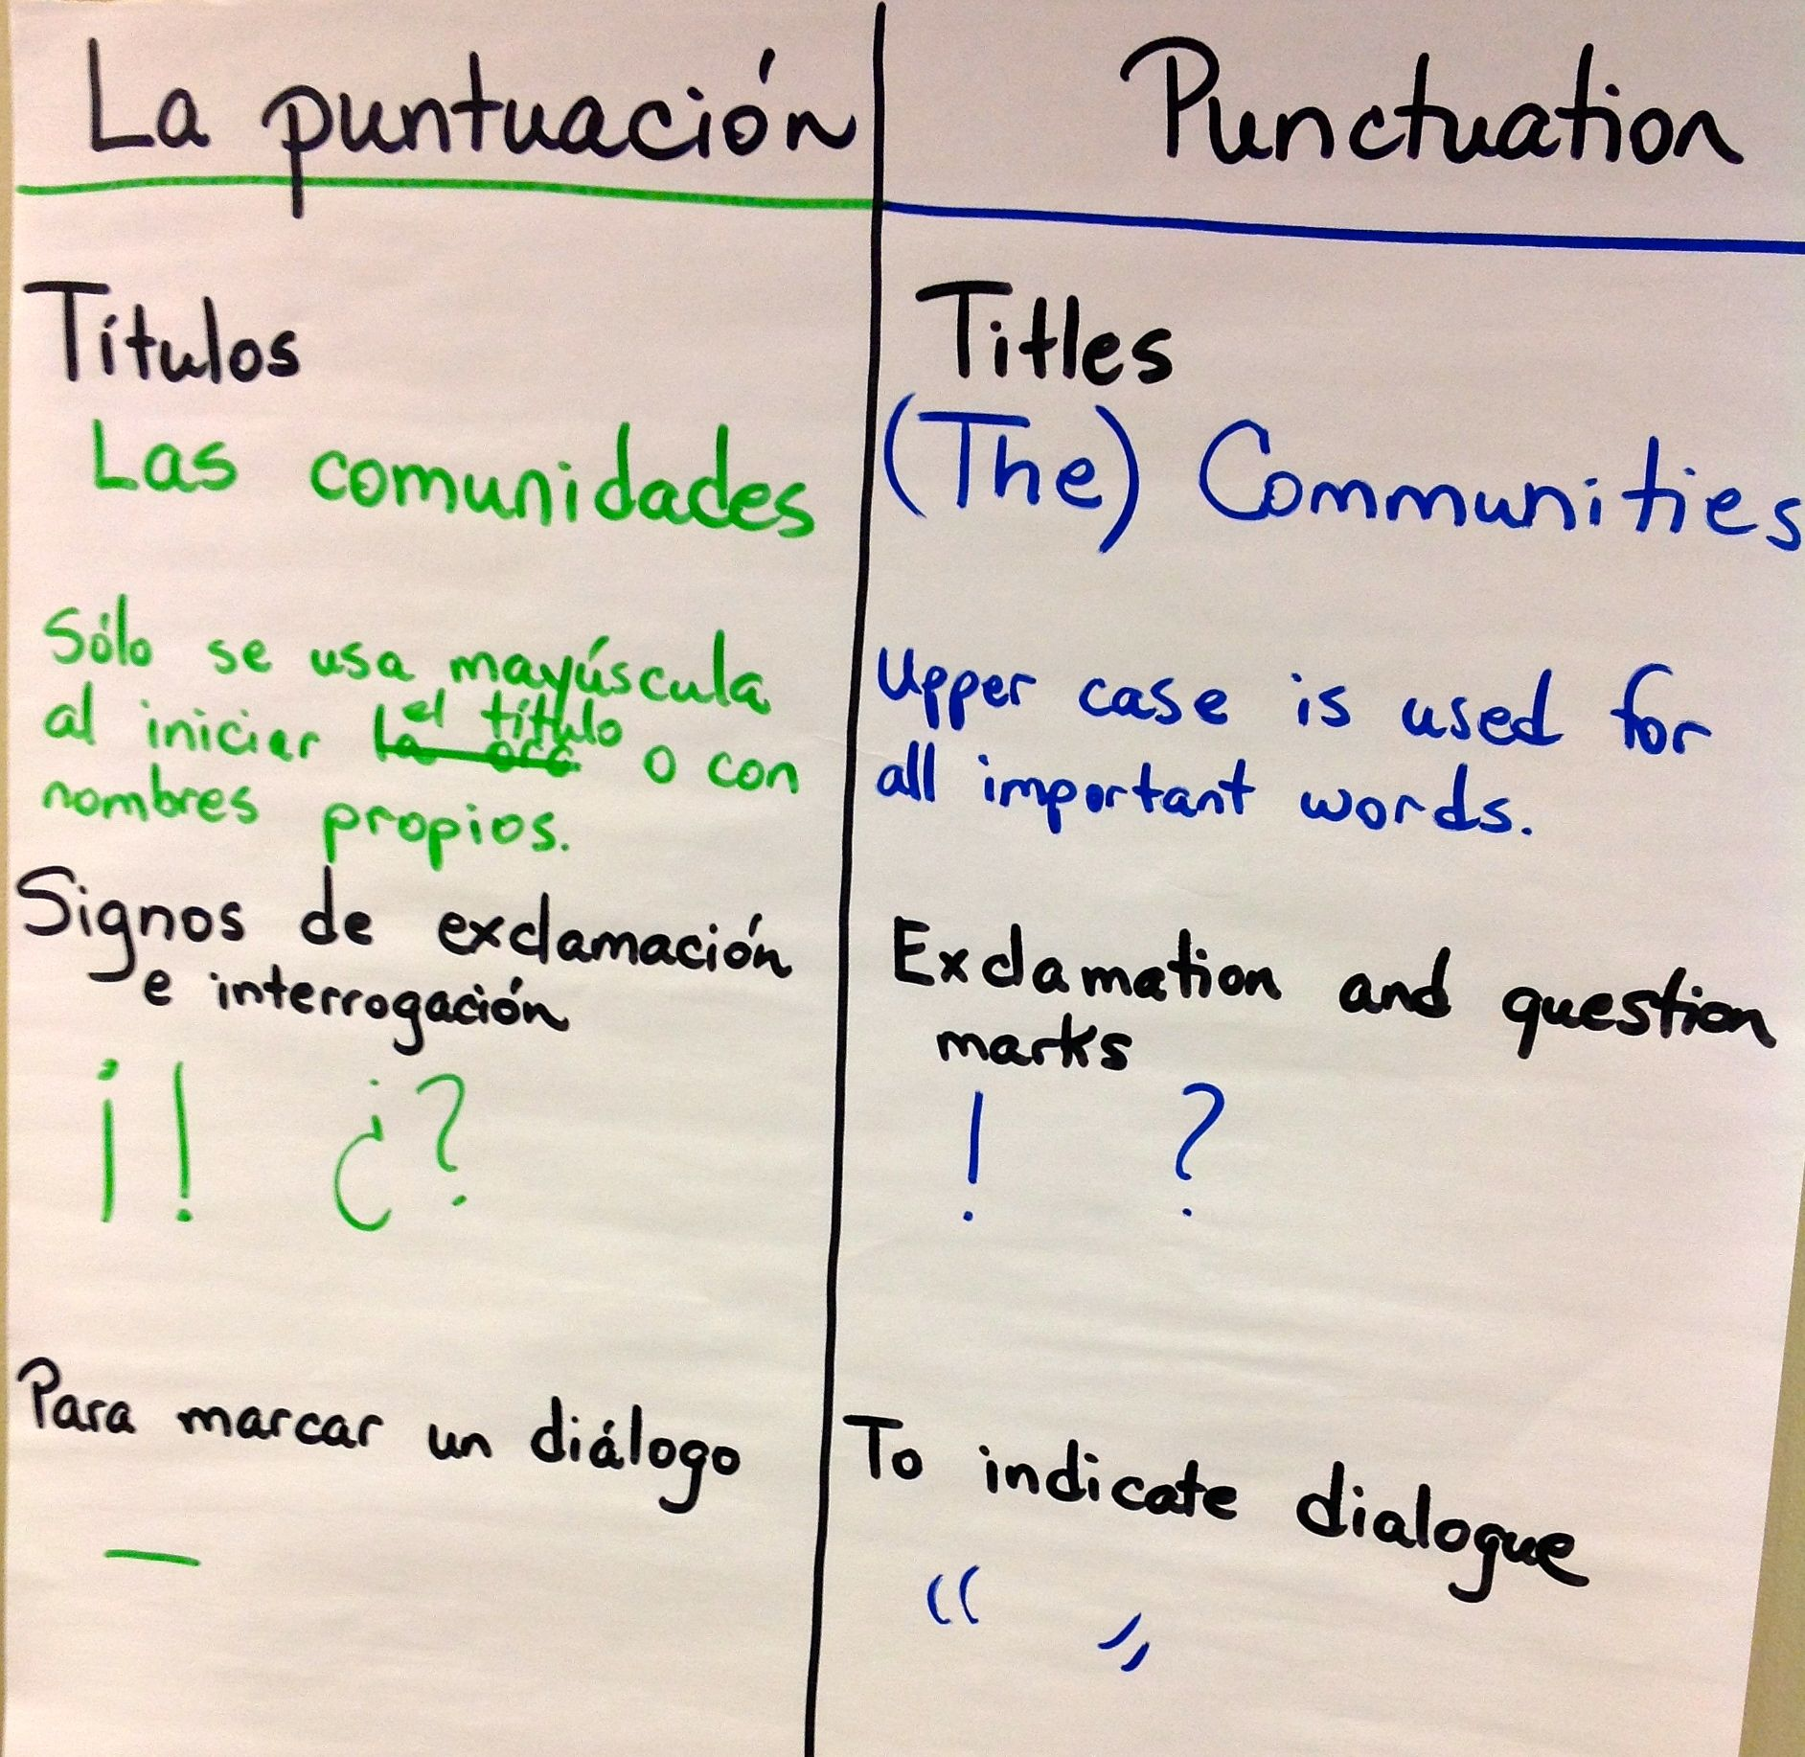

Four Areas of Contrastive Analysis: Part Two of the Bridge
Element and area of focus | Examples
Phonology (sound system)  - Sounds that are different in the two languages.  - Sounds that are similar in the two languages. | - Sound-symbol correspondence (e.g., the [k] sound: “qu” or “c” in Spanish; “c” or “k” in English)  - Silent letters (e.g., “h” and “u” in Spanish; many in English)  - The existence of the [th] sound in English but not in Spanish; therefore, students select the closest Spanish phoneme, which is /d/
Morphology (word formation): prefixes and suffixes shared between the two languages (cognates) | informal – informal  informar – inform  socialismo – socialism  desastroso – disastrous  preparar – prepare  profesión – profession  educación – education
Syntax and grammar (sentence structure)  - Rules for punctuation, grammar, word order, etc. unique to each language  - Areas that are similar and areas that are different | Spanish uses the initial inverted exclamation point; English does not (e.g., ¡Me encanta! – I love it!)  Articles have gender in Spanish but not in English (e.g., el título – the title; la revolución – the revolution)  In Spanish accents change the meaning of words (e.g., el Papa vive en Roma; la papa es deliciosa; mi papá es muy trabajador)  Spanish has many reflexive verbs; English has few (e.g., Se me cayó)  Conjugation of verbs in Spanish reduces the need for the pronoun. (e.g., ¡Voy!)  English contains possessive nouns; Spanish does not (e.g., my grandmother’s house – la casa de mi abuela)
Pragmatics (language use)  - Cultural norms or contexts that are reflected in language use.  - Use of overlapping cultural norms in a bilingual context. | Questions about age avoid the word “old” in Spanish because it has negative connotations (¿Cuántos años tienes?)  Figurative language from English is translated directly into Spanish: Estoy encerrado afuera (I am locked out!) rather than Me quedé afuera.  Spanish constructs are used during English (e.g., Mis padres ganan mucho dinero. My fathers win lots of money).

Beeman, K. and Urow, C. (2013). Teaching for Biliteracy: Strengthening Bridges between Languages. Brookes Publishing: Baltimore, MD.

Planning for the Bridge
- Review in the language of instruction | 4. The Bridge for Transfer: Match the key words/phrases/sentences to the other language
2. Elicit key words/phrases/sentences in the language of instruction from students | 5. The Bridge for Contrastive Analysis
3. The Bridge for Transfer: Practice the terms in the new language (i.e., build oracy in the opposite language). | 6. The Bridge for Transfer: Practice

Assessment in Language Programs

Adapted from Gottlieb, M. and Nguyen D. (2007). Assessment and Accountability in Language Education Programs. Philadelphia, PA: Caslon Publishing

Principles:
- Assessment should capture student growth in both language development and academic achievement in each language.
- Formative assessment should mirror instruction and should be administered and collected over time using rubrics, checklists, and other assessments.
- Standardized assessments reflect district, state, and federal guidelines.

Language of Instruction | Language Assessments | Academic Achievement Assessments
Spanish | Formative or Instructional:  Interim:  Standardized (occur once): | Formative or Instructional:  Interim:  Standardized:
English | Formative or Instructional:  Interim:  Standardized: | Formative or Instructional:  Interim:  Standardized:

SAMPLE: Assessment in Language Programs

Language of Instruction | Language Assessments | Academic Achievement Assessments
Spanish | Formative or Instructional:  - Language Development Rubrics for Spanish (WIDA CAN DO descriptors)  - Oracy Anecdotal Record Charts  - Initial oracy for science  - Oracy before reading  - Spanish as a Second Language Checklists  - Language Development Rubrics  - Speaking Rubrics  - Listening Rubrics  Interim:  - Language Development Rubrics for Spanish (WIDA CAN DO descriptors)  Summative/ Standardized:  - AVANT STAMP Language Proficiency Test  - DELE (from Spain)  - ELLOPA (PK-5)  - LAS Links español | Formative or Instructional:  - Writing rubrics in Spanish  - Reading Inventories  - Dictado Checklists  - Content area project rubrics  - Teacher made tests  - Performance based tasks  - Anecdotal Record Charts  Interim: EDL2 or STAR  Standardized:  - LAS  - APRENDA
English | Formative or Instructional:  - Language Development Rubrics (WIDA’s CAN DO descriptors) used formatively  - ESL Checklists  - Language Development Rubrics  - Speaking Rubrics  - Listening Rubrics  - Reading and Writing Rubrics  Interim:  - Language Development Rubrics for English (WIDA CAN DO descriptors)  Standardized:  - ACCESS (WIDA states)  - CELLA (Florida)  - ELPAC (California) | Formative or Instructional:  - Writing rubrics in English  - Reading Inventories  - Spelling Growth  - Fluency Measures  - Content area project rubrics  - Teacher made tests  - Performance based tasks  - Anecdotal Record Charts  Interim: DRA or STAR  Standardized:  - State large scale testing (PARCC and Smarter Balance) example: Illinois Assessment of Readiness
Sample A District Biliteracy Vision and Pedagogy: 80/20

Goals of Our Dual Language Program

The goal of our program is for our students to become bilingual and biliterate (Spanish/English) and socio-culturally competent global citizens as they achieve grade level (or higher) standards.

Who is our Dual Language Program for?

Our program is designed to be inclusive, aiming to also close the opportunity/achievement gap for our English Learners. We accept students identified as English Learners (whether sequential or simultaneous) from Spanish-speaking homes. If there are still seats available, students with a different home language, also identified as English Learners, are eligible. The remaining seats are offered, via a lottery, to any non-English Learner whose family wishes them to acquire a second language.

Program Structure

In our program, students have a balanced daily routine using a 80/20 program model. Students receive instruction in each program language every day. From kindergarten through 5th grade, students spend half of their instructional minutes in a Spanish classroom and the other half in an English classroom. This ensures that they are fully immersed in both languages, fostering their bilingual and biliterate development.

Our Instructional Pedagogy

Biliteracy instruction aims for students to learn effective, comprehensible reading and writing strategies in Spanish and English by engaging with each language daily. According to Watkins and Kritsonis, an integrated unit allows students to notice meaning and purpose and to gain a deeper understanding of the content (2007). Therefore, standards-based interdisciplinary units of instruction are used to craft instruction.

Using an inquiry-based literacy model, students in our program engage with multiple high-leverage strategies and independent reading/writing, small group instruction, interactive reading/writing, mini-lessons, and group sharing based on a foundation of oracy, language comprehension, and background knowledge. Reading and writing achievement is developed through instruction that consistently scaffolds for language by using language supports (sensory, graphic, and interactive) in multiple environments strategically selected by the teacher based on student needs and include abundant, rich, diverse, and culturally relevant texts.

Student language proficiency levels in Spanish and in English are used to formatively assess student language proficiency, and they are also used to plan differentiated instruction. And finally, the three linguistic spaces, Spanish, English, and the Bridge, are an important component of the dual language program. They organize student learning and students co-create the anchor charts with teachers.

Sample B: District Biliteracy Vision and Pedagogy: 80/20

Why Dual Language? According to various researchers, bilingual individuals can enjoy:
- Academic advantages for all, including highest-achieving model program for Multilingual (English) Learners
- Social Emotional benefits of culturally sustaining strong ties with family, culture, and community
- Cognitive benefits of improved attention span and multi-tasking skills compared to monolinguals
- Health advantages of delayed cognitive decline with conditions like Alzheimer's or dementia
- Communication benefits of being able to converse and interact with a broader variety of people
- Cultural benefits of increased empathy and multicultural awareness, competence, and appreciation
- Economic benefits of increased job competitiveness and higher earnings than monolinguals

Program Goals:
- High levels of oracy and biliteracy in both Spanish and English
- High, grade-level academic achievement and excellence across subjects in both languages
- Socio-cultural competence and commitment to equity

Pedagogy: To meet the goals of DL, teachers are expected to remain in the language of instruction per allocation plans while providing necessary language acquisition supports and strategies. Students are expected to engage in the language of instruction and push themselves to continuously build proficiency in all language domains, in each language.

We achieve our goals by ensuring our pedagogy is culturally sustaining, research-based, and purposefully orchestrated to meet the needs of emergent bilinguals. We explicitly use metalinguistic knowledge and translanguaging to develop three linguistic spaces for our students: Spanish, English, and a bridge between them to help students transfer academic content from one language to another. We plan rigorous, standards-based, integrated biliteracy units with clear language objectives and authentic materials where students are active, hands-on learners. We include multiple sensory, graphic, and interactive scaffolds to ensure all students with varying degrees of language proficiency and literacy in either language can fully participate.

All students receive comprehensive literacy instruction in both languages every day. We regularly collect, analyze, and leverage student learning and achievement data to provide challenging and supportive instruction for all. We strive for high engagement where students take ownership of their understanding of oracy, literacy, and content knowledge in both languages across various subjects. Our students develop a bilingual identity and use their knowledge to work toward a more empathetic and equitable world where all peoples’ rich cultures, traditions, histories, and languages are valued, learned from, and respected.
Individual Reflection
Agenda Item | List your “take-aways”
Goal and pillars of Dual Language Programs

Students who participate in dual language programs

Defining Biliteracy

The Biliteracy Unit Framework (BUF)
Student Language Proficiency Levels
Characteristics of Effective Biliteracy Instruction
Dual Language Program Vision and Pedagogy
The Multilingual Perspective
Teacher Language Use: Establishing a Language Policy
Other

Individual Planning for Next Steps

Elements we have in place: Affirmations | Areas to work on: Next Steps | Other

High-Leverage Biliteracy Strategies

Strategy | Notes | Listening | Speaking | Reading | Writing
Closed Sort

Numbered-Heads Together

Stand and Pair

Agree-Disagree Chart

Concept Attainment

Adapted Readers’ Theater

Fishbowl

Picture Sort with Sentence Prompts

Language Experience Approach

Dictado

