Dual Language Immersion Professional Development
Sheridan Way Elementary School
Ventura Unified School District

Presenter: Karen Beeman
TeachingForBiliteracyKB@gmail.com
Center for Teaching for Biliteracy

Monday, May 4, 2026 | Tuesday, May 5, 2026 | Wednesday, May 6, 2026
- Welcome  - Review of Goals  - Sharing Debrief  - Next Steps | - The Bridge  - Elements of Planning for the Bridge  - The Bridge Sort  - Application to Practice | - Establishing a Language Policy  - The Multilingual Perspective  - Application to Practice  - Biliteracy Schedules – Gallery Walk

Thursday, May 7 and Friday, May 8, 2026, will be dedicated to Standards-Based Biliteracy Curriculum Mapping with representatives from the other 2 elementary dual language schools in VUSD.

Characteristics of Effective Use of the Three Linguistic Spaces

Characteristic | Not there yet  Create Goals | In Progress  Evaluate Goals | Met  Provide Evidence | Notes
Represent what the students are learning in each language.

Reflect your grade level language and content allocation plan.

Students participate actively in co-creating the anchor charts in each space so that they use them as they listen, speak, read, and write in each language (developmentally appropriate).

Strategically store and add charts throughout the year:
- Some charts stay up all year long
- Other charts that are specific to a unit and are no longer needed, are stored where students can find them.

The linguistic spaces are referred to and used during instruction and as often as needed.

For language arts, each component of comprehensive literacy is represented in each language:
- Development of oracy and background knowledge (embedded in all areas)
- Content if appropriate
- Reading
- Writing
- Foundational Skills

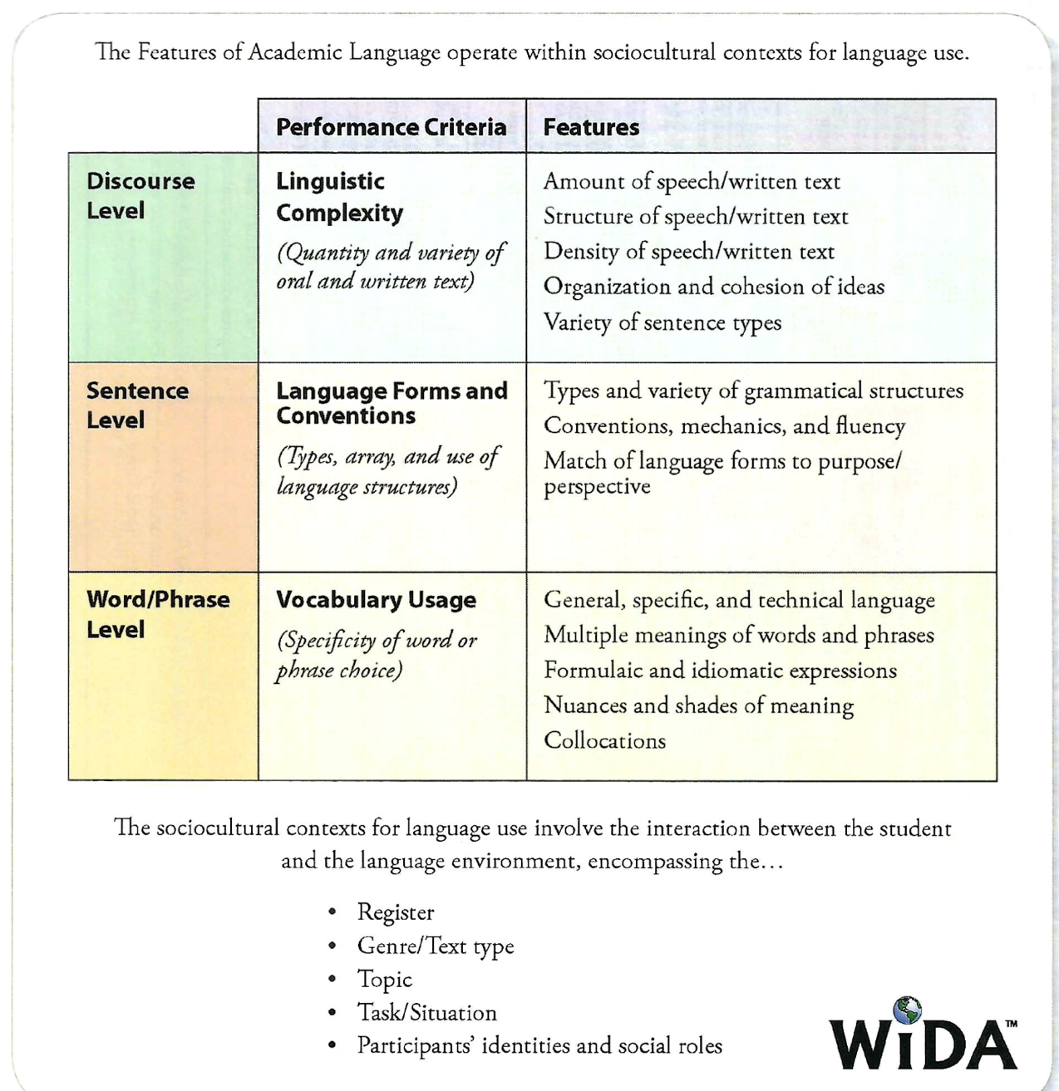

Receptive Language
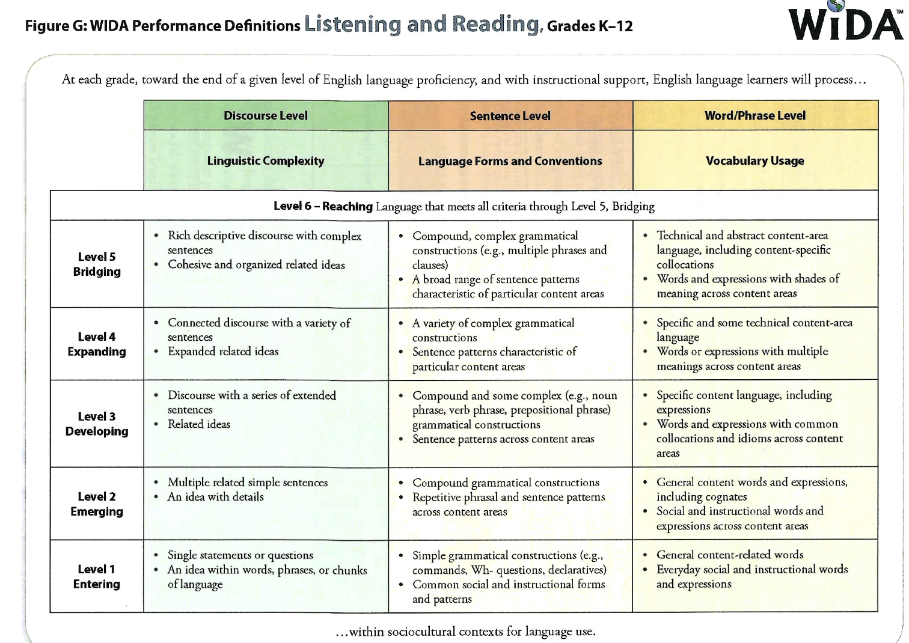

Productive Language
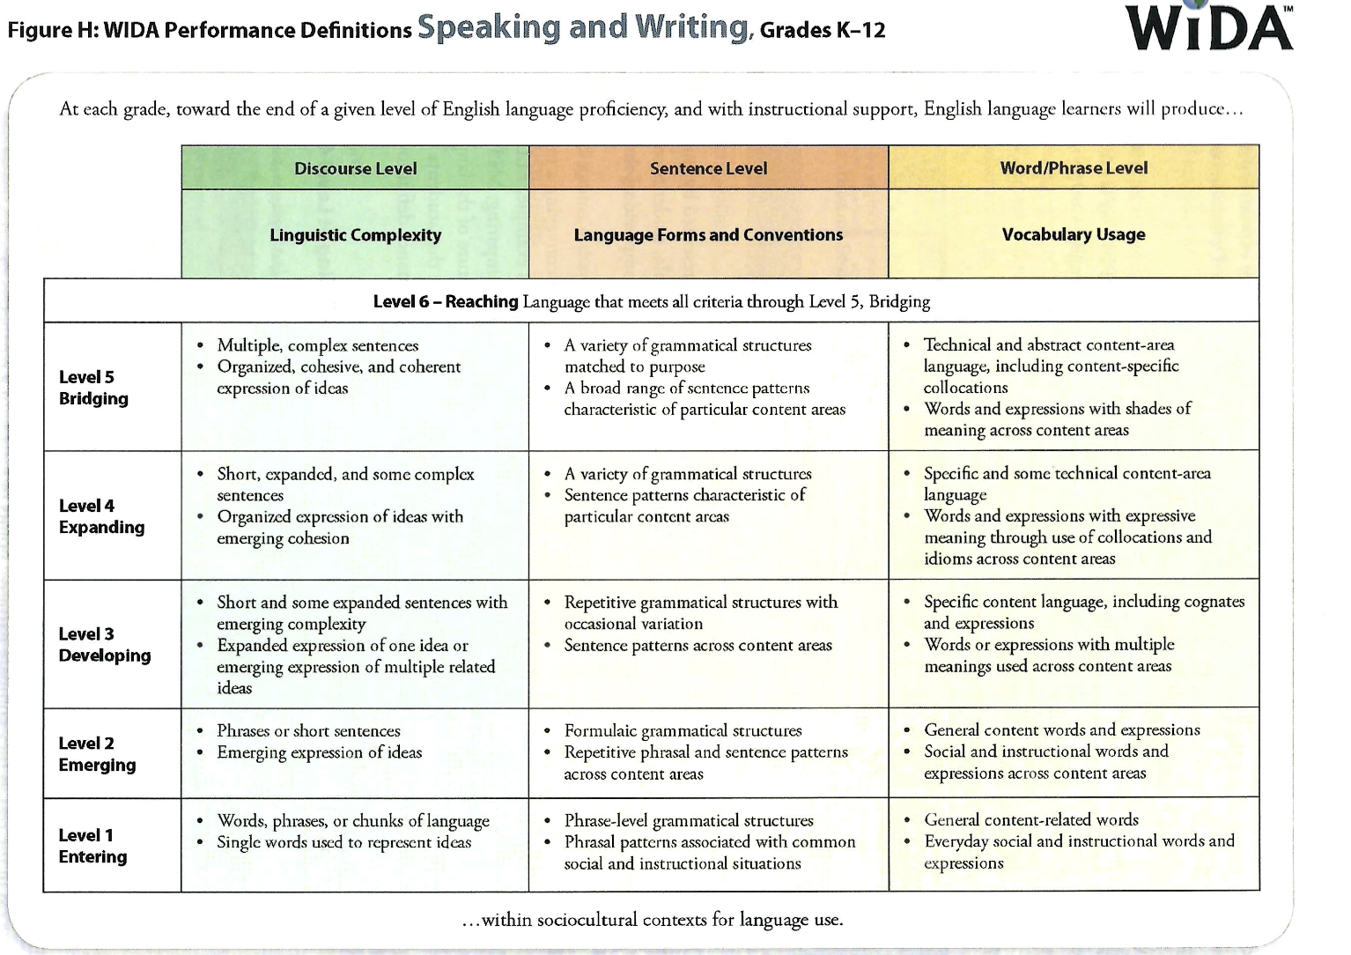

Characteristics of Effective Use of Data Collection Using the CAN Dos*
(Formative Assessment of Language Proficiency)

Characteristic | Not there yet  Create Goals | In Progress  Evaluate Goals | Met  Provide Evidence | Notes
The use of sensory, graphic, and interactive supports is present when collecting data for students at levels 1, 2 and 3.

Data is collected at the beginning of the school year (baseline) and again at least twice more (each semester or quarterly).

The formative assessment data is used to compare with students’ ELPAC scores.

The data is used to determine the student’s strengths in each language as well as challenges. Use this information to create instructional plans.

Student language proficiency levels are used to plan differentiated instruction.

When developmentally appropriate, have students self-assess their language proficiency in each language and help them establish language goals for the year, which are then revisited periodically

Vertical Alignment: Meet with the teachers of the next grade and share some of the trends you have found with your student CAN Dos. Share additional information as needed for each student (newcomers, interrupted schooling, possible learning challenges, etc.).

Integrate the CAN Dos into parent/teacher conferences.

* Data collection is measurable and evidence based. It should include assessing students while using high leverage biliteracy strategies (concept attainment, LEA, ART, fishbowl) through observations, checklists, etc.. For productive language, writing samples can be used as well as data of students reading.

