
Center for Teaching for Biliteracy
www.TeachingForBiliteracy.com

Teaching for Biliteracy
Summer Institute

Grandview, WA
June 23-25, 2026

Presenters | Contact Information
Karen Beeman | teachingforbiliteracyKB@gmail.com
Dana Baum Hardt | teachingforbiliteracyDH@gmail.com
Crystal Ramos | teachingforbiliteracyCR@gmail.com
Melody Wharton | teachingforbiliteracyMW@gmail.com

Institute Outcomes:

- Describe the goals of dual language programs, including why districts have dual language programs, who they benefit, and how the goals of the program will be met (i.e., vision and pedagogy statement).
- Describe the students in language acquisition and biliteracy programs in the US and how the language acquisition program meets the needs of all of its students.
- Experience and explain how biliteracy instruction and the learning environment reflect best practices for developing bilinguals.
- Identify and describe high leverage biliteracy strategies to use during instruction in any language.
- Describe how language development supports (sensory, graphic, and interactive) engage all learners and are included during instruction in each program language.
- Describe biliteracy, the Biliteracy Unit Framework (BUF) and its characteristics, including that a unit is taught in one language, it integrates language, literacy and content, and includes the Bridge at the end of the unit, which has two purposes.
- Explain how teacher language use impacts student language use, and the importance therefore of the teacher using language strategically.
- Summarize how programmatic systems and structures support effective biliteracy instruction and ensure instructional equity.
- Identify short-and-long term goals that support the implementation of effective biliteracy instruction.

Center for Teaching for Biliteracy Resources and Links
Handouts and Presentation Slides on Teaching for Biliteracy Website | https://www.teachingforbiliteracy.com/handouts  
Center for Teaching for Biliteracy Reference List | https://bit.ly/4aepEbX  
Biliteracy Strategies Glossary | https://bit.ly/BSI2024InstructionalStrategies  
Three Linguistic Spaces | https://bit.ly/ThreeLinguisticSpaces  
Supporting Newcomers | https://bit.ly/T4BNewcomers  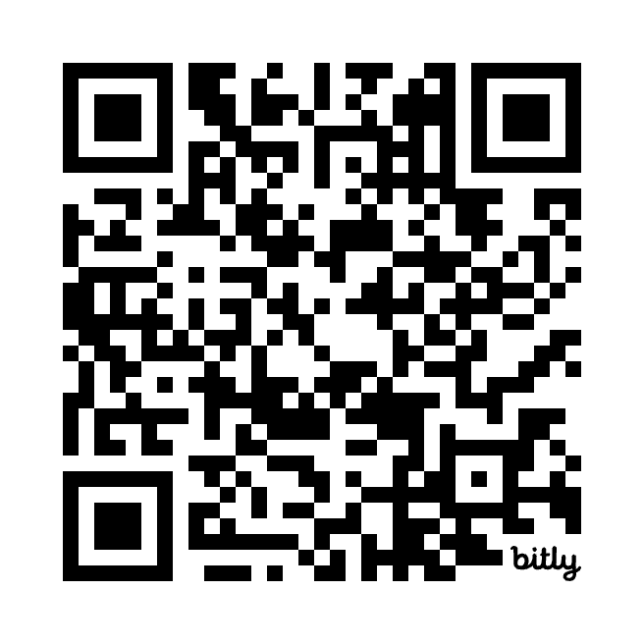
A Systems Approach to Teaching for Biliteracy:  Digital Tools | Splash Page https://bit.ly/T4BHandbook  
Final Session Evaluation Form | bit.ly/3QtcW4Q  

Publication Date  and Author | Additional Resources and Links
2018  Michael D. Guerrero and Joan R. Lachance | National Dual Language Education Teacher Preparation Standards  https://bit.ly/DLTeacherStandards  
February 2022  Kathy Escamilla, Laurie Olsen, and Jody Slavic | Toward Comprehensive Effective Literacy Policy and Instruction for English Learner/Emergent Bilingual Students  https://rb.gy/v149xq  
March 7, 2022  Claude Goldenberg et al. | A response to “Toward Comprehensive Effective Literacy Policy and Instruction for English Learner/Emergent Bilingual Students” by The National Committee on Effective Literacy (NCEL)  https://bit.ly/GoldenbergResponse2022  
May 24, 2023  Kari Kurto | Clarifying the Science of Reading  https://bit.ly/ClarifyingSOR  
October 2023  Published by the Reading League | The Reading League Joint Statement  https://bit.ly/TRLJointStatement  

Teaching for Biliteracy Summer Institute Overview

Tuesday, June 23, 2026 | Wednesday, June 24, 2026 | Thursday, June 25, 2026
7:30 - 8:30 AM  Arrival, registration, materials pick-up, and hot breakfast buffet | 7:30 – 8:30 AM  Arrival, sign-in, and hot breakfast buffet | 7:30 – 8:30 AM  Arrival, sign-in, and hot breakfast buffet
8:30 - 11:45 AM  Whole Group  - Institute Welcome and Introductions  - Students and Goals of Biliteracy Programs  - The Biliteracy Unit Framework (BUF) | 8:30 - 11:45 AM  Whole Group  - Debrief Sample Instruction  - The Multilingual Perspective  - Strategic Use of Teacher Language: Language Policy  - Research on Dual Language Programs  - Planning for Sustainability: Vision and Pedagogy documents | 8:30 - 10:15 AM  Whole Group  - Biliteracy Assessment  - Planning for Sustainability: Effective Systems and Structures  10:30 AM – 12:00 PM  Breakout Groups (Same as Days 1 & 2)  - Sample Instruction Part 3: The Bridge  - Institute Closure
Lunch 11:45 AM to 12:30 PM | Lunch 11:45 AM to 12:30 PM | 12:00 pm  Boxed Lunch and Dismissal
12:30 - 3:30 PM  Breakout Groups (by grade bands: PK-2nd grade; 3rd-5th grade; secondary: 6th – 12th grade)  - Sample Instruction Part 1: Oracy Instruction in preparation for content inquiry and literacy | 12:30 - 3:30 PM  Breakout Groups (same as Day 1)  - Sample Instruction Part 2: Content, Literacy (reading and writing), and the Summative Assessment

Goals of Dual Language Education
Goal | What it means | What it looks like in action
Pillar 1:
Bilingualism and Biliteracy
Pillar 2:
Grade-level Academic Achievement
Pillar 3:
Sociocultural Competence
(a term encompassing identity development, cross-cultural competence, and multicultural appreciation)
Guiding Principles for Dual Language Education (Howard et al., 2018; p. 3)

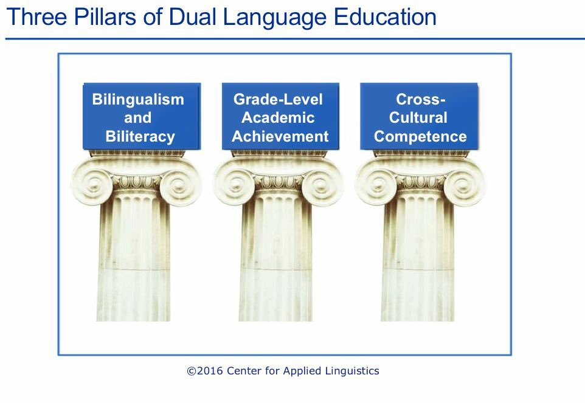
The Goal of Dual Language Programs

“…the term dual language refers to any program that provides literacy and content instruction to all students through two languages and that promotes bilingualism and biliteracy, grade-level academic achievement, and sociocultural competence
– a term encompassing identity development, cross-cultural competence, and multicultural appreciation – for all students.”

Guiding Principles for Dual Language Education, Third Edition

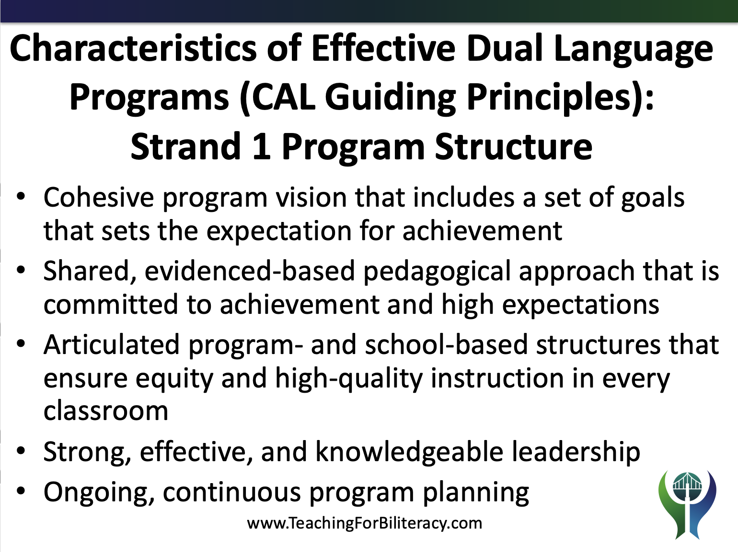

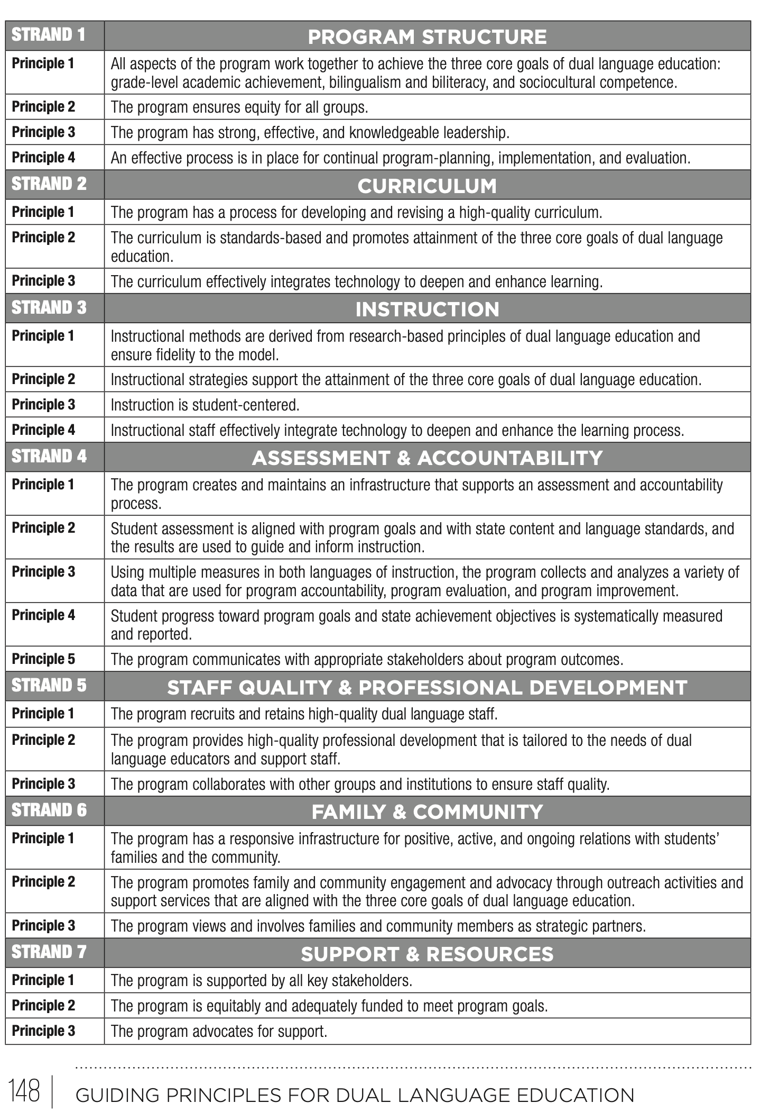

Students in Language Acquisition and Biliteracy Programs

Green students – Students who enter the program with linguistic resources all in the non-English Dual Language program language.
- These students enter the program as ELs
- These students are typically sequential bilinguals

Orange students – Students who enter the program with linguistic resources in a language other than the Dual Language program languages.
- These students are typically sequential bilinguals but can enter as simultaneous bilinguals.
- These students qualify for EL services

Blue-green students – Students who enter the program with linguistic resources in both program languages.
- These students may or may not qualify as ELs
- These students are typically simultaneous bilinguals

Blue students – Students who enter the program with linguistic resources all in English.
- In dual language programs, these students are sequential bilinguals

One and Two – Teacher Models
- Both types of models (1 and 2 Teacher) can be used with 80/20 and 50/50 programs
- Schools and districts may choose to use both 1 and 2 teacher model

Type of Model | Pros | Cons
One Teacher Model (One teacher teaches both languages) | Teachers get to know students across both their languages  Time can be more flexible | It may be harder for the teacher to stay in the target language  It may be harder for the students to stay in the target language
Two Teacher Model  (One teacher teaches English and another teacher teaches Spanish to the same students) | Spanish time is protected by place, time, and person  When collaboration works well, it is powerful! | It is harder for teachers to get to know students across both languages  When collaboration is not effective, it is challenging for all.

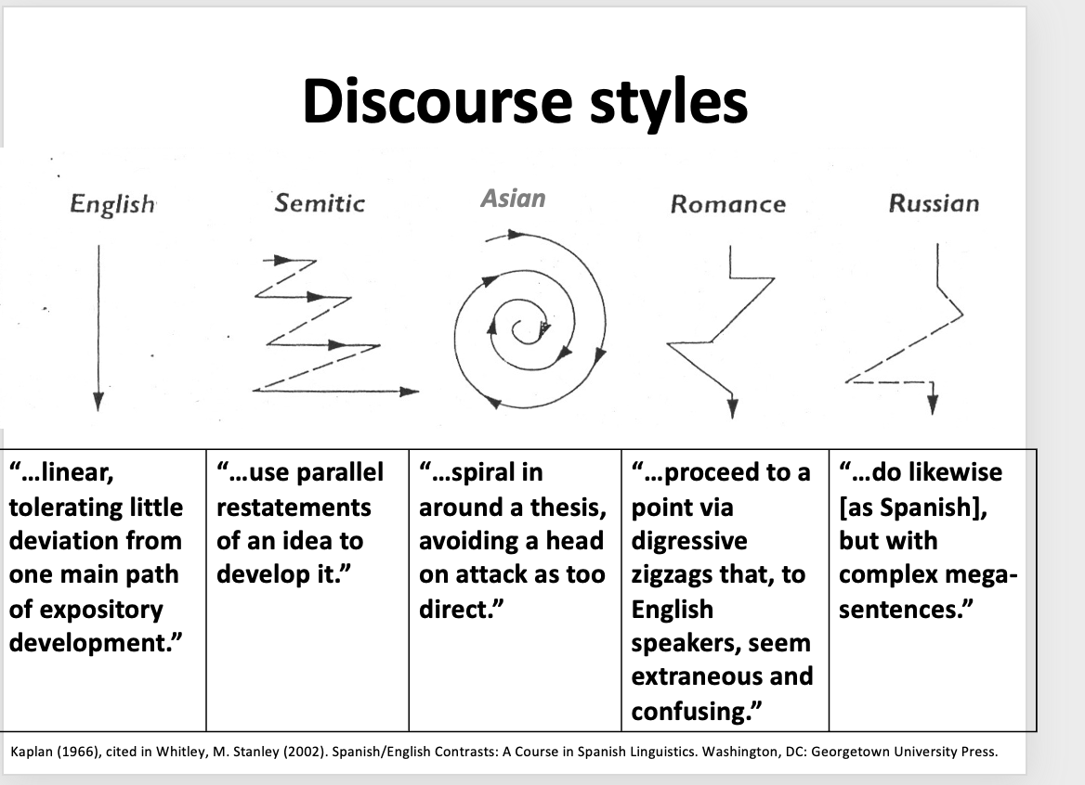
(Montaño-Harmon, 1991, Sáez, 2003, Butvilofsky et al, 2023)

Language Allocation
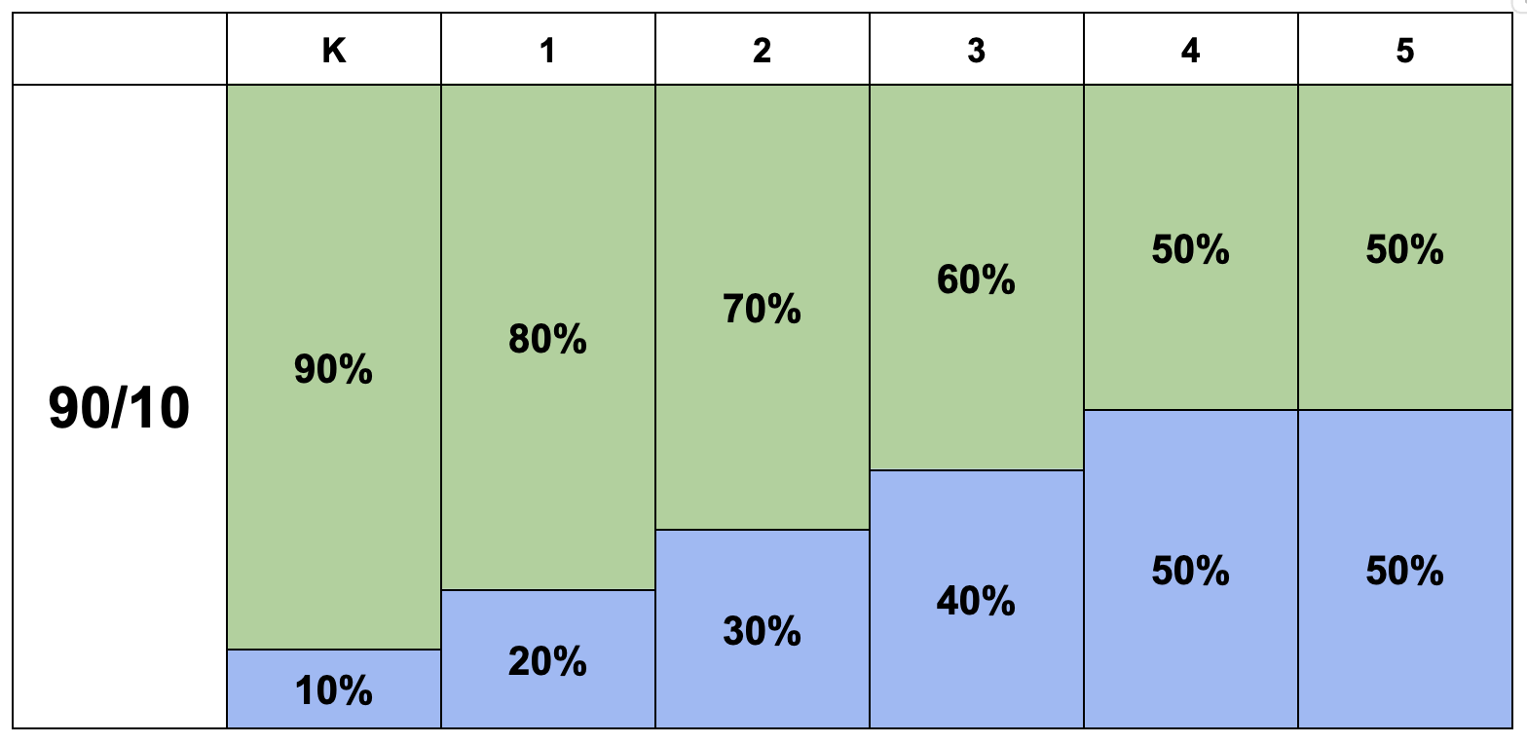

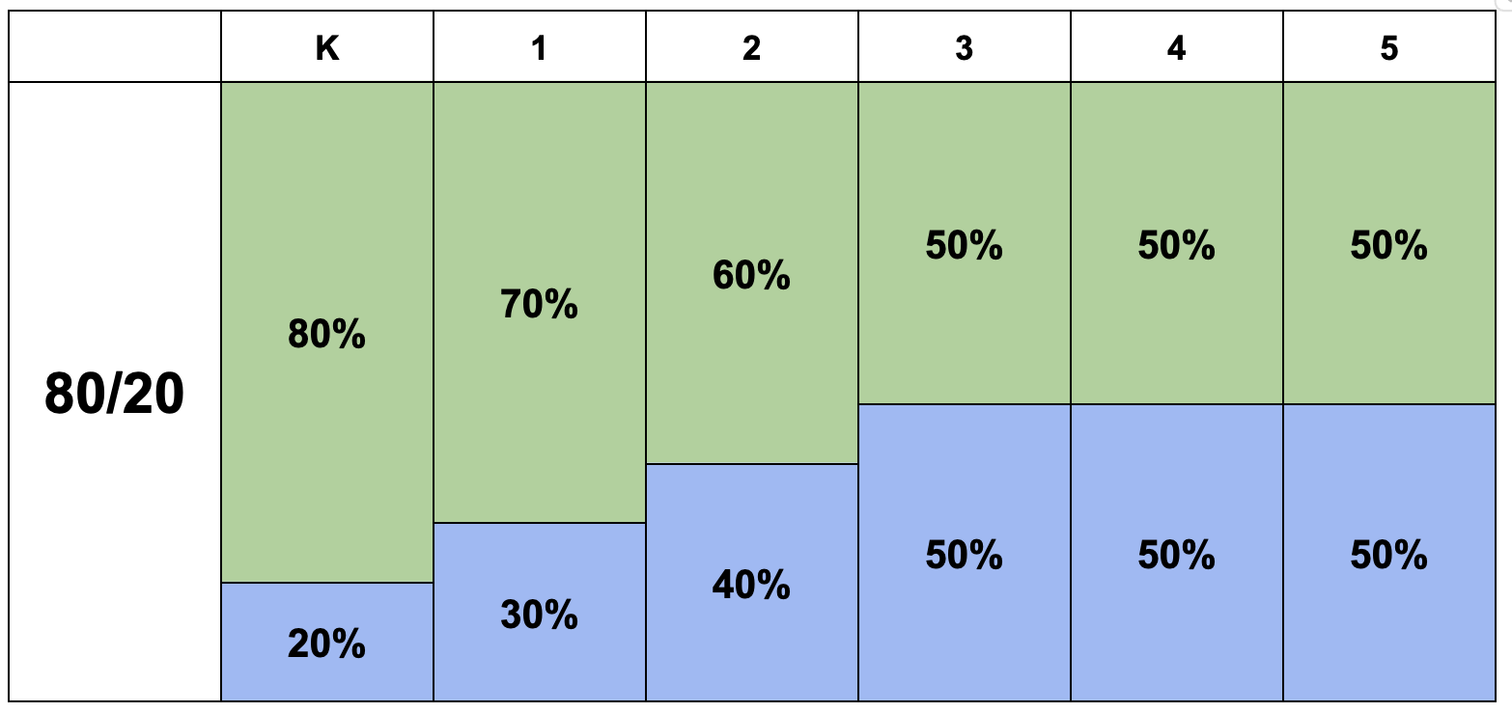

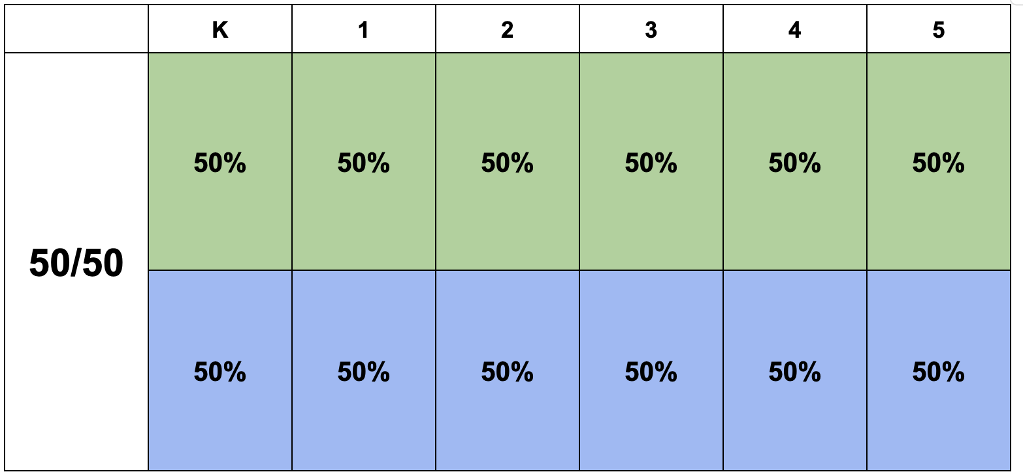

Literacy and Biliteracy - Agree- Disagree Chart

Statement | Agree or Disagree
- Phonics instruction is the most important element in teaching students how to read in K-2.
- Daily instruction in Spanish and English (without teaching the same topic) is an effective way of developing biliteracy in all students.
- Without language comprehension, students cannot have reading comprehension.
- Oral language and background knowledge are good for students to know, but not necessary since they’re not directly related to comprehension
- Language learners learn how to read and write more effectively when the unit is all related around a meaningful theme, allowing the language to be repeated and deepened, and knowledge to be developed, as the unit progresses.

- When students do not understand the text they are reading, the teacher should read the text in the other language to support comprehension.
- Word recognition is an essential component of reading comprehension, but not the only component.
- Teaching phonics only in English in K -1, and reading, writing and word recognition (phonics) in Spanish K-1 is a feasible path to biliteracy.
- Students should be familiar with the meaning of the words and examples used to learn foundational skills (or word recognition).
- Siloing literacy instruction (i.e., teaching foundational skills separate from reading, separate from writing) organizes literacy well for dual language students.
- Oracy and background knowledge are crucial elements in reading comprehension.
- Reading, writing, and foundational skills should be taught within a theme that connects all literacy activities. This is a feasible path to biliteracy when practiced in each program language.

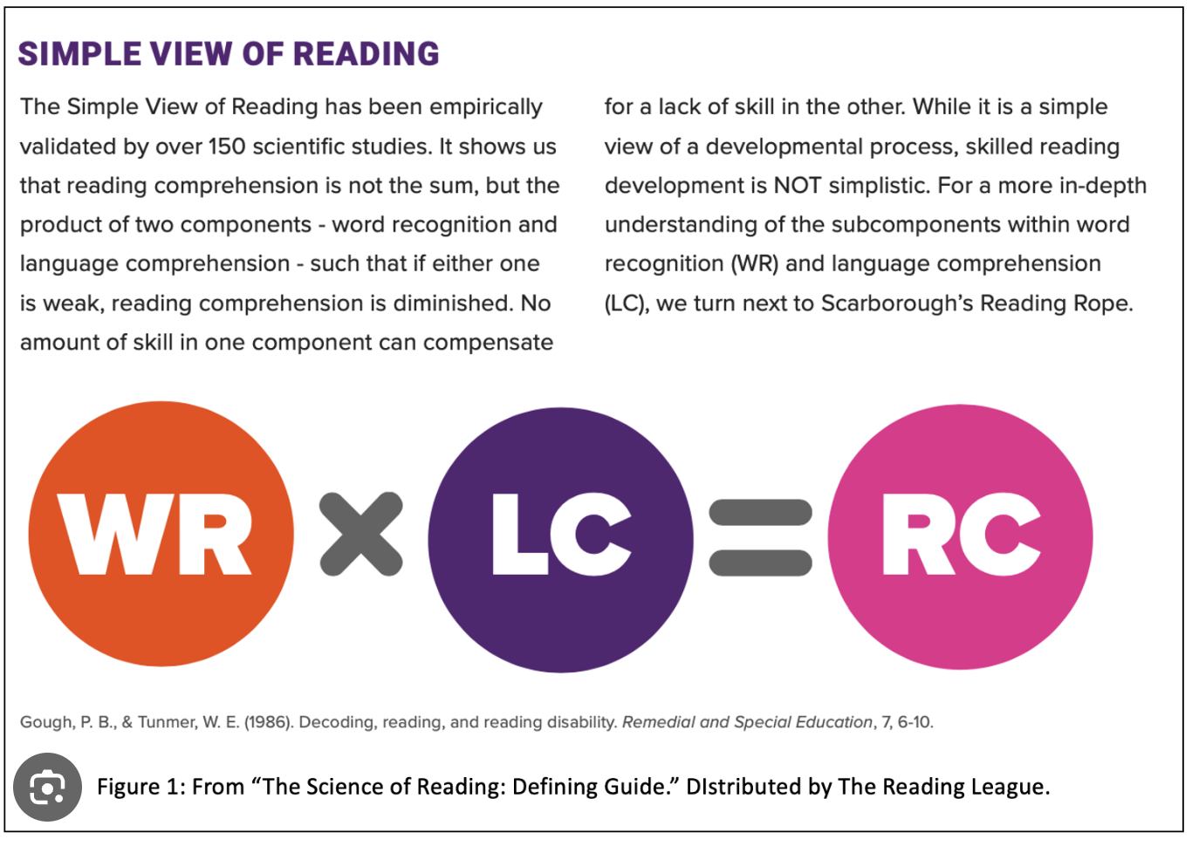

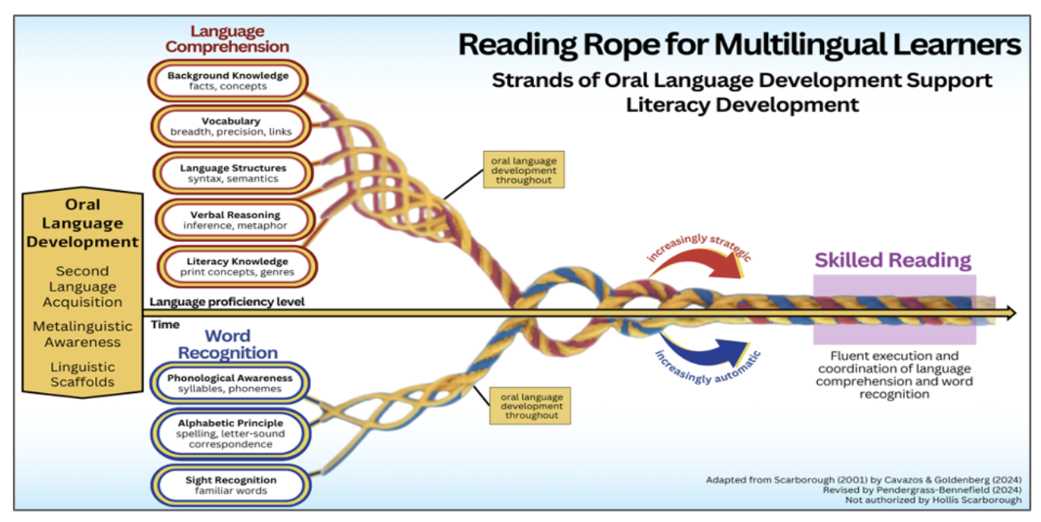
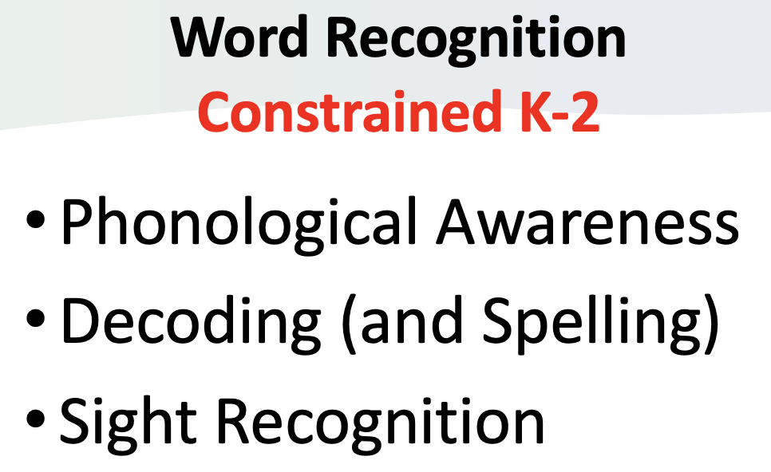 | 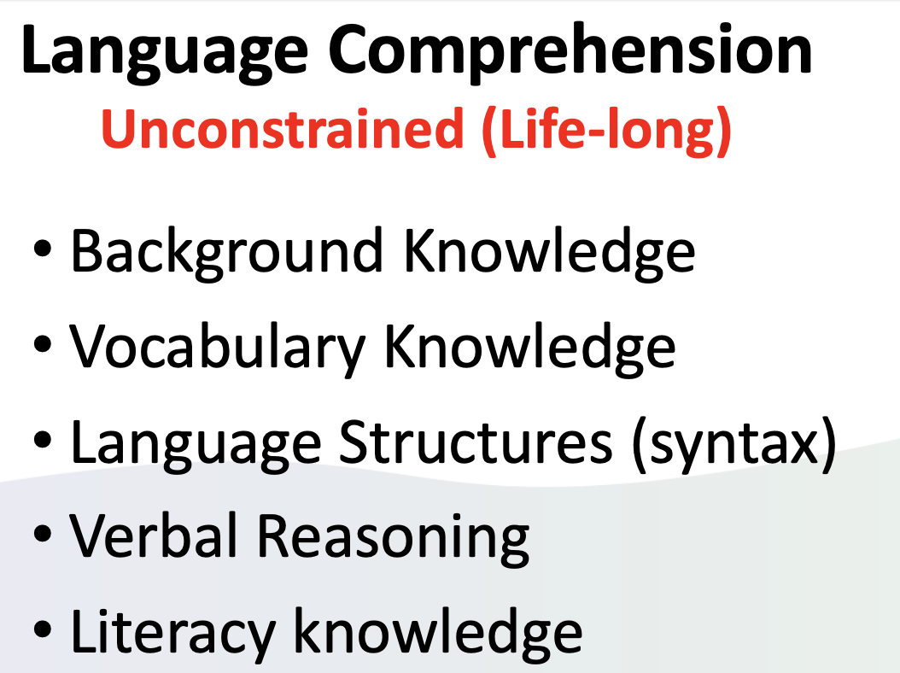

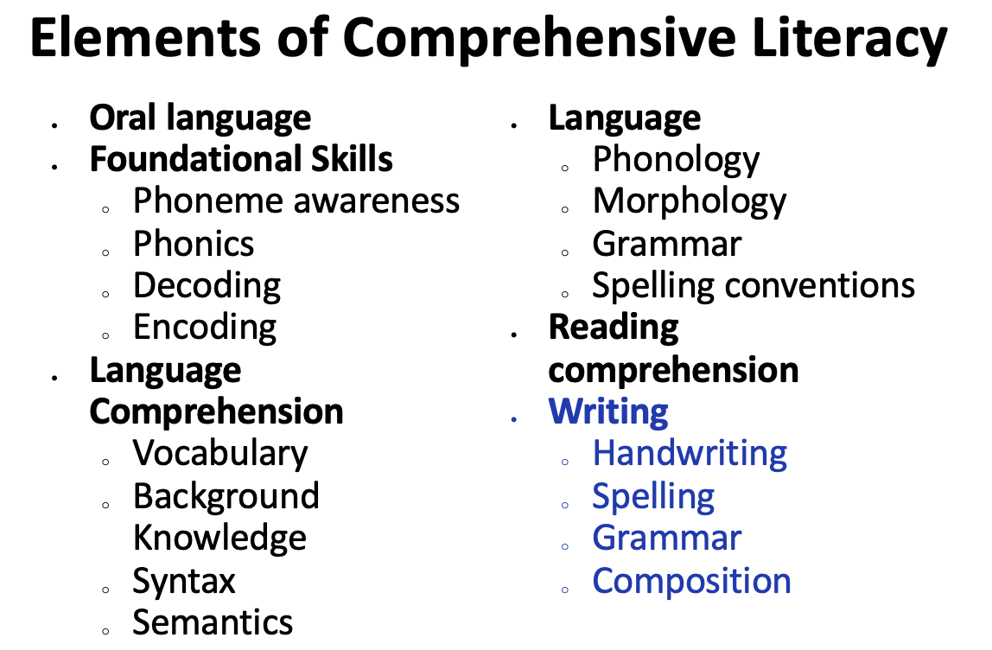

Sally

Sally first tried setting loose a team of gophers. The plan backfired when a dog chased them away. She then entertained a group of teenagers and was delighted when they brought their motorcycles. Unfortunately, she failed to find a Peeping Tom listed in the Yellow Pages. Furthermore, her stereo system was not loud enough. The crab grass might have worked but she didn’t have a fan that was sufficiently powerful. The obscene phone calls gave her hope until the number was changed. She thought about calling a door-to-door salesman but decided to hang up a clothesline instead. It was the installation of blinking neon lights across the street that did the trick. She eventually framed the ad from the classified section.
Biliteracy Unit Framework (BUF) updated, second edition
Interdisciplinary Unit – Language, Literacy, and Content taught in Spanish
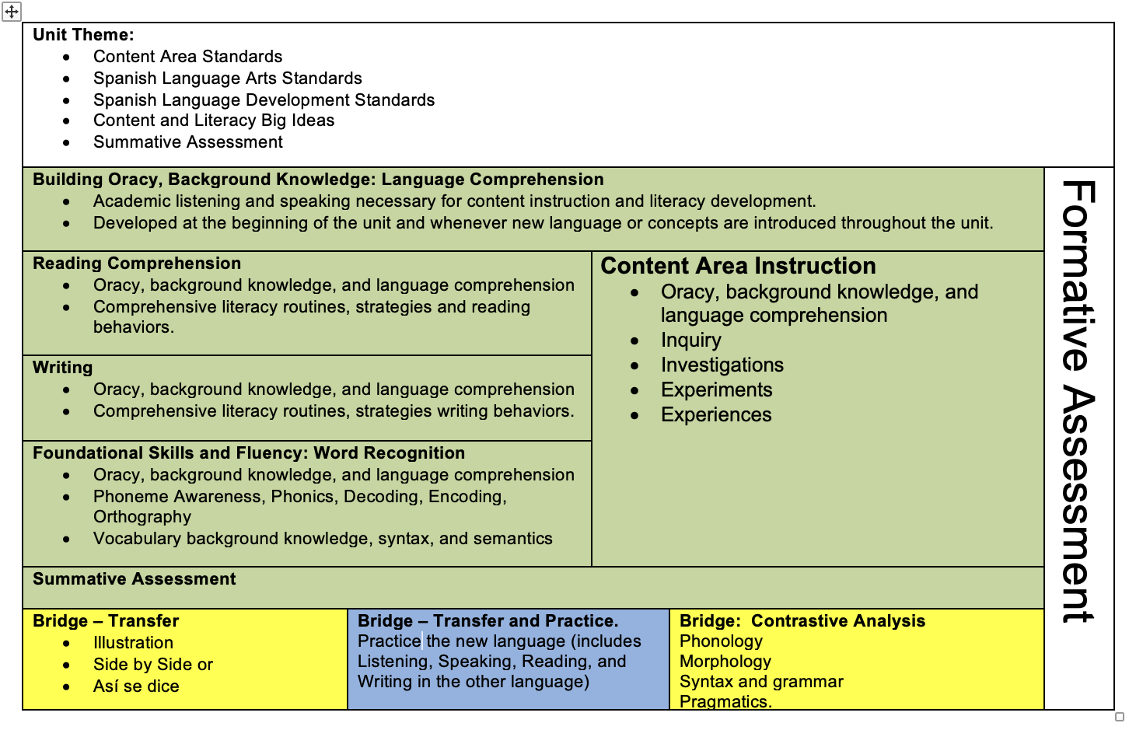
Biliteracy Unit Framework (BUF) updated, second edition
Interdisciplinary Unit – Language, Literacy, and Content taught in English
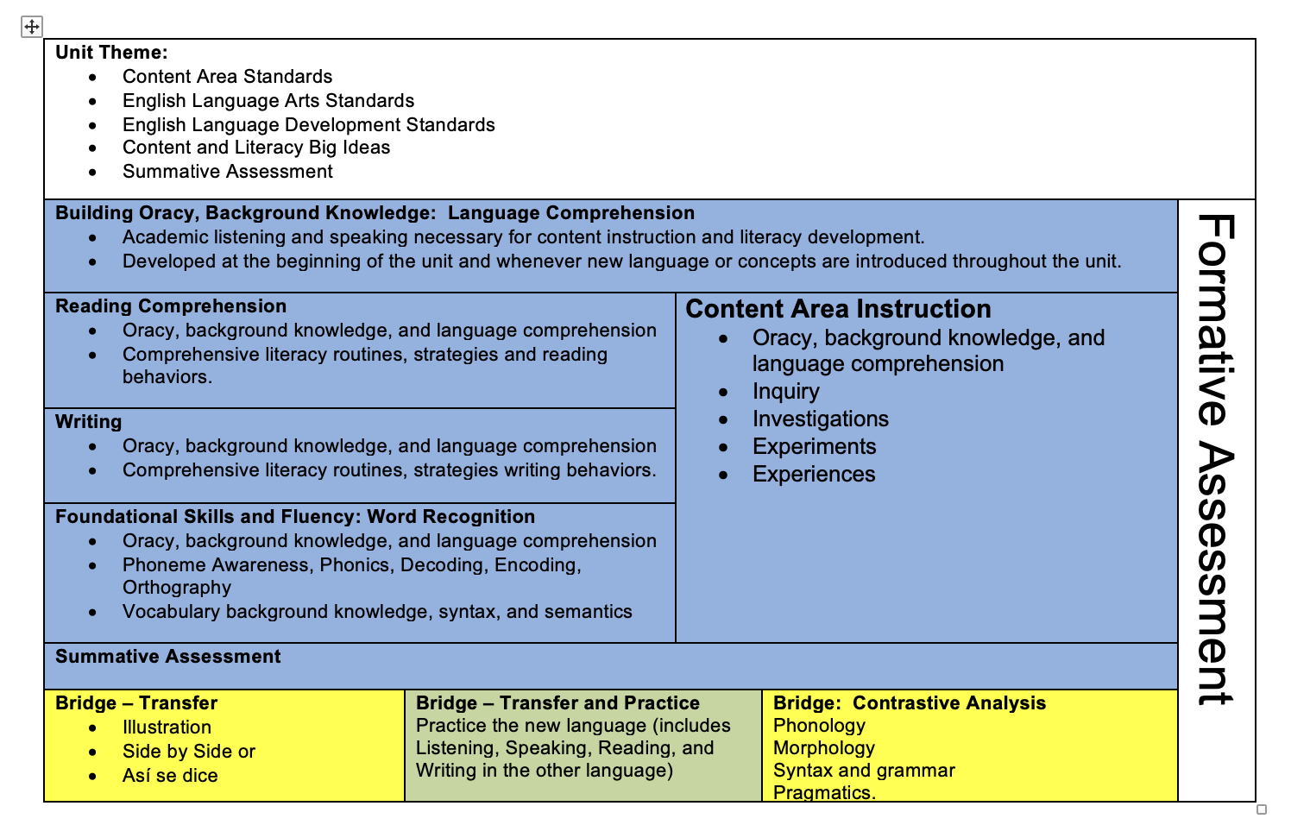

Setting up the Biliteracy Learning Environment

- Each language has its own dedicated space (relevant only to a 1 teacher model)
- Every Biliteracy classroom includes the Bridge
- Teachers use different colors for each language
- Teachers visually indicate the language of instruction

One Teacher Model | Two Teacher Model – Spanish | Two Teacher Model – English
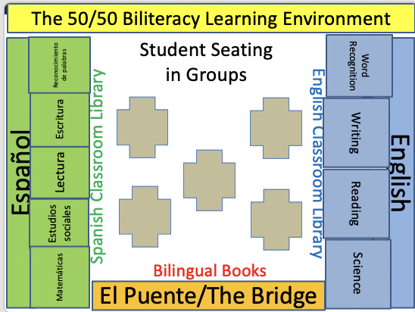 | 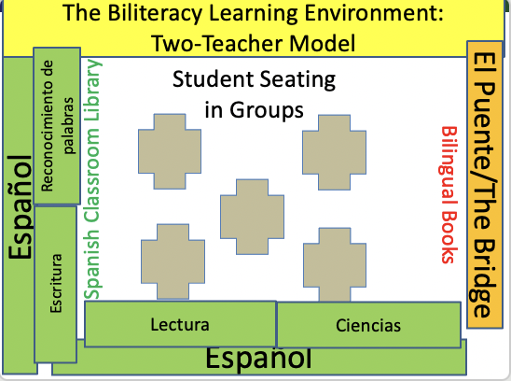 | 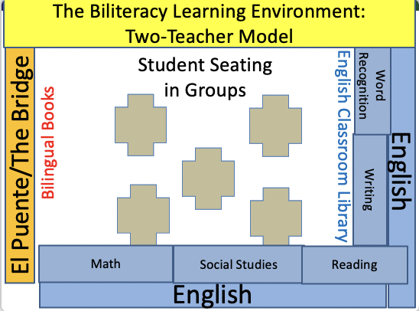

The Biliteracy Learning Environment:
Three Linguistic Spaces
(For 1 Teacher Model and 2 Teacher Model)

Spanish | The Bridge | English
- Teacher maintains Spanish  - Students maintain Spanish (teacher scaffolds with language learning supports)  - Materials, instruction and assessments are in Spanish  - Literacy instruction is in Spanish  - Content in Spanish (Science, Social Science, and/or Math – following the Language and Content Allocation Plan) | - Planned moment at the end of a unit (and after summative assessment) when the teacher brings the two languages together for transfer and contrastive analysis.  - Bridging is when teachers guide students in making cross-linguistic connections in each language, during the unit of instruction using contrastive analysis (AKA cross-linguistic connection) charts created during the Bridge or created during the unit. | - Teacher maintains English  - Students maintain English (teacher scaffolds with language learning supports)  - Materials, instruction and assessments are in English  - Literacy instruction is in English  - Content in English all year (Science, Social Science, and/or Math – following the Language and Content Allocation Plan)  - For newcomers (Spanish speakers new to English in grades 2 and up), mediated and personalized use of Spanish.
Characteristics of Biliteracy Instruction
Engages all students actively and meaningfully using a variety of high-leverage strategies and language supports. | Intentionally builds oracy (listening and speaking) and background knowledge in preparation for literacy (reading and writing) and content instruction throughout the unit.
Includes a meaningful frame for learning: integrating content or a universal theme with language development and literacy instruction. | Strategically plans for the  three linguistic spaces:  Spanish, the Bridge, and English
Program Design Recommendations: Planning for Biliteracy

Biliteracy Recommendations for Pre-K:
- Biliteracy PreK classrooms are developmentally appropriate PreK classrooms (Developmentally Appropriate Practice, NAEYC Position Statement Adopted April 2020)
- Students are provided integrated, engaging learning experiences in each language every day that they are in class. These experiences are part of a knowledge-rich curriculum where students make meaningful connections across developmental domains and subject areas.
- Teachers and other adults engage students in each program language at different times of the day. This is called language and content allocation.
- Students are together for differentiated, but not separate, instruction.
- Instruction is facilitated strategically in one language by the teacher, and all materials are in that language. Classroom instruction includes a variety of supports, high leverage strategies, and the development of oral language and background knowledge that promotes student comprehension and production.

Biliteracy Recommendations for K-5:
- All students receive literacy (language arts) instruction in each program language every day, beginning when they enter the program (TK/PK/Kindergarten). Each language arts class is contextualized around a meaningful theme or topic in which all components of literacy are taught and addressed as interconnected practices that support each other.
  - It is highly recommended that each literacy class cover different standards and themes or topics to reduce redundancy and optimize transfer.
- Students are together for differentiated, but not separate, instruction, ensuring all students are present during Tier 1 instruction.
- In Pre-K – 5th grades, whenever possible, content and literacy are integrated.
- If possible, each content area (math, science, social studies) is taught in one language only at each grade level. This is called content allocation.
- Instruction is facilitated strategically in one language by the teacher, and all materials are in that language. Classroom instruction includes a variety of supports, high leverage strategies, and the development of oral language and background knowledge that promotes student comprehension and production.

Biliteracy Recommendations for Secondary:
- Students take both an English Language Arts and a Spanish language arts class every quarter/semester. Each language arts class is contextualized around a meaningful theme or topic in which all components of literacy are taught and addressed as interconnected practices that support each other.
  - It is highly recommended that each literacy class cover different standards and themes or topics to reduce redundancy and optimize transfer.
- Content is taught in one language only at each grade level while literacy is shared between both languages. This is called content allocation.
- Students have access to the same electives and services that are available to all other students in the school.
- All teachers of dual language students, whether in English and Spanish, consider themselves biliteracy/dual language teachers.
- Instruction is facilitated strategically in one language by the teacher, and all materials are in that language. Classroom instruction includes a variety of supports, high leverage strategies, and the development of oral language and background knowledge that promotes student comprehension and production.

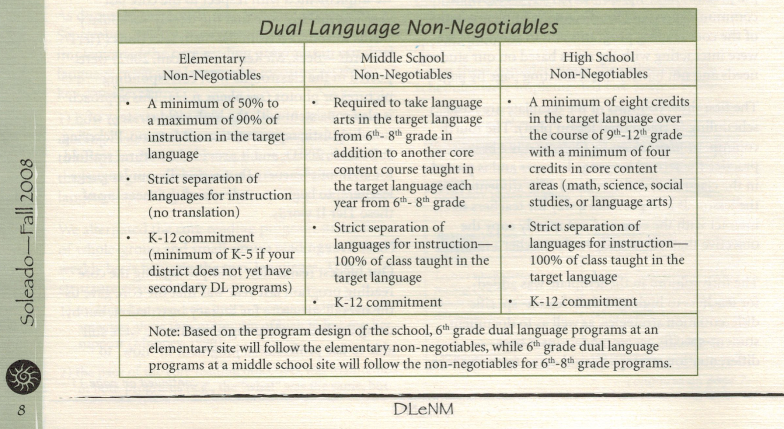

At the secondary level (middle and high school), biliteracy is typically organized by number of courses. In middle school, along with English Language Arts and content courses in English, students also take 2 courses in the non-English language: one Language Arts class in the non-English language and one content area in the non-English language.

At the high school level, biliteracy is often organized around credit hours - a minimum of 8 in the non-English language. And, while the dual language students may be together for the Spanish medium classes, they may or may not be together for the English medium classes, depending on the size of the dual language program and the size of the secondary school.
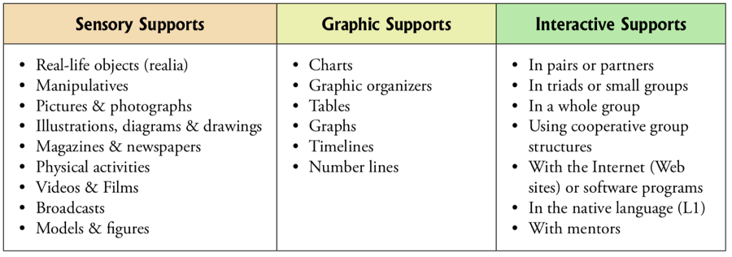
© WIDA Language Development Standards
Comparison of the Monolingual and Multilingual Perspectives
Area | Monolingual Perspective | Multilingual Perspective
Perspective of Student Language Ability | Students have a dominant language (or L1, first language). | All students have an L1. For many students, their L1 is bilingual. All students become developing bilinguals as they engage in biliteracy.
Perspective of Student Language Ability | When students make linguistic approximations (puchar; planching) it is a sign of confusion or that they have gaps in their language development. | Students are expected to use language like developing bilinguals. Instruction anticipates and prepares for linguistic approximations.
Perspective of Student Language Ability | Students are expected to produce “monolingual-like Spanish”, especially if they come from a Spanish speaking family. | Students are expected to make linguistic approximations, and classroom instruction strategically moves students from informal to formal language.
Programmatic Structure  Curriculum, Instruction and Assessment | Students receive literacy instruction in their L1. L2 literacy instruction occurs once monoliteracy has been established. | Students receive robust literacy instruction in BOTH languages from the moment they enter the program.
 | Literacy instruction in each language looks like monolingual instruction. For example, during English literacy instruction, the biliteracy students are taught the same way and follow the same units of instruction as the monolingual classrooms. The same occurs in Spanish. | Units that integrate language, literacy and content are used in each language. Instruction in each language occurs within a meaningful frame where language acquisition strategies and language supports (sensory, graphic, and interactive) are used consistently, in both English and Spanish.
 | Programs teach literacy in one language (L1) and transition once monoliteracy has been established. (Sequential literacy) | Programs teach literacy in 2 languages daily from Kinder on and help students transfer what they know in 1 language to the other and vice-versa (Simultaneous literacy).
 | Only some components of comprehensive literacy are taught in one or both program languages (i.e., only phonics). Or reading is taught in English, and writing is taught in Spanish. | All the components of comprehensive literacy (oracy, background knowledge, reading, writing, and foundational skills) are taught in each of the program languages.
 | It is expected that bilingual/dual language schedules and curriculum look like those in the general education (monolingual) program. | Bilingual/dual language schedules and curriculum intentionally look different than those in the general education (monolingual) program.
 | Assessment is conducted in one language only and data typically focuses on academic achievement. | Assessment is conducted in each language so that students are looked at holistically across their 2 languages. Data is collected for language development and academic achievement in each language.
Beeman, K. and Urow, C. (2013). Teaching for Biliteracy: Strengthening Bridges between Languages. Brookes Publishing: Baltimore, MD.
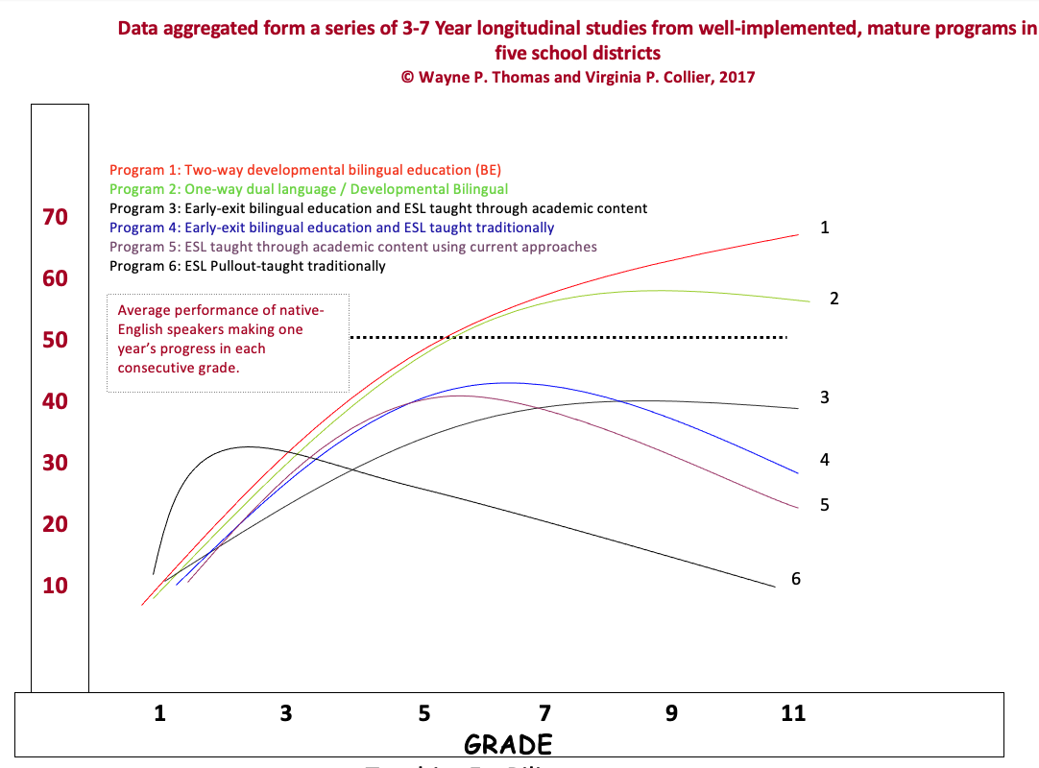

Sample B: Content and Language Allocation – Middle School
Grade | Spanish Medium Courses | English Medium Courses
6 | Spanish Language Arts  - Honors or AP Spanish  - Regular Spanish  Science - Variety of levels and areas of focus | English language arts:  - Honors English  - Regular English  - Literacy Based ESL (for newcomers)  Math – Variety of levels and areas of focus  Social Studies – Variety of levels and areas of focus  Specials and electives
7 | Spanish Language Arts  - Honors or AP Spanish  - Regular Spanish  Social Studies - Variety of levels and areas of focus | English language arts:  - Honors English  - Regular English  - Literacy Based ESL (for newcomers)  Math – Variety of levels and areas of focus  Science – Variety of levels and areas of focus  Specials and electives
8 | Spanish Language Arts  - Honors or AP Spanish  - Regular Spanish  Science - Variety of levels and areas of focus | English language arts:  - Honors English  - Regular English  - Literacy Based ESL (for newcomers)  Math – Variety of levels and areas of focus  Social Studies – Variety of levels and areas of focus  Specials and electives

80/20 Content Allocation: Planning Content in Spanish and English K- 5
Note: For additional 80/20 K-5 examples go to www.teachingforbiliteracy.com/systems/infrastructuresupports

Sample: 80/20 Model
Math and Social Studies move to English in grade 3. Science remains in Spanish, K-5.

 | Spanish | Bridge | English
Kindergarten  80/20 | 80%  Language Arts  Science  Social Studies  Math | K (end of every unit):  Spanish to English:  - Language Arts  - Science  - Social Studies  - Math  1 and 2 (end of every unit):  Spanish to English:  - Language Arts/ Science  - Math  English to Spanish:  - Language Arts/Social Studies  3rd -5th Grade: (end of every unit)  Spanish to English:  - Language Arts/Science  English to Spanish:  - Language Arts/Social Studies  - Math | 20%  Language Arts using a universal theme
First Grade  70/30 | 70%  Language Arts  Science  Math |  | 30%  Language Arts  Social Studies
Second Grade  60/40 | 60%  Language Arts  Science  Math |  | 40%  Language Arts  Social Studies
Third Grade  50/50 | 50%  Language Arts  Science |  | 50%  Language Arts  Social Studies  Math
Fourth Grade  50/50 | 50%  Language Arts  Science |  | 50%  Language Arts  Math  Social Studies
Fifth Grade  50/50 | 50%  Language Arts  Science |  | 50%  Language Arts  Math  Social Studies

Advantages | Considerations
True for all 80/20 Options:  - It is more likely that all students will achieve higher levels of Spanish achievement in 80/20 models because of the potential for developing stronger oracy and literacy in Spanish for all students.  - The value of Spanish is elevated because of more Spanish in K-2, resulting in more respect towards the language and a stronger desire to study in it. For this reason, there may be more potential for deeper cross-cultural understanding on the part of the students as well as higher academic achievement.  This sample is perhaps the easiest model to implement, from a staffing and organizational point of view.  Keeping Social Studies in English in grades 3-5 will optimize materials in English. Attention to background knowledge on the part of ELs will continue to be very important in social studies at those grades.  Because English and Spanish share academic language in science, as long as the Bridge is occurring at the end of each unit, students will be able to demonstrate in English what they learned in science in Spanish.  Since Math is in English in grade 3-5, there will be more time for Spanish language arts. | True for all 80/20 Options:  - For two-way, dual language programs, 80/20 models can be harder to sell politically. Staff members must be trained in understanding why more Spanish in the earlier grades is better for all students and will result in higher levels of biliteracy.  - Though materials exist to deliver content in Spanish, training for teachers on Spanish literacy will be an important priority. A concerted effort to train teachers on how to teach literacy in Spanish as opposed to how to teach in English will be necessary.  Given that in grades 3-5 there is less time for language arts in English since Math is taught in English, language arts and social studies will have to be tightly integrated. While this is pedagogically good, it requires in depth planning.  Doing the Bridge at the end of every unit will be crucial to the success of this option since Science is taught only in Spanish and SS in English, 1-5.

50/50 Content Allocation: Planning Content in Spanish and English Elementary School K-5
Note: For additional 50/50 K-5 examples go to www.teachingforbiliteracy.com/systems/infrastructuresupports

Sample: 50/50 Model: Switch subjects to the other language after three years (at third grade).
 | Spanish | Bridge | English
Kindergarten | Language Arts  Social Studies | Spanish to English (end of every unit):  - Language Arts/ Social Studies  English to Spanish (end of every unit):  - Language Arts/Science  - Math | Language Arts  Science  Math
First Grade | Language Arts  Social Studies | Spanish to English (end of every unit):  - Language Arts/ Social Studies  English to Spanish (end of every unit):  - Language Arts/Science  - Math | Language Arts  Science  Math
Second Grade | Language Arts  Social Studies | Spanish to English (end of every unit):  - Language Arts/ Social Studies  English to Spanish (end of every unit):  - Language Arts/Science  - Math | Language Arts  Science  Math
Third Grade | Language Arts  Science  Math | Spanish to English (end of every unit):  - Language Arts/Science  - Math  English to Spanish (end of every unit):  - Language Arts/Social Studies | Language Arts  Social Studies
Fourth Grade | Language Arts  Science  Math | Spanish to English (end of every unit):  - Language Arts/Science  - Math  English to Spanish (end of every unit):  - Language Arts/Social Studies | Language Arts  Social Studies
Fifth Grade | Language Arts  Science  Math | Spanish to English (end of every unit):  - Language Arts/Science  - Math  English to Spanish (end of every unit):  - Language Arts/Social Studies | Language Arts  Social Studies

Advantages | Considerations
-Students build a strong foundation, over a number of years, in each language in each content area.  -Consistency is built in over time, allowing all participants to predict and anticipate language and content. | Teaching math in English K-2 may make math learning harder for English Language Learners. If this is a concern, consider Option D where math is taught in Spanish K-2.  Like all content plans, effective transfer requires consistent use of the Bridge at the end of every unit.

Sample TK Content and Language Allocation Plans

80/20
Spanish 80% | The Bridge | English 20%
State Early Learning standard taught in Spanish within integrated units:  Circle Time  Gross Motor  Centers | From Spanish to English at the end of every unit:  - Circle time  - Centers  From English to Spanish at the end of every unit:  - Centers  - Circle Time | State Early Learning Standards taught in English within integrated units.  Circle Time (only in half day)  Gross Motor (included in full day)

50/50

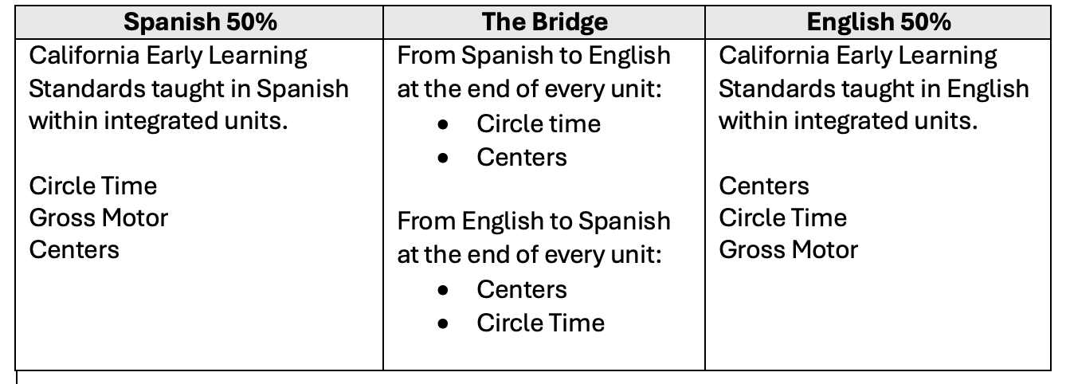

Sample PreK Half-Day Schedule 80/20

Half day - 180 total minutes
- 140 Spanish minutes
- 40 English minutes
8:15-8:40 | Arrival/Journal Writing/Quiet Reading | Spanish
8:45-8:55 | Circle Time (Large Group) | Spanish
9:00-9:30 | Gross Motor | Spanish
9:30-10:30 | Free Choice Time/Interest Areas (Small Groups) | Spanish
10:30-10:35 | Clean Up Time | Spanish
10:35-10:50 | Circle Time (Large Group) | English
10:50-11:10 | Free Choice Time/Interest Areas (Small Groups) | English
11:10-11:15 | Dismissal | English

Sample PreK Full-Day Schedule 80/20
Full day – 395 total minutes – 50 min rest = 345 instructional min
Approximately:
- 276 Spanish minutes
- 69 English minutes
8:35-8:50 | Arrival/Breakfast | Spanish
8:50-9:05 | Circle Time (Large Group) | Spanish
9:05-9:35 | Gross Motor/Outside Play | Spanish
9:35-10:35 | Centers/Interest Areas (Small Groups) | Spanish
10:35-10:45 | Clean Up/Books at the Carpet | Spanish
10:45-11:00 | Wash Hands/Line Up/Walk to Lunch | Spanish
11:00-11:30 | Lunch | Spanish
11:30-11:40 | Bathroom/Walk Back to Classroom | Spanish
11:40-12:30 | Rest Time | Spanish
12:30-1:30 | Centers/Interest Areas (Small Groups) | Spanish
1:30-1:40 | Clean Up/Books at Carpet | Spanish
1:40-2:00 | Circle Time (Large Group) | Spanish
2:00-2:30 | Gross Motor/Outside Play | English
2:30-3:05 | Circle Time (Large Group) | English
3:05-3:10 | Folders/Backpack/Dismissal | English

Sample PreK Full-Day Schedule 50/50

Full day – 395 total minutes - 50 min rest = 345 instructional minutes
Approximately:
- 172 Spanish minutes
- 172 English minutes
8:35-8:50 | Arrival/Breakfast | Spanish
8:50-9:05 | Circle Time (Large Group) | Spanish
9:05-9:35 | Gross Motor/Outside Play | Spanish
9:35-10:35 | Centers/Interest Areas (Small Groups) | Spanish
10:35-10:45 | Clean Up/Books at the Carpet | Spanish
10:45-11:00 | Wash Hands/Line Up/Walk to Lunch | Spanish
11:00-11:30 | Lunch | Spanish
11:30-11:40 | Bathroom/Walk Back to Classroom | Spanish
11:40-12:30 | Rest Time | Spanish
11:40-12:30 | Rest Time | English
12:30-1:30 | Centers/Interest Areas (Small Groups) | English
1:30-1:45 | Clean Up/Books at Carpet | English
1:45-2:15 | Circle Time (Large Group) | English
2:15-2:45 | Gross Motor/Outside Play | English
2:45-3:05 | Circle Time (Large Group) | English
3:05-3:10 | Folders/Backpack/Dismissal | English

Sample Biliteracy Schedule – 80% of Day in Spanish and 20% of Day in English

Time | Subject | Language
8:00 – 8:20 a.m. | SEL and Classroom Community Building | Spanish
8:20 – 10:30 a.m. | SS/Spanish Language Arts OR  Science/Spanish Language Arts (alternating units)  - Over the course of each unit, the students will engage in…  - Oracy and background knowledge development  - SS/Science experiences/inquiry  - Whole group instruction  - Writing (independent, small group and whole group)  - Reading (independent, small group and whole group)  - Foundational Skills and Language Comprehension (Word Study)  - Independent Practice | SPANISH
10:30-11:00 a.m. | Interventions (based on student need) | Language determined by the teacher and based on student need
11:00 a.m. – 12:00 p.m. | Specials | If possible, half are offered in Spanish and half in English
12:00 – 12:45 p.m. | Lunch | Student choice
12:45 – 2:00 p.m. | Math in Spanish  - Oracy and background knowledge development  - Math skills and practice  - Reading and writing as applied to math. | SPANISH
2:00 – 3:00 p.m. | English Language Arts  Over the course of each unit, the students will engage in…  - Oracy and background knowledge development  - Experiences  - Whole instruction  - Writing (independent, small group and whole group)  - Reading (independent, small group and whole group)  - Foundational Skills and Language Comprehension (Word Study)  - Independent Practice | ENGLISH
- The literacy routines included in these schedules are examples. Districts should include their own district-specific literacy routines in the biliteracy schedule.
- Integrated Language Arts units can alternate between SS and Science
- In these schedules, intervention time is not factored into the total Spanish or English time.

Sample Biliteracy Schedule – 50% of Day in Spanish and 50% of Day in English

Time | Subject | Language
8:00 – 8:20 | SEL and Classroom Community Building | SPANISH
8:20– 10:45 | Science and Language Arts  Over the course of each unit, the students will engage in…  - Oracy and background knowledge development  - Science experiences/inquiry  - Whole group instruction  - Writing (independent, small group and whole group)  - Reading (independent, small group and whole group)  - Foundational Skills and Language Comprehension (Word Study)  - Independent Practice | SPANISH
10:45 to 11:15 | Interventions (based on student need) | Language determined by the teacher and based on student need
11:15 – 12:00 | Lunch/Recess | Student choice
12:00 – 1:00 | Math - over the course of a math unit, the students will engage in:  - Oracy and background knowledge development  - Math practice  - Reading and writing as applied to math | ENGLISH
1:00-2:40 | Social Studies and Language Arts  Over the course of each unit, the students will engage in…  - Oracy and background knowledge development  - SS experiences/inquiry  - Whole group instruction  - Writing (independent, small group and whole group)  - Reading (independent, small group and whole group)  - Foundational Skills and Language Comprehension (Word Study)  - Independent Practice | ENGLISH
2:40-3:10 | Specials | If possible, half are offered in Spanish and half in English

NOTE: The literacy routines included in this schedule are examples. Districts should include their district specific literacy routines in the biliteracy schedule.

Sample Middle School Schedule

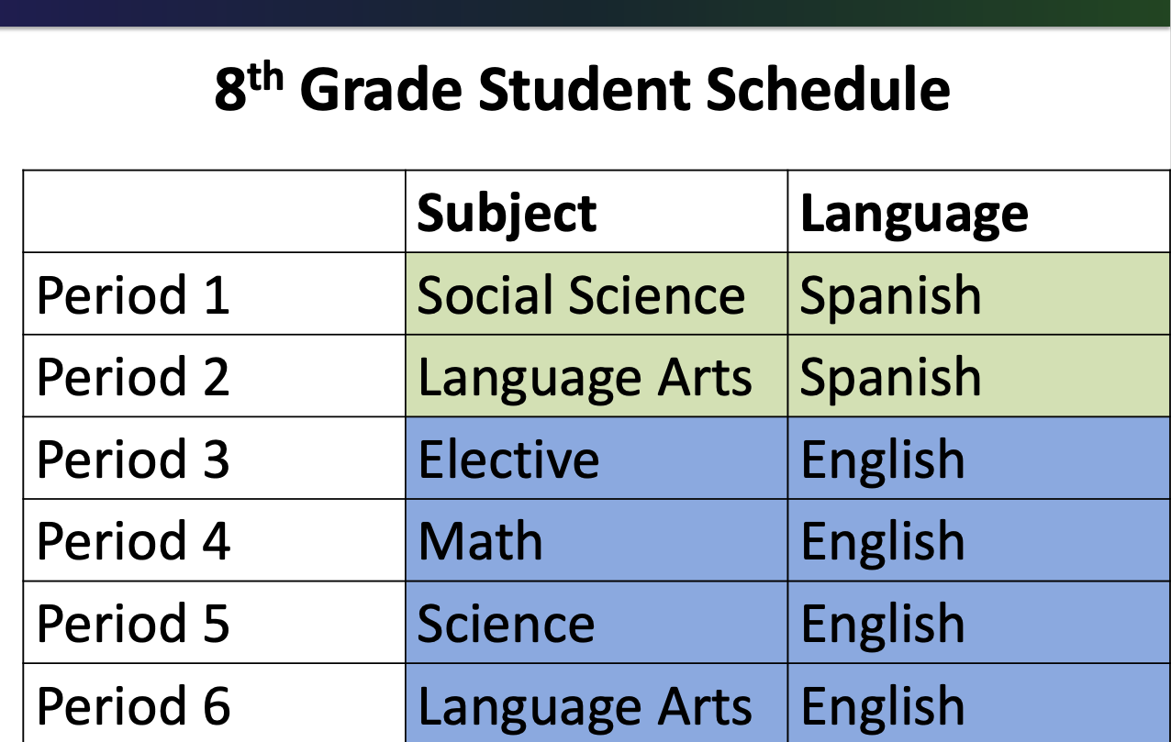

Sample Middle School Course Offerings

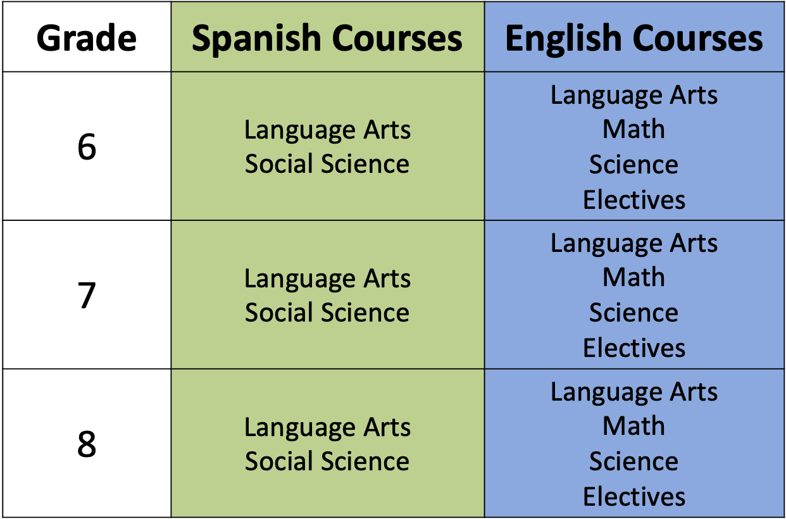

WIDA Language Proficiency Levels
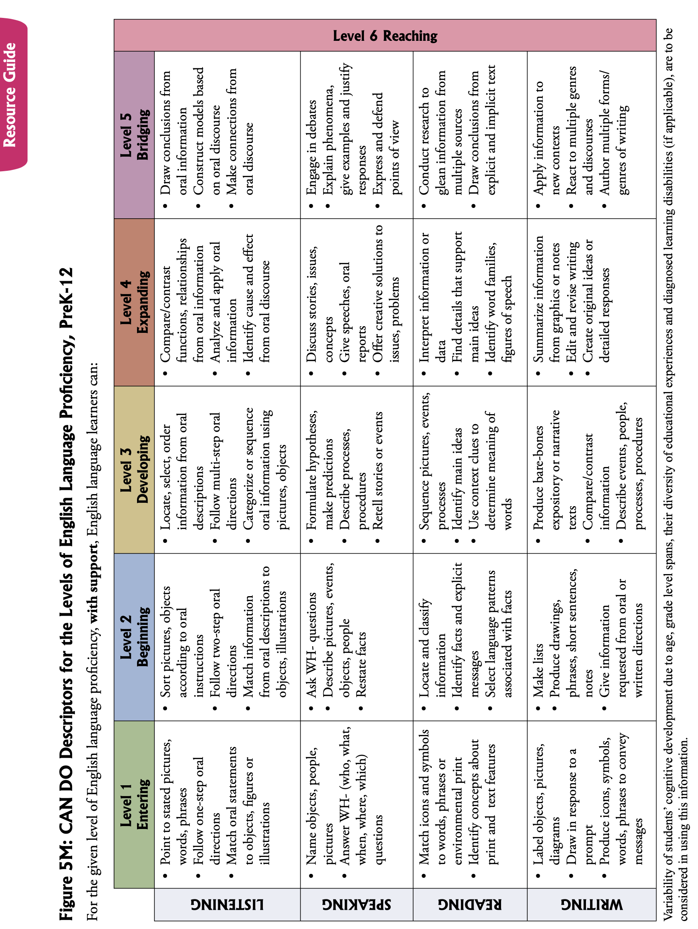

For more information and for grade level clustered rubrics, go to https://www.wida.us/standards/CAN_DOs/

For Spanish language rubrics, look for “Los descriptores podemos” on the WIDA website: www.wida.us
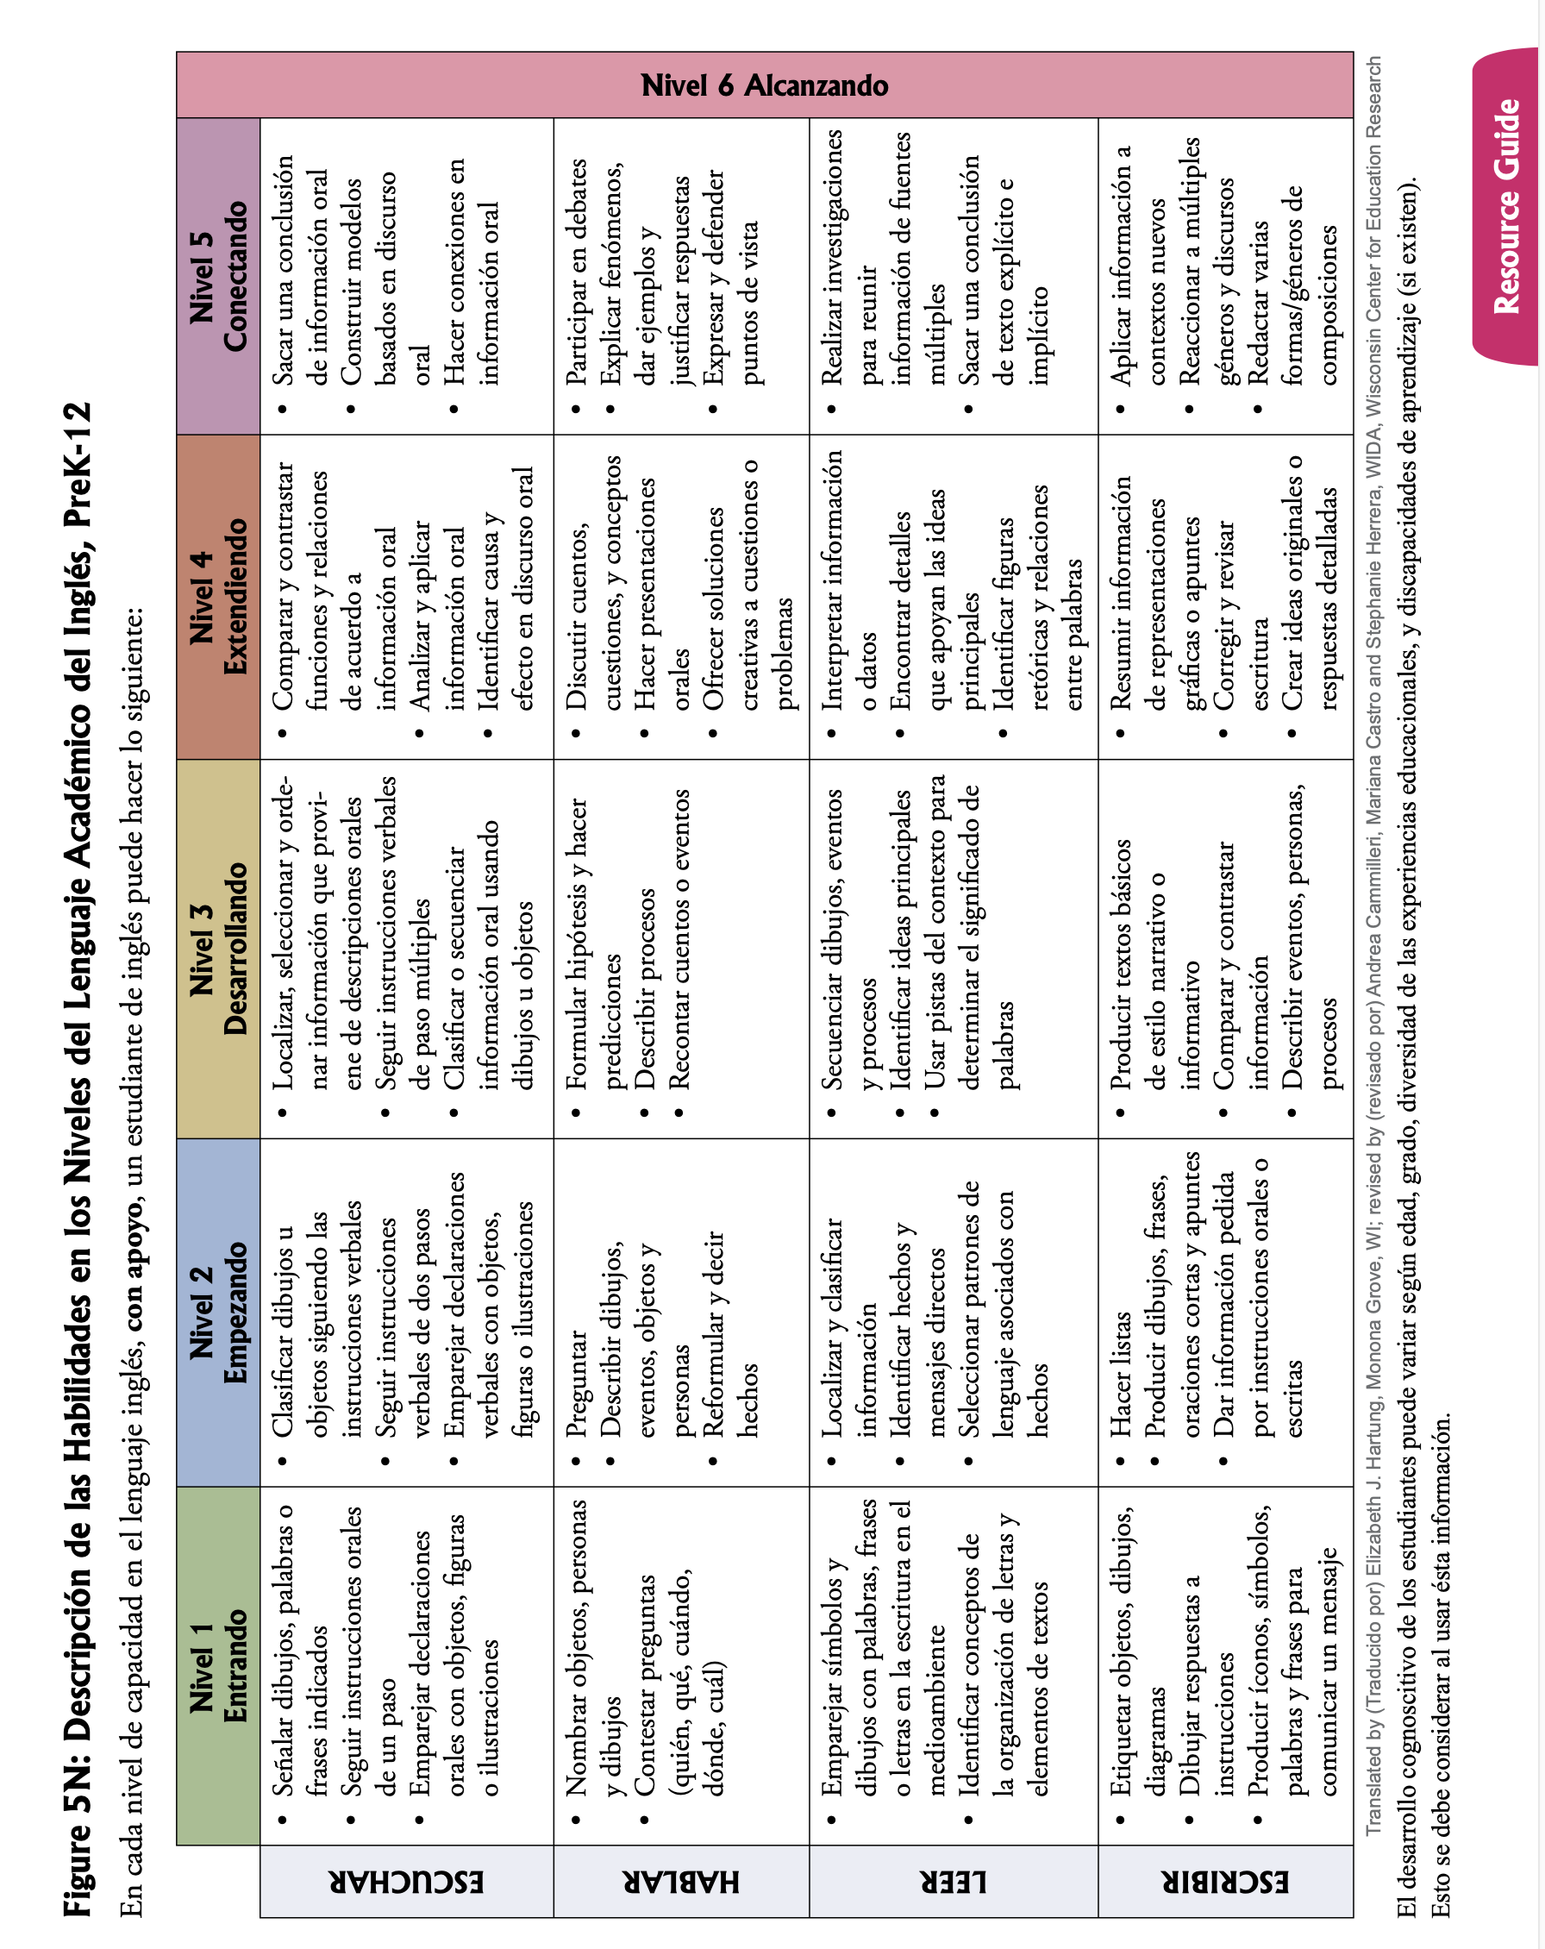

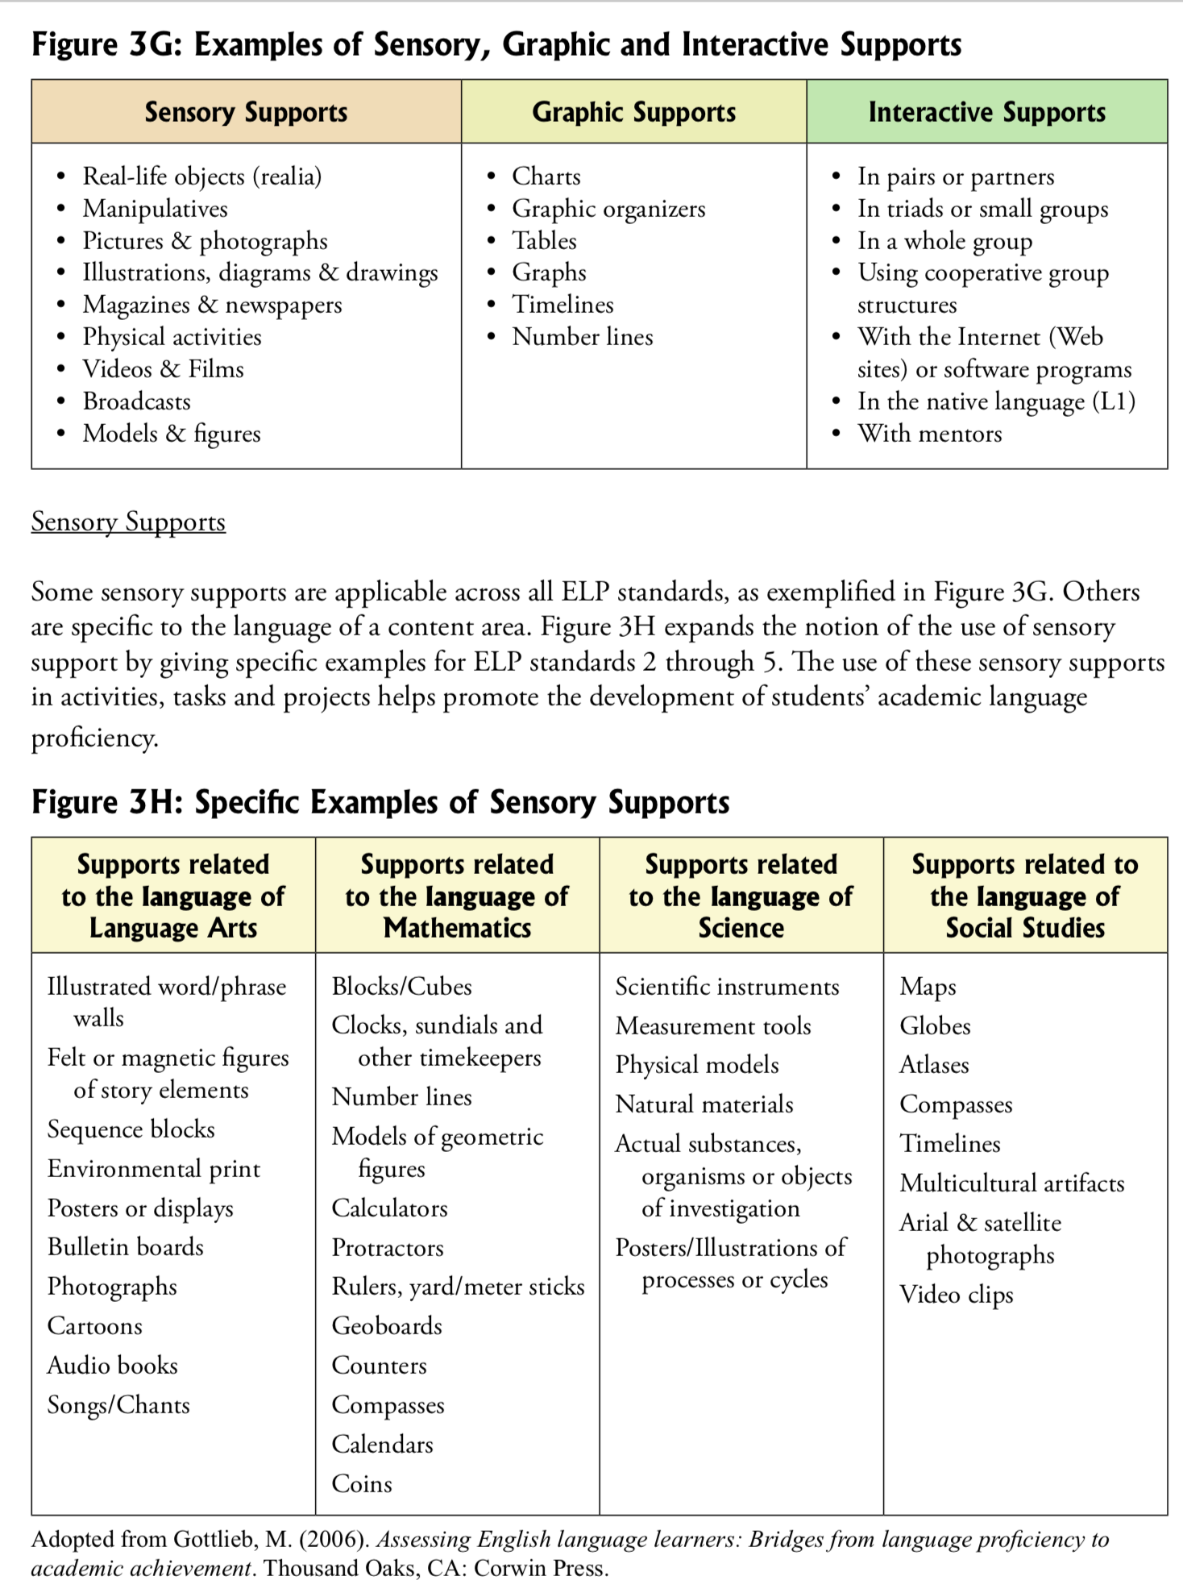

Overview: Biliteracy Curriculum Mapping Process
Steps | Components
I. A  Program Design  and First Draft of  Biliteracy Curriculum Map | Develop the program Vision and Pedagogy Statement and Look Fors that match the program pedagogy.
 | Using the Teaching for Biliteracy Recommendations, create the Language and Content Allocation Plan for all grades and schedules that match for each grade level.
Review the instructional shifts of the standards:
- NGSS
- C 3 Framework for SS
- CCSS Language Arts (page i of the bilingual CCSS grade level packet)

*If using a published program or resource:
- Review its organization to determine how the standards and all the instructional shifts of each set of standards are reflected and incorporated into the resource.
- Determine if the resource includes all the standards the grade level is responsible for (language arts, science, social studies, etc.)
  - Create a plan for how any missing standard sets will be addressed.
    - For example, if the resource includes only language arts standards, how, when, and with what will the science and social studies standards be addressed?

Draw the grade level Language and Content Allocation on Butcher Paper. Start mapping by bundling the content area standards.

Standards-Based | Standards-Aligned (Published Program)
Start mapping by bundling the content area standards.  Begin to write year-long and unit storylines, starting with the content focus.  Select the writing standards and the writing genre, making sure they are a good fit with the content.  Select the reading standards, thinking of the connection between reading and writing (i.e., the reading texts become mentor texts for writing).  Revise the storylines by adding the literacy portion to the storylines and by describing how content, literacy (reading and writing) is integrated. | Create a yearlong grade level standards map using the published program (for each language).  Include the unit theme, the meaningful context for learning (such as the topic of the unit), and the standards addressed.  - Analyze the unit themes. Are they concrete or abstract? Are they developmentally appropriate? Keep the units that provide a concrete meaningful frame and make appropriate revisions/adjustments to those that do not. Do this for each program language (Spanish and English).  - List the standards for each unit. Determine what sets of standards are used (CCSS ELA, SS, NGSS). Analyze how the standards in each unit reflect the instructional shifts and organization of the standards. Adjust as needed.  Write the first draft of your year-long storylines for each language.

I.B.  Audit: Record, Reflect and Revise | Record, reflect, and revise the map by:  - Using the rubric, Evaluating the content standards bundles in the map and make sure all the content standards are represented, reflecting the shifts in the standards.  - Engaging in the Record, Reflect and Revise process, analyzing the first draft of the map, focusing on rigor and balance of the language arts standards in each language.  - Revise storyline and bundles as needed  *If using a published program or resource:  - If using content standards, use the rubric to evaluate the bundles in the map and make sure all the content standards are represented, reflecting the shifts in the standards.  - Engaging in the Record, Reflect and Revise process, analyzing the first draft of the map, focusing on rigor and balance of the language arts standards in each language.  - Revise storyline and bundles as needed
II. Unit Backwards Design | Create a BUF for each unit on the map: *(If using a published program or resource, for each step below, the published resource will be consulted and used wherever it fits.)  - List the standards from the map  - Unpack all the standards in the unit into outcomes, listing the outcomes from the least to the most rigorous. Formative assessments assess the outcomes.  - Craft the big ideas for content and literacy based on the standards.  - Write the summative assessment.  - Create a flow chart which is used to write the storyline that describes what students will do and how the standards are integrated.  - Add instructional activities for meeting the standards and outcomes to each section of the BUF:  - Building Oracy and background Knowledge (& corresponding formative assessments)  - Content Area Instruction (& corresponding formative assessment)  - Reading Comprehension (& corresponding formative assessment)  - Writing (& corresponding formative assessment)  - Foundational Skills/Language Comprehension (& corresponding formative assessment)  - The Bridge for Transfer and for Contrastive Analysis (& corresponding formative assessment)
III. Unit Learning Plan | Create a week-by-week learning plan that includes:  - Outcomes to be covered  - Formative assessments that will assess student performance based on the outcomes  - The instructional activities that will be used (from step 2)  - High leverage biliteracy strategies  - Language supports: sensory, graphic and interactive  - Partnerships  - Sentence prompts, word banks, etc.

Bridge and “bridging”
The Bridge is… | Bridging is…
pre-planned by the teacher, occurs at the end of a robust unit of instruction that has been conducted all-in-one language | when teachers guide students in making cross-linguistic connections, in each language, during the unit of instruction.
about transfer – supporting students in transferring their learning (standards, concepts, essential understandings) from the language of instruction to the opposite language | the opportunity for the teacher to intentionally guide students in applying and building on the contrastive analysis (AKA cross-linguistic connection) charts created during the Bridge.
about contrastive analysis: comparing and contrasting the Spanish and English in the transfer charts in the areas of phonology, morphology, syntax and grammar, and pragmatics | When students add their noticings to the contrastive analysis charts already learned
highly interactive and student-centered | not the same as Bridge.
not a translation, or just about cognates | not the teacher giving students the words.

Three Types of Bridges: Part One of the Bridge

Illustration | Side-by-Side | Así se dice
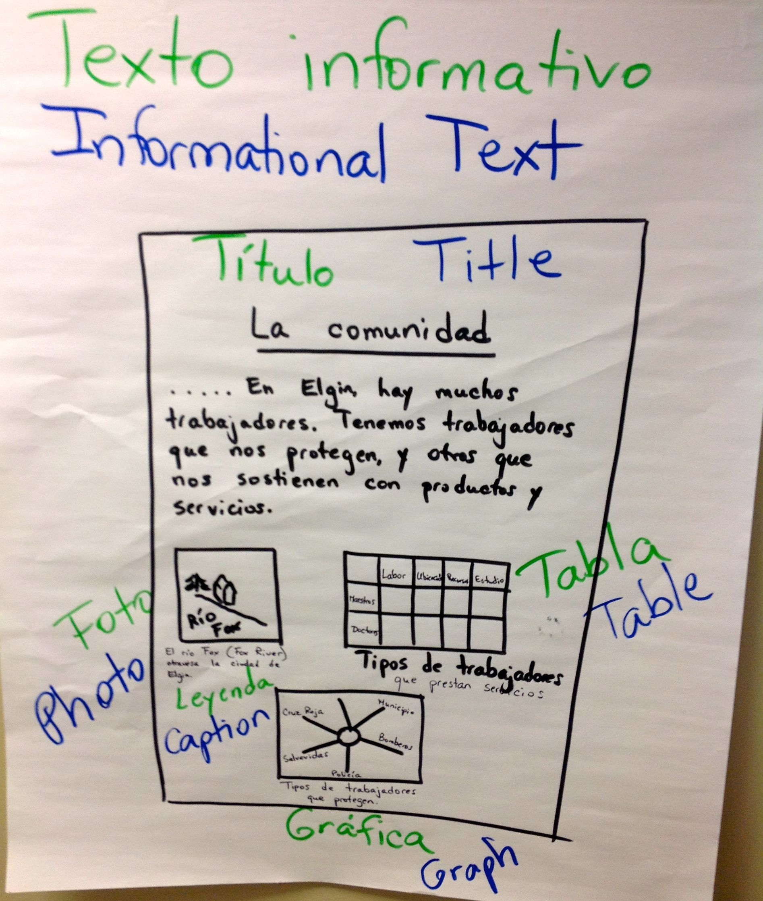 | 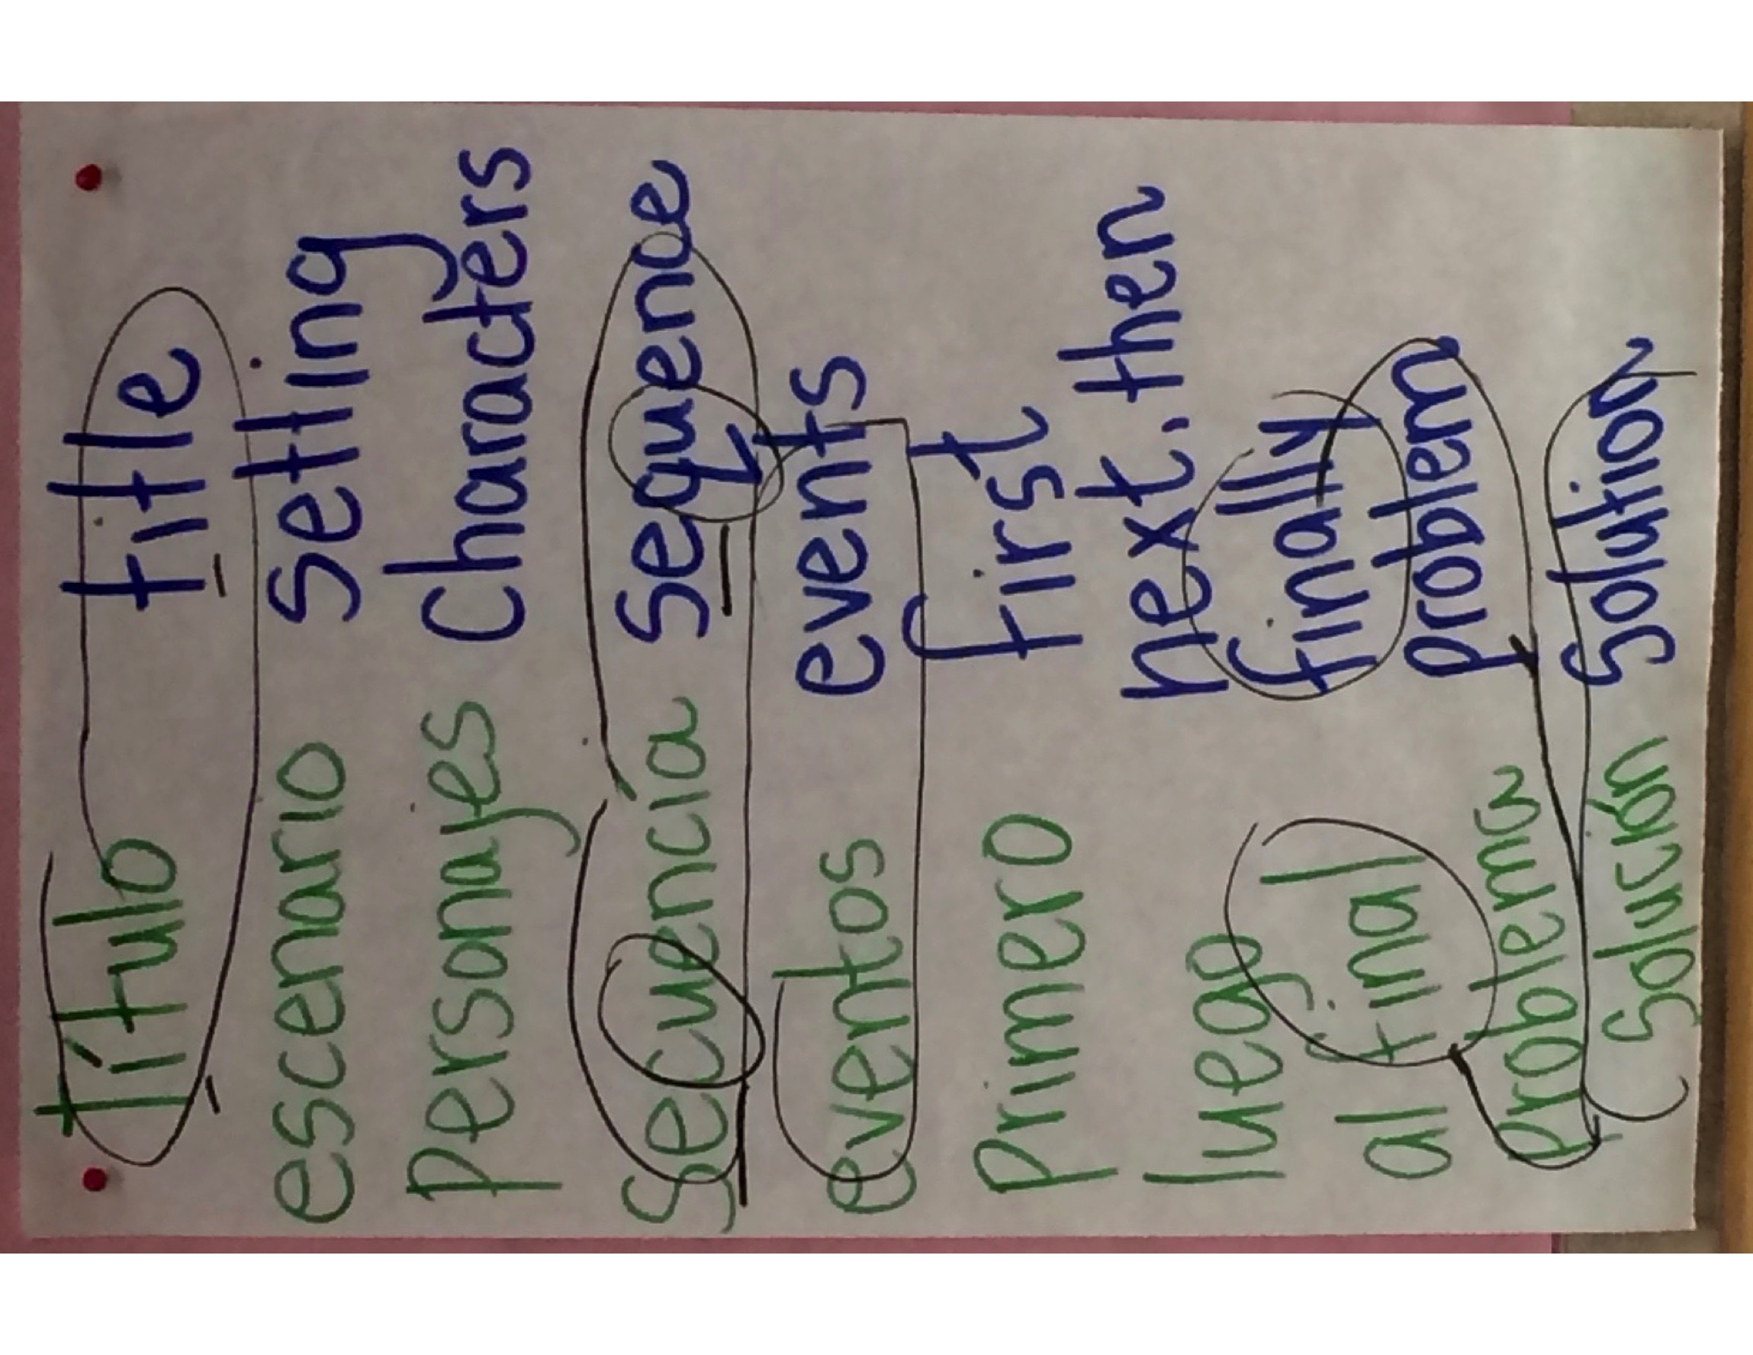 | 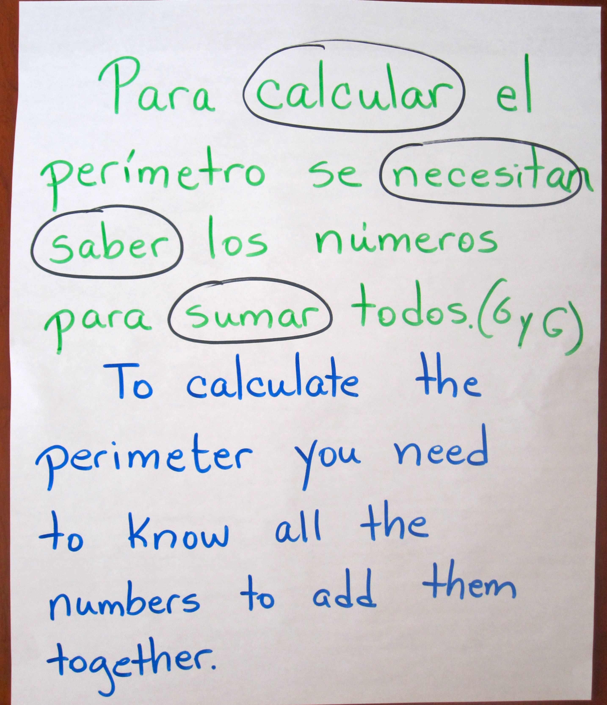

Three Types of Contrastive Analysis Charts: Part Two of the Bridge and part of “bridging”

Phonology | Morphology | Syntax and Grammar
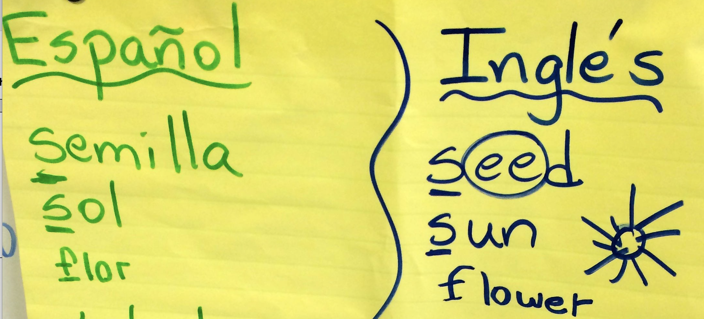 | 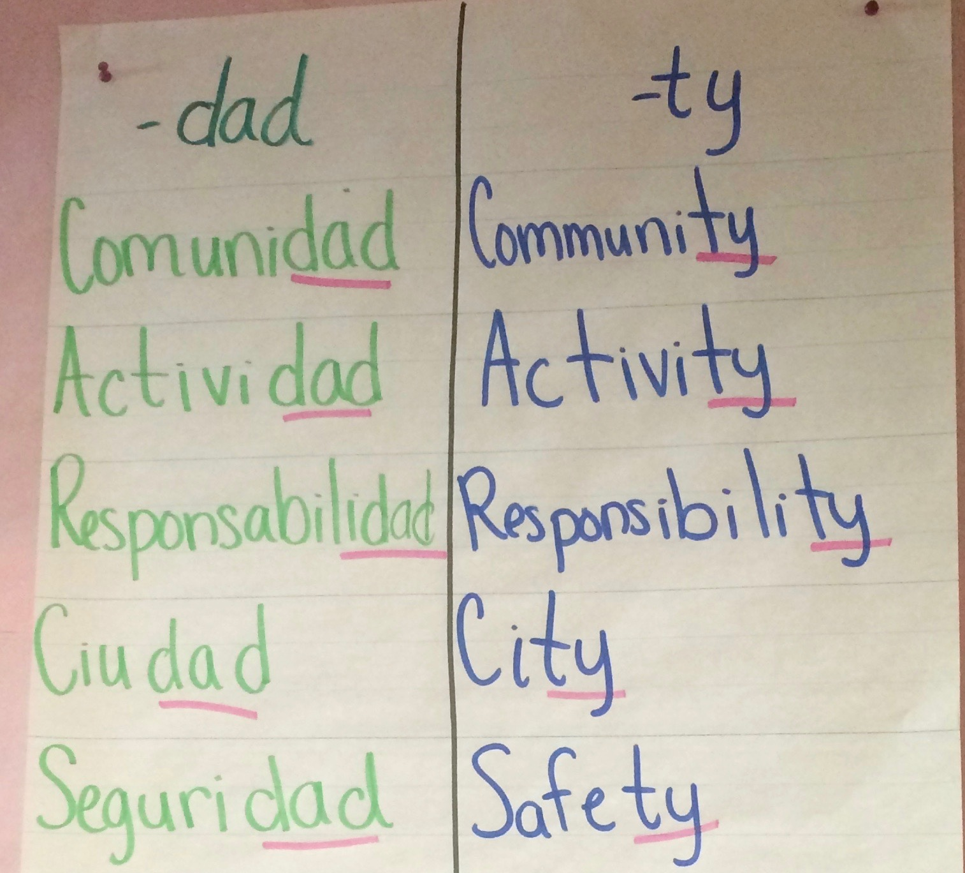 | 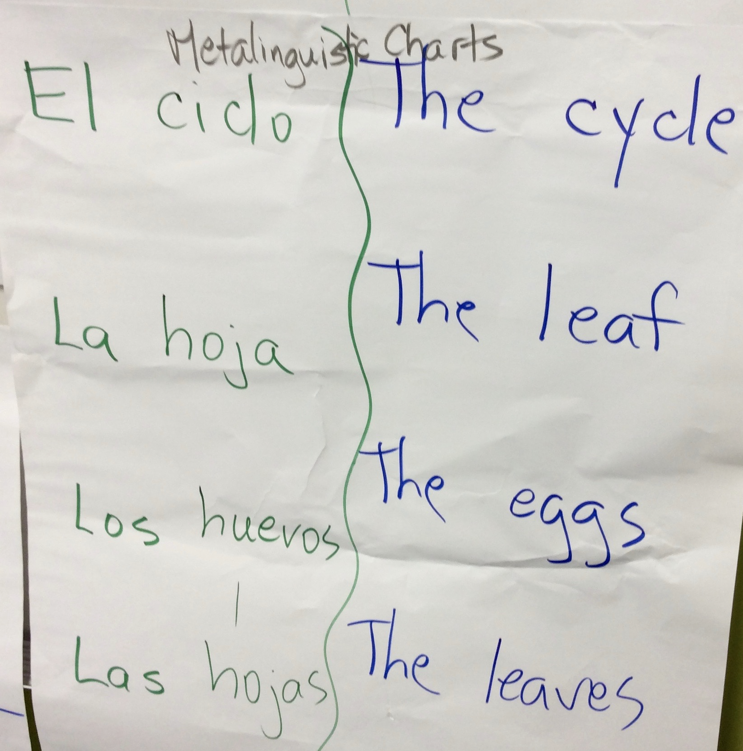
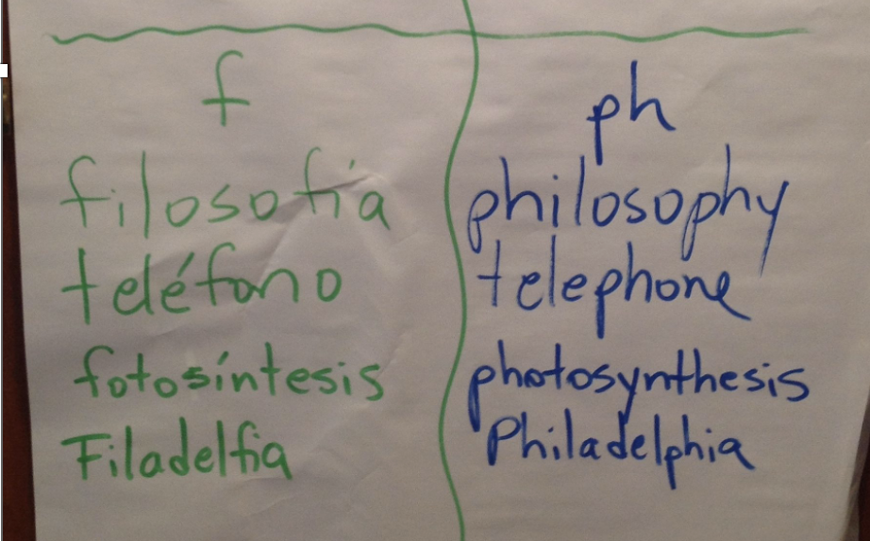 | 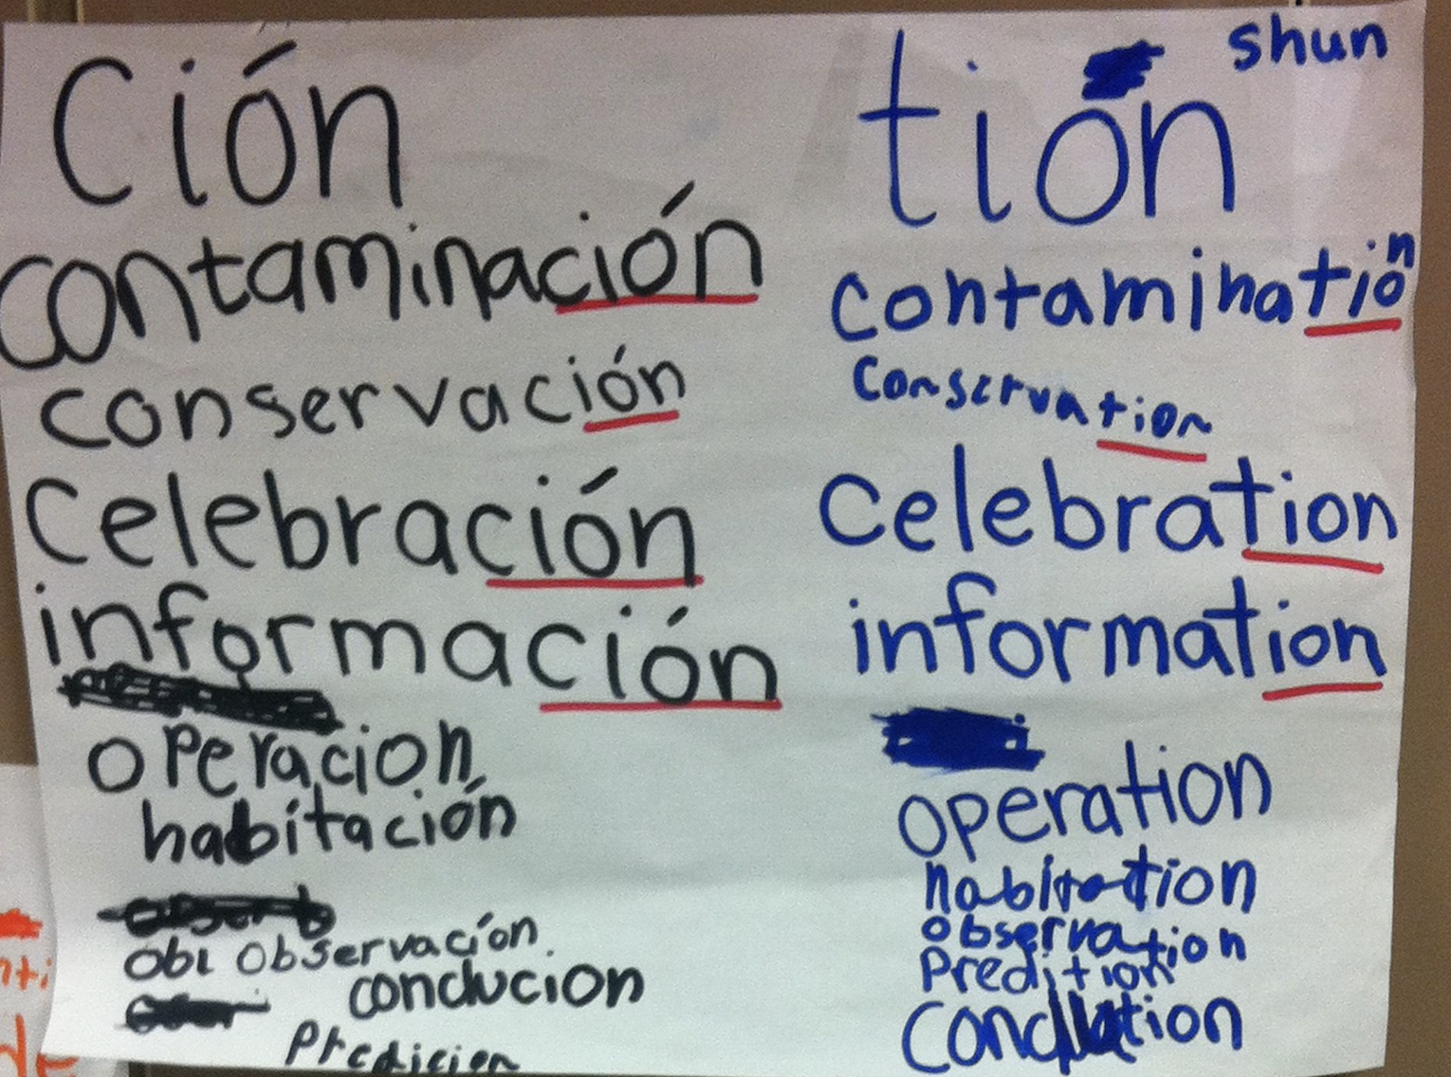 | 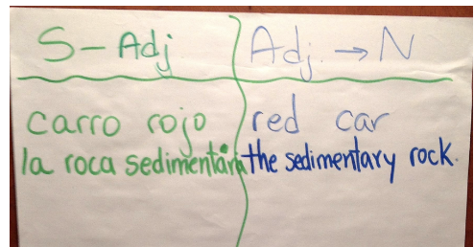  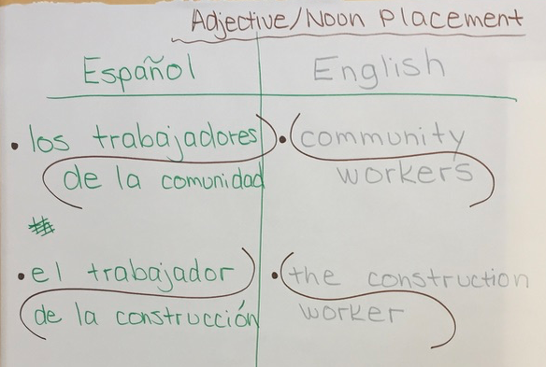
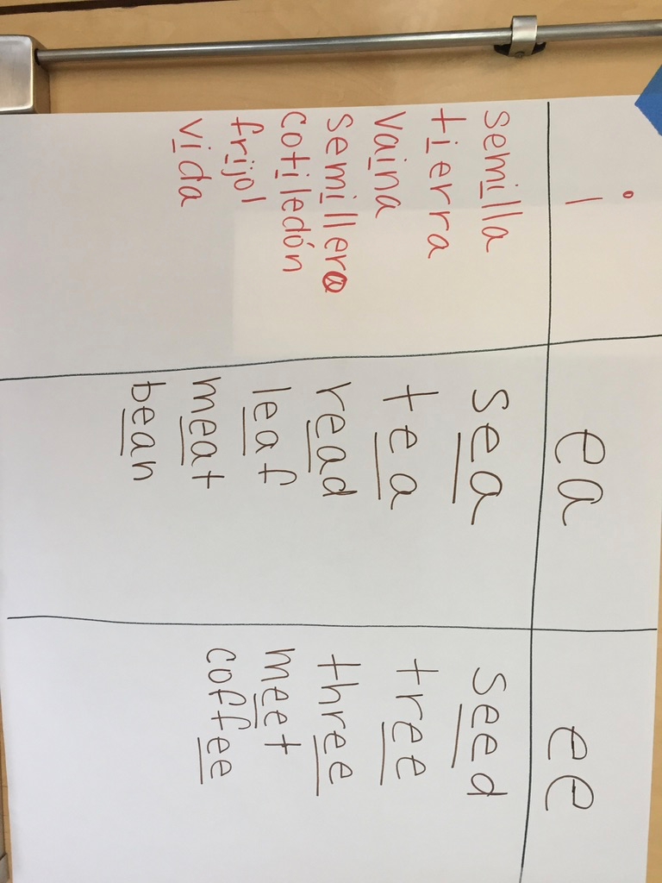 | 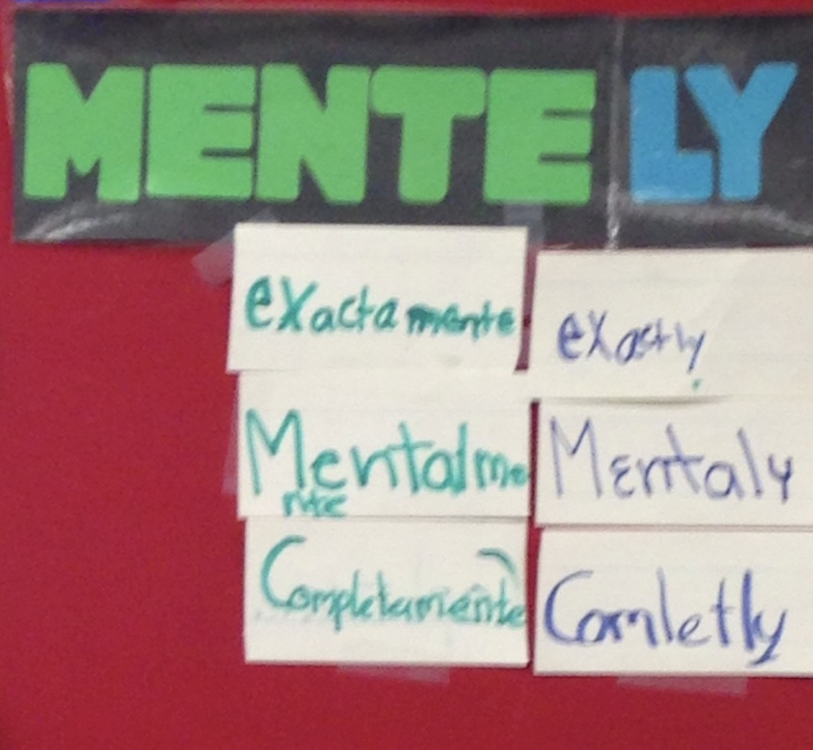 | 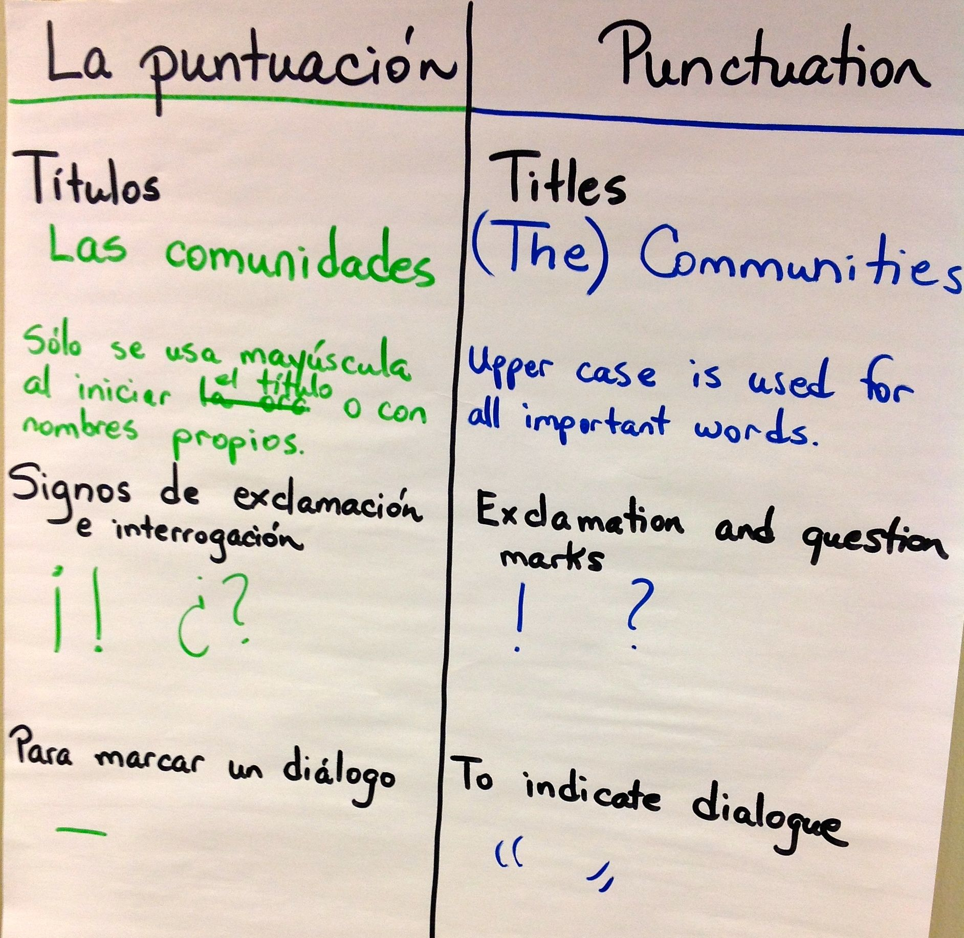

Four Areas of Contrastive Analysis: Part Two of the Bridge
Element and area of focus | Examples
Phonology (sound system)  - Sounds that are different in the two languages.  - Sounds that are similar in the two languages. | - Sound-symbol correspondence (e.g., the [k] sound: “qu” or “c” in Spanish; “c” or “k” in English)  - Silent letters (e.g., “h” and “u” in Spanish; many in English)  - The existence of the [th] sound in English but not in Spanish; therefore, students select the closest Spanish phoneme, which is /d/
Morphology (word formation): prefixes and suffixes shared between the two languages (cognates) | informal – informal  informar – inform  socialismo – socialism  desastroso – disastrous  preparar – prepare  profesión – profession  educación – education
Syntax and grammar (sentence structure)  - Rules for punctuation, grammar, word order, etc. unique to each language  - Areas that are similar and areas that are different | Spanish uses the initial inverted exclamation point; English does not (e.g., ¡Me encanta! – I love it!)  Articles have gender in Spanish but not in English (e.g., el título – the title; la revolución – the revolution)  In Spanish accents change the meaning of words (e.g., el Papa vive en Roma; la papa es deliciosa; mi papá es muy trabajador)  Spanish has many reflexive verbs; English has few (e.g., Se me cayó)  Conjugation of verbs in Spanish reduces the need for the pronoun. (e.g., ¡Voy!)  English contains possessive nouns; Spanish does not (e.g., my grandmother’s house – la casa de mi abuela)
Pragmatics (language use)  - Cultural norms or contexts that are reflected in language use.  - Use of overlapping cultural norms in a bilingual context. | Questions about age avoid the world “old” in Spanish because its use in this context is inappropriate. (¿Cuántos años tienes? Not, ¿Qué tan vieja eres?)  Figurative language from English is translated directly into Spanish: Estoy encerrado afuera (I am locked out!) rather than Me quedé afuera.  Spanish constructs are used during English (e.g., Mis padres ganan mucho dinero. My fathers win lots of money).

Beeman, K. and Urow, C. (2013). Teaching for Biliteracy: Strengthening Bridges between Languages. Brookes Publishing: Baltimore, MD.

Planning for the Bridge
- Review in the language of instruction | 4. The Bridge for Transfer: Match the key words/phrases/sentences to the other language
2. Elicit key words/phrases/sentences in the language of instruction from students | 5. The Bridge for Contrastive Analysis
3. The Bridge for Transfer: Practice the terms in the new language (i.e., build oracy in the opposite language). | 6. The Bridge for Transfer: Practice

Assessment in Language Programs

Adapted from Gottlieb, M. and Nguyen D. (2007). Assessment and Accountability in Language Education Programs. Philadelphia, PA: Caslon Publishing

Principles:
- Assessment should capture student growth in both language development and academic achievement in each language.
- Formative assessment should mirror instruction and should be administered and collected over time using rubrics, checklists, and other assessments.
- Standardized assessments reflect district, state, and federal guidelines.

Language of Instruction | Language Assessments | Academic Achievement Assessments
Spanish | Formative or Instructional:  Interim:  Standardized (occur once): | Formative or Instructional:  Interim:  Standardized:
English | Formative or Instructional:  Interim:  Standardized: | Formative or Instructional:  Interim:  Standardized:

SAMPLE: Assessment in Language Programs

Language of Instruction | Language Assessments | Academic Achievement Assessments
Spanish | Formative or Instructional:  - Language Development Rubrics for Spanish (WIDA CAN DO descriptors)  - Oracy Anecdotal Record Charts  - Initial oracy for science  - Oracy before reading  - Spanish as a Second Language Checklists  - Language Development Rubrics  - Speaking Rubrics  - Listening Rubrics  Interim:  - Language Development Rubrics for Spanish (WIDA CAN DO descriptors)  Summative/ Standardized:  - AVANT STAMP Language Proficiency Test  - DELE (from Spain)  - ELLOPA (PK-5)  - LAS Links español | Formative or Instructional:  - Writing rubrics in Spanish  - Reading Inventories  - Dictado Checklists  - Content area project rubrics  - Teacher made tests  - Performance based tasks  - Anecdotal Record Charts  Interim: EDL2 or STAR  Standardized:  - LAS  - APRENDA
English | Formative or Instructional:  - Language Development Rubrics (WIDA’s CAN DO descriptors) used formatively  - ESL Checklists  - Language Development Rubrics  - Speaking Rubrics  - Listening Rubrics  - Reading and Writing Rubrics  Interim:  - Language Development Rubrics for English (WIDA CAN DO descriptors)  Standardized:  - ACCESS (WIDA states)  - CELLA (Florida)  - ELPAC (California) | Formative or Instructional:  - Writing rubrics in English  - Reading Inventories  - Spelling Growth  - Fluency Measures  - Content area project rubrics  - Teacher made tests  - Performance based tasks  - Anecdotal Record Charts  Interim: DRA or STAR  Standardized:  - State large scale testing (PARCC and Smarter Balance) example: Illinois Assessment of Readiness
Topics for Individual or Team Institute Reflection

Agenda Item | Reflection
Students and Goals of Biliteracy Programs

The Multilingual Perspective of Language
The Biliteracy Unit Framework (BUF)
Strategic Use of Teacher Language Use: Establishing a Language Policy
Educational Equity: Research on Dual Language Programs
The Teaching for Biliteracy Recommendations
Planning for Sustainability: Handbook of Biliteracy Systems and Structures
Characteristics of Effective Biliteracy Instruction

Individual or Team Planning for Next Steps

Elements we have in place: Affirmations | Areas to work on: Next Steps | Other

